22of october | NEWS TODAY  Latest news and updates |  |  |  |  | Issue  #10
Sea anemone and clownfish teach humans a valuable lesson about cooperation  The latest updates  If you don’t already know the sea anemone and the clown fish cooperate with each other because the clownfish gets protection and the sea anemone gets a guard. Lets dig deeper into their story. Lets start with the sea anemone, A sea anemone is a soft-bodied marine invertebrate belonging to the order Actiniaria, part of the phylum Cnidaria, which also includes corals and jellyfish. They are characterized by a cylindrical body with a central mouth surrounded by tentacles, which they use to capture prey. Sea anemones are primarily sedentary and can be found in various marine environments, from tidal zones to deep ocean floors. They are known for their colorful appearance and often form symbiotic relationships with clownfish. now on the other hand a clownfish is a small fish that is usually red, orange, or yellow with white stripes, and lives in warm or tropical seas .clownfish are primarily found in the warm, tropical waters of the indo-pacific region. so they both are cooperative animals that use symbioses to make their life better where the sea anemone gets a guard and the clownfish gets protection. these two animals are a perfect example of teamwork they protect each other, feed each other, and love each other. And that’s exactly how us humans should be loving, caring. And protective. that’s all for today newspaper |  |  | 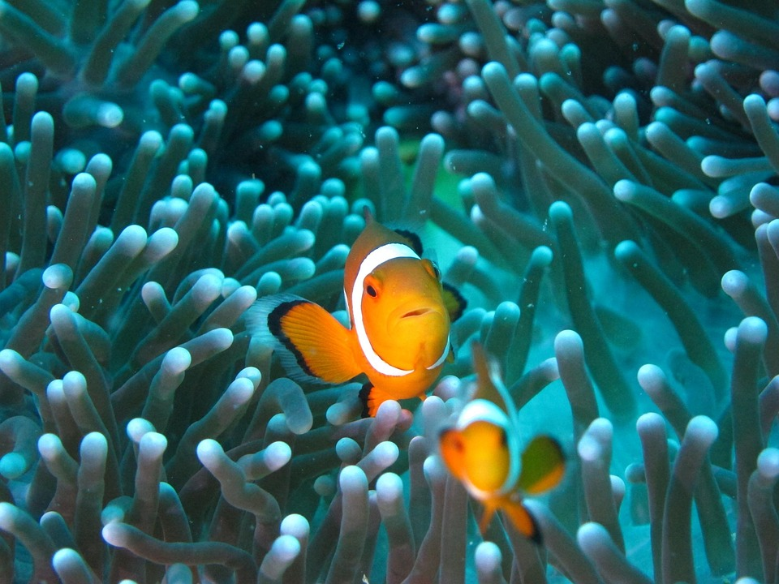
 |  |  | Picture Caption: To make your document look professionally produced, Word provides header, footer, cover page, and text box designs that complement each other.
 |  |  |  | Page 1

