📝 Upcoming Speaking Assessment

📢 Message to Parents | ❓ Sample Questions for Students
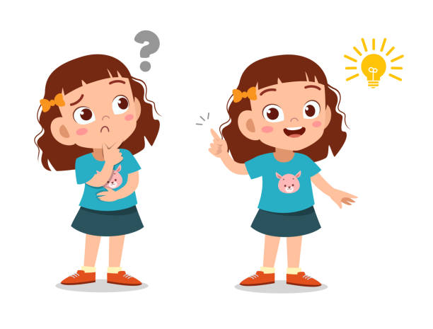  Dear Parents,  We would like to inform you that the upcoming assessment will be based on the topic **“my feelings.”**  During this assessment, students will be asked **critical thinking questions** related to the theme.  Each student will have 1 minute to respond. The goal is for students to use their **own words** and express their **personal thoughts and opinions** freely. Memorized answers are not encouraged—we want them to share their ideas naturally.  Thank you for your support in encouraging your child to think independently and speak with confidence. | Question 1: Students will be given cards with different faces showing feelings “happy, sad, angry, scared” .  Students must tell at least one sentence about that feeling and mention the synonyms of both “angry= upset,  scared =afraid “  Question 2: Students must speak about one time they felt either happy, sad, angry or scared. As the teacher will ask.

أولياء الامور الأعزاء,,
📌نود إعلامكم أن التقييم القادم سيكون حول موضوع " مشاعر ".
📝 خلال هذا التقييم، سيُطلب من الطلاب الإجابة عن أسئلة تفكير ناقد مرتبطة بالموضوع.
⏱️ سيكون لكل طالب دقيقة واحدة للإجابة.
💬 الهدف هو أن يستخدم الطلاب كلماتهم الخاصة ويعبروا عن أفكارهم وآرائهم الشخصية بحرية.
🚫 لا نشجع الحفظ المسبق، بل نريد منهم مشاركة أفكارهم بشكل طبيعي.
🙏 شكرًا لدعمكم في تشجيع أبنائكم على التفكير باستقلالية والتحدث بثقة.

