

Grade Three remedial Booklet
First Semester
2025-2026


Name:_______________________


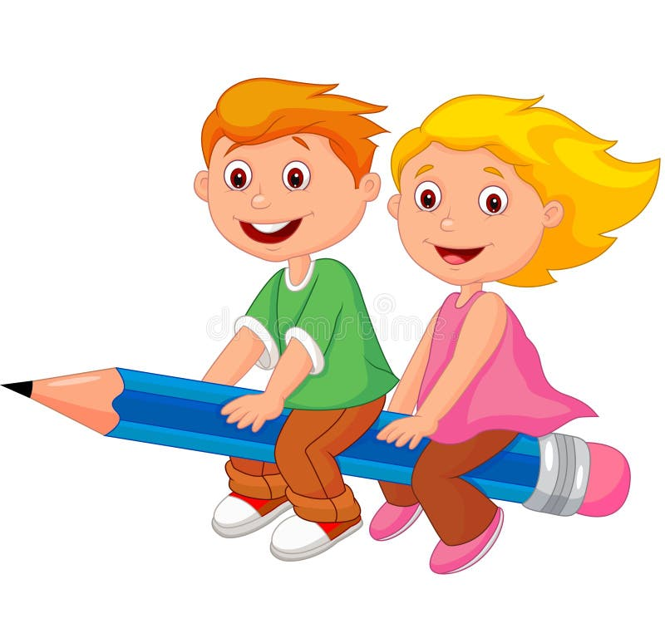

Key words+ academic words

 English  Department | My name is:
 | Grade: 3

outcome: students should recognize the new vocabulary

Write the word under each picture.
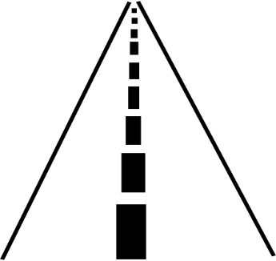



letters
_________ _________ __________
street
flower


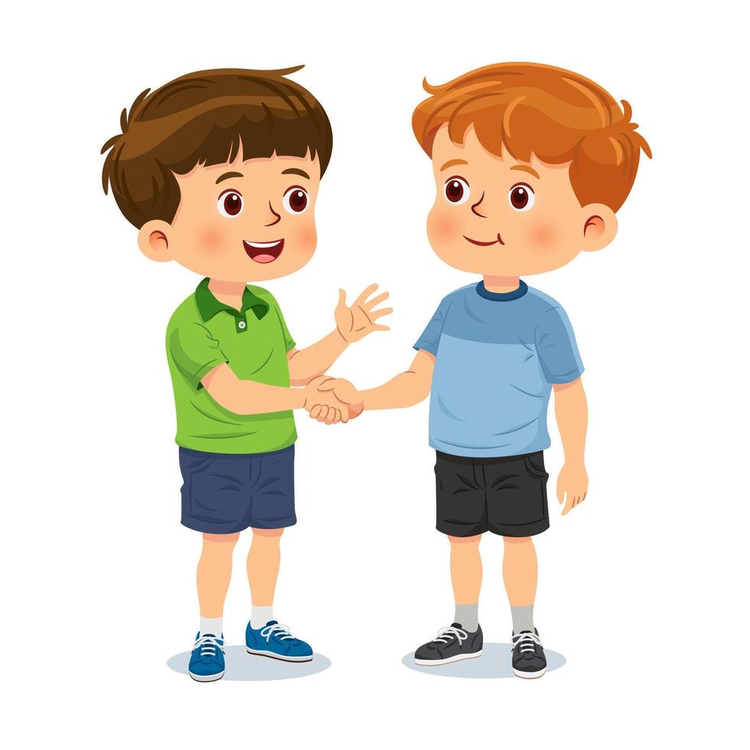
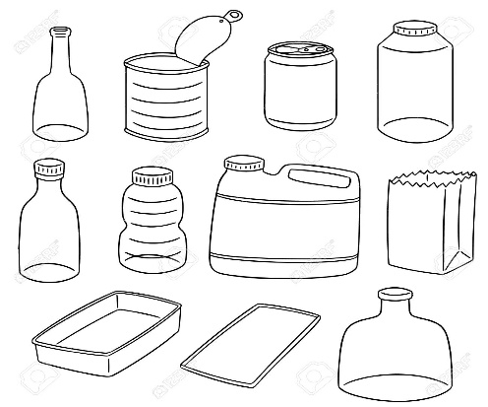

purchase
_________ _________ __________
greet
items
Subject Pronouns
English  Department | My name is:
 | Grade: 3

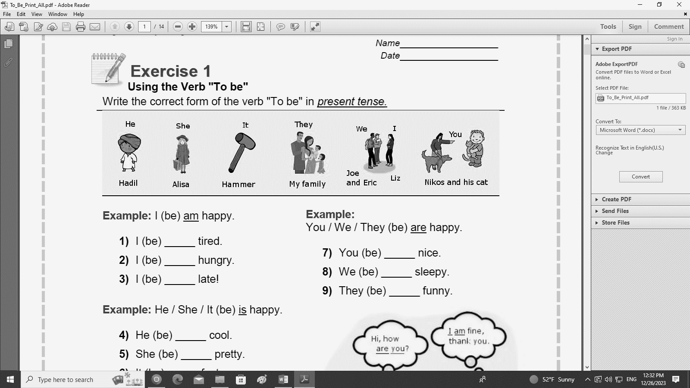
Outcome: Students should be able to recognize and identify the singular and plural pronouns.

We use subject pronouns at the beginning of the sentences.


- Write the suitable pronoun for each picture:

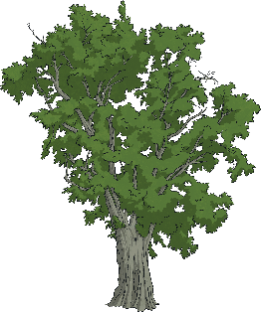
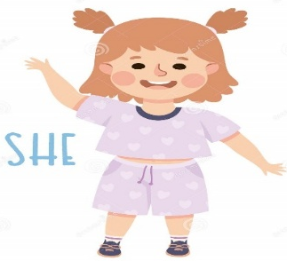

you

I
we
it
he
she
_______________
_________________
________________
_________________
_________________

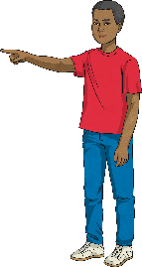


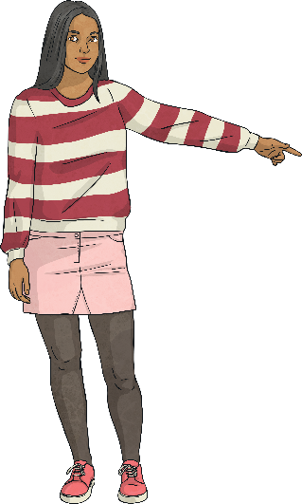

they
you
__________________ _________________

Present simple, Be verbs
English  Department | My name is:
 | Grade: 3

Outcome: Students should be able to identify the use of the simple present tense.

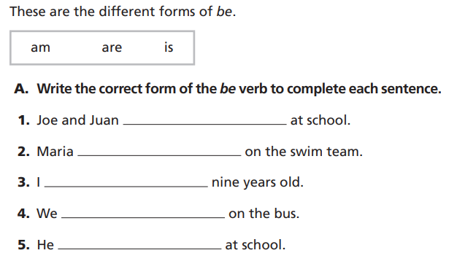
am
is
is
are
are

Phonics, long and shoet vowels
English  Department | My name is:
 | Grade: 3

Outcome: Students should be able to identify the sound of Long and Short Vowel and read correctly.

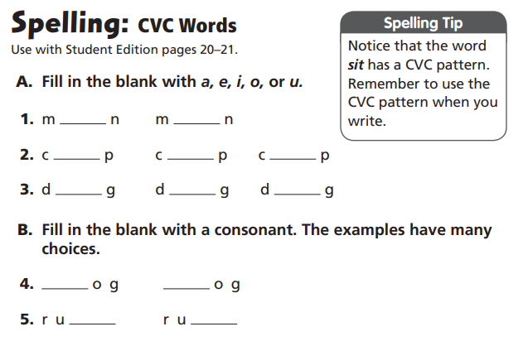
English  Department | My name is:
 | Grade: 3

a
e
o
u
a
u
i
o

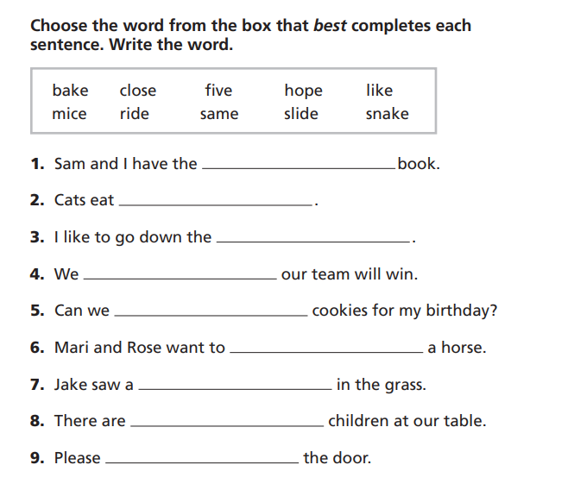

same
mice
hope
slide
bake
ride
five
snake
close
Reading comprehension
English  Department | My name is:
 | Grade: 3

Outcome: Students should be able to read and answer the questions
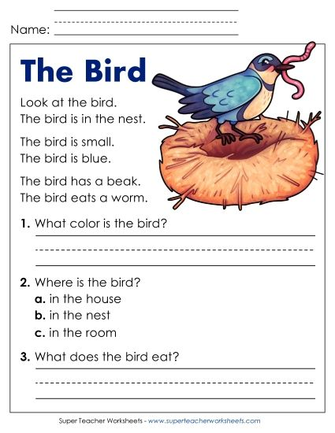
It eats a worm
It is blue.

English  Department | My name is:
 | Grade: 3
Key words+ academic words
outcome: students should recognize the new vocabulary.
English  Department | My name is:
 | Grade: 3

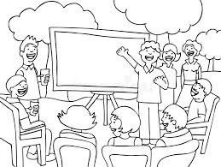

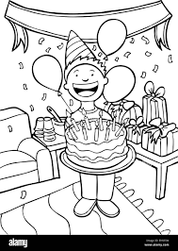
Write the word under each picture.

gather
crowd
celebrate
_________ _________ __________





company
weekend
_________ _________ __________
contribute

English  Department | My name is:
 | Grade: 3

Fill in the blank with the correct word:
contribute celebrate weekend similar

weekend
- Friday and Saturday are _______________.
similar
- These hats are ___________________.
contribute
- I ________________ old books to the library.
celebrate
- I like to _________________ my birthday with my friends.



Grammar (singular & plural nouns)

English  Department | My name is:
 | Grade: 3
Outcomes:
➢ Students should be able to recognize singular and plural nouns.
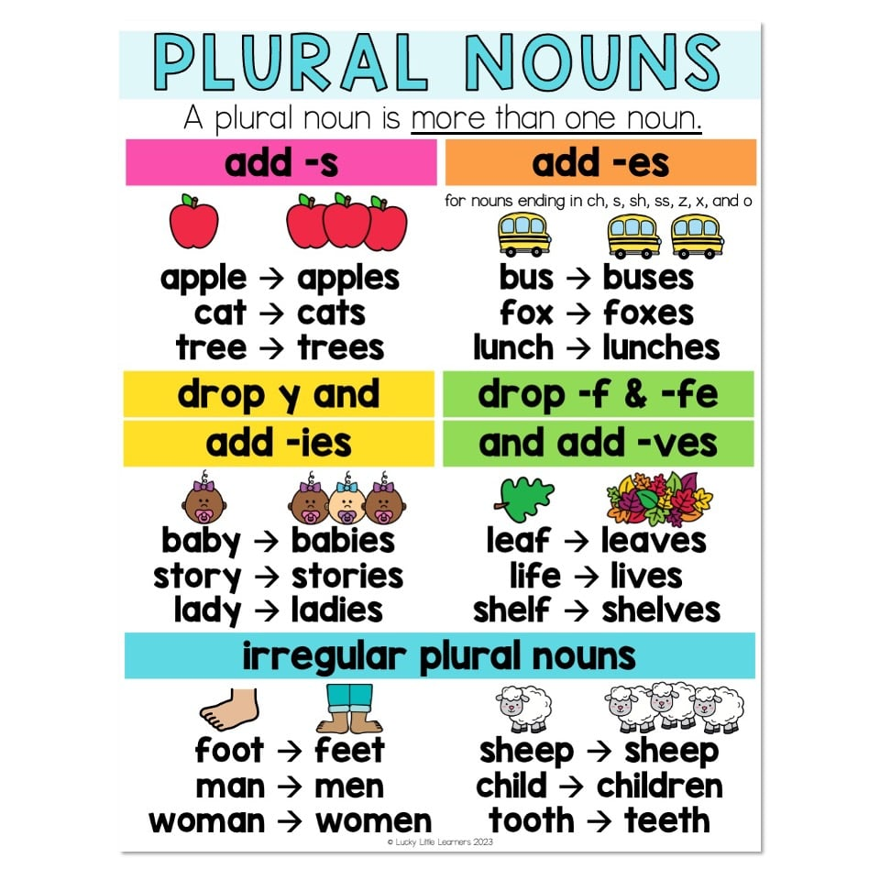
➢ Students should be able to spell the words correctly.

Change the following singular nouns into plurals:

- Book: 2- Woman:
Women
Books
- Foot: 4- Apple:
Apples
Feet
- Bus: 6-wish:
Wishes
Buses
Reading comprehension

English  Department | My name is:
 | Grade: 3
Outcome: Students should be able to read and answer the questions

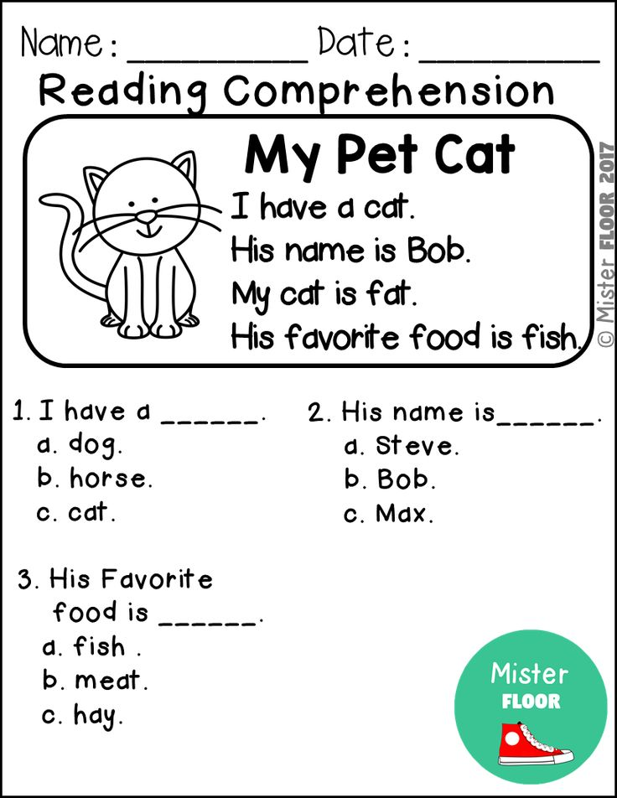

Key words+ academic words
English  Department | My name is:
 | Grade: 3

outcome: students should recognize the new vocabulary
Write the word under each picture.
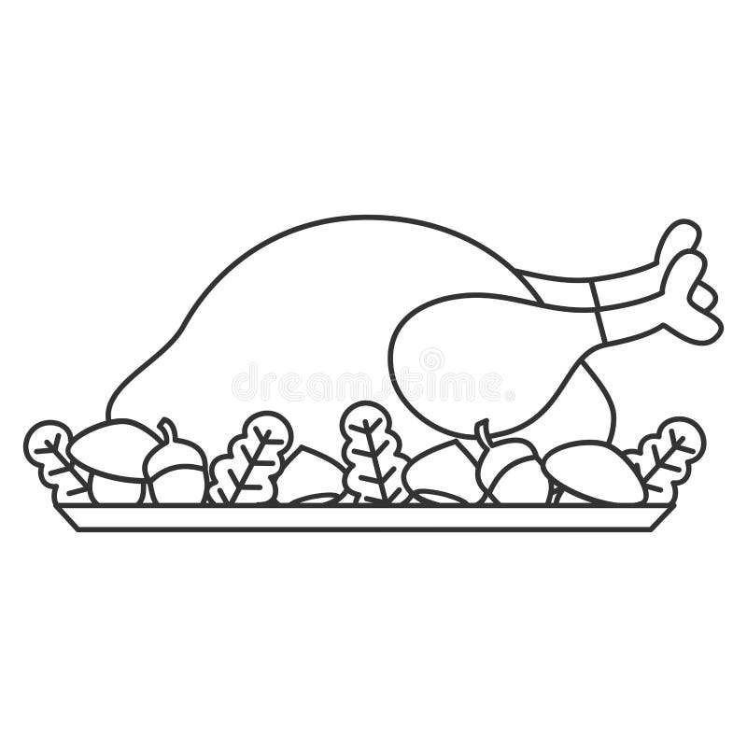
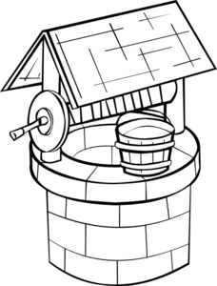
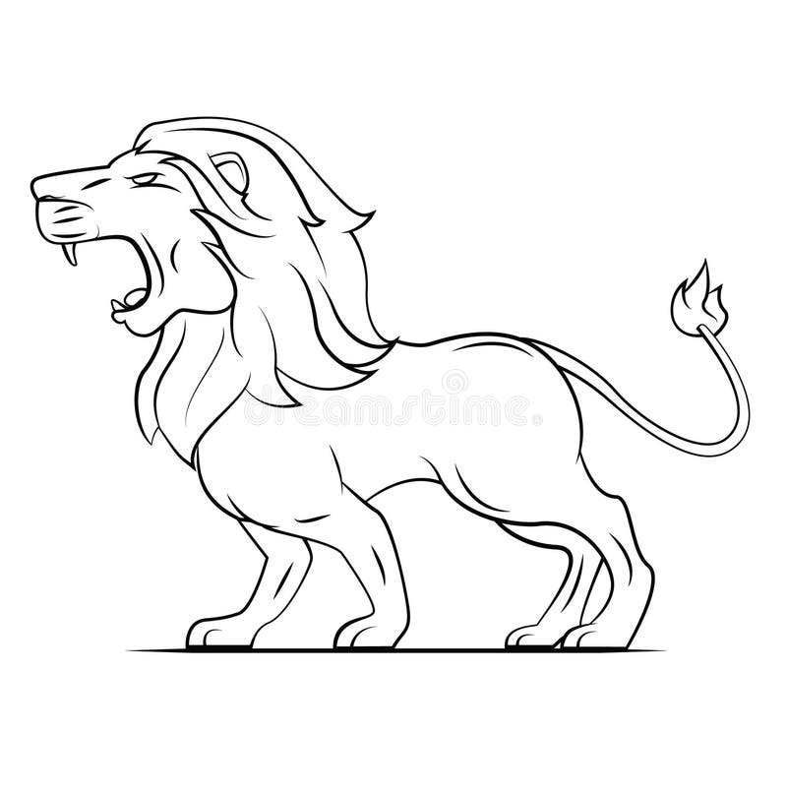

_________ _________ __________

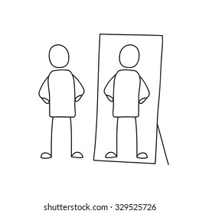


___________ ___________

English  Department | My name is:
 | Grade: 3

- Fill in the blank with the suitable words
(dinner, well, roars, reflection, focus, )
- The last meal of the day________________.

- I can see my ___________________ in the mirror.

- I can ______________ my mother’s cooking by smelling it.

- A hole in the ground with water in it__________.

- The duck quacks and the lion ________________.

6- I have to ___________________ on my lessons.

Long vowel pairs

English  Department | My name is:
 | Grade: 3
Outcomes: Students should be able to identify the sound of Long Vowel Pairs.

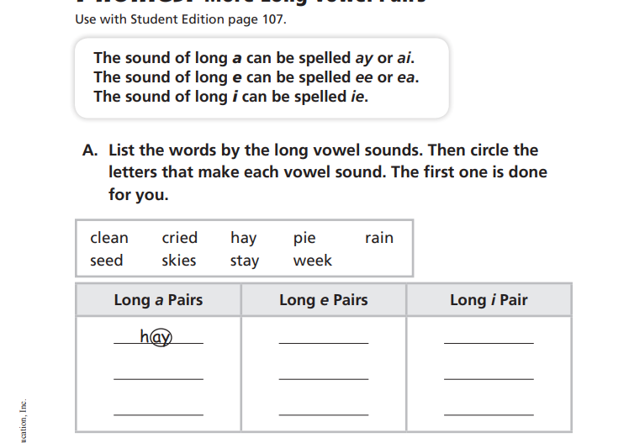

Pronouns
English  Department | My name is:
 | Grade: 3

Outcomes:
➢ Students should be able to recognize subject pronouns.
➢ Students should be able to recognize object pronouns.
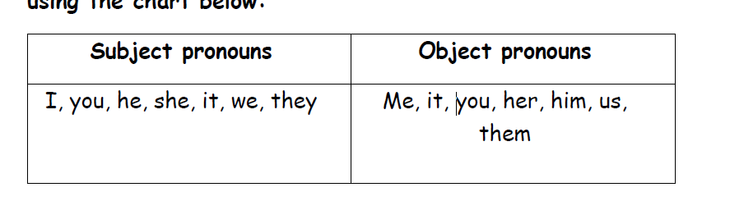
Circle the right pronouns
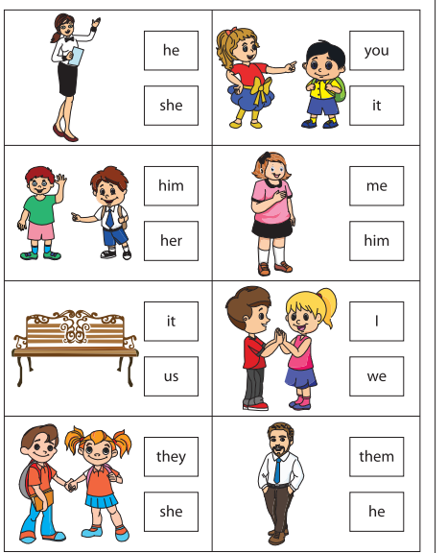

Reading comprehension

English  Department | My name is:
 | Grade: 3
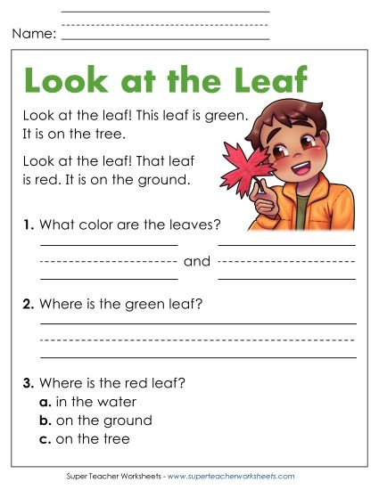
Outcome: Students should be able to read and answer the questions.

Key words+ academic words

English  Department | My name is:
 | Grade: 3

outcome: students should recognize the new vocabulary

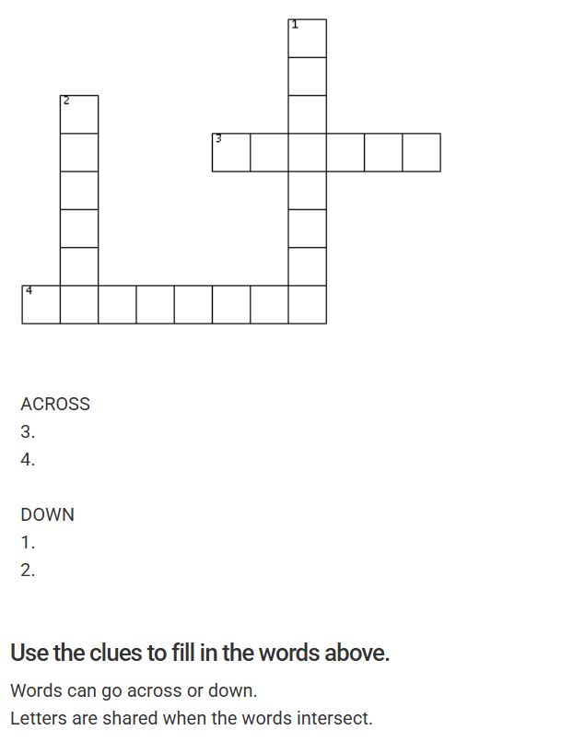
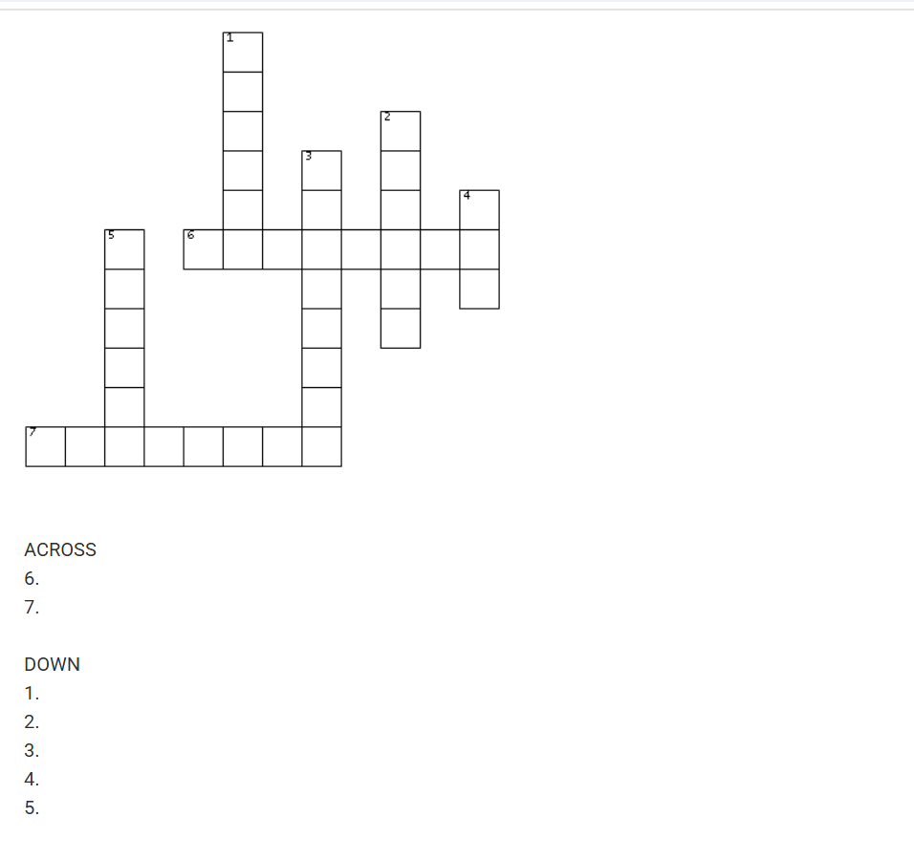
Spider / web/ clouds/ stronger/ brighter/ attitude/ affect

Present simple
English  Department | My name is:
 | Grade: 3

Outcome: Students should be able to identify the use of the simple present tense.
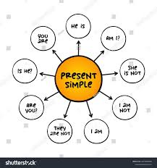
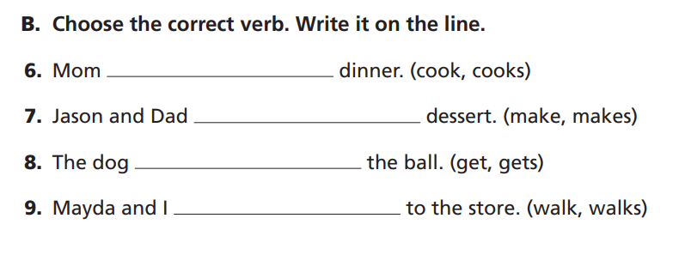
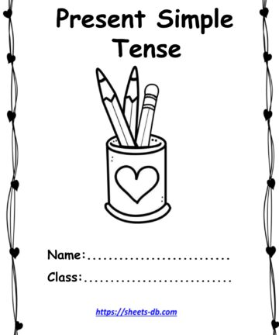

Reading comprehension

English  Department | My name is:
 | Grade: 3
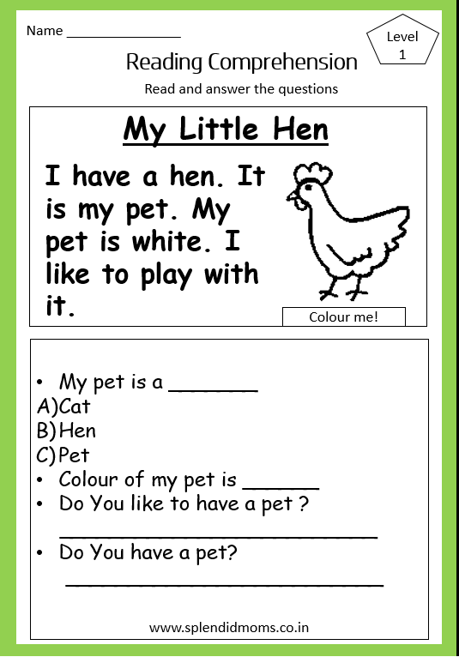
Outcome: Students should be able to read and answer the questions.

