Key words+ academic words
 English  Department | My name is:
 | Grade: 3

outcome: students should recognize the new vocabulary
Write the word under each picture.
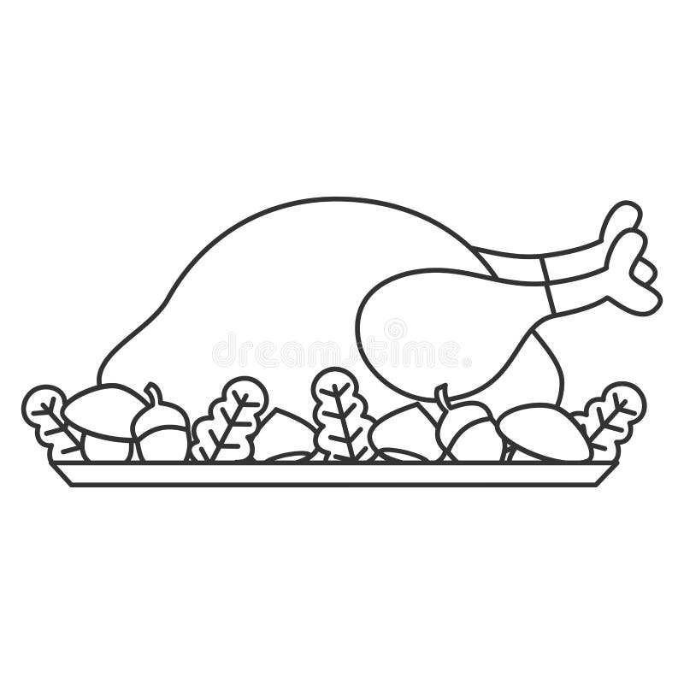
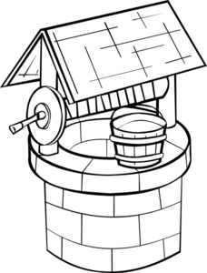
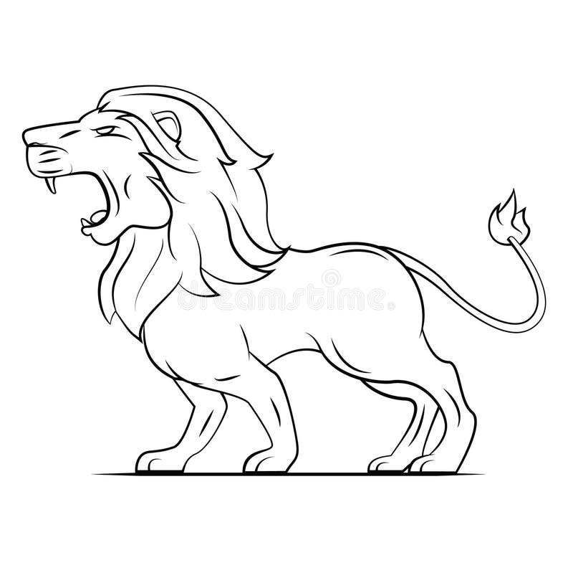

dinner well roar

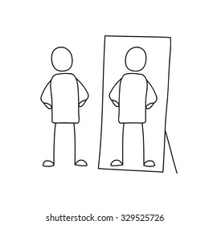


reflection focus

English  Department | My name is:
 | Grade: 3

- Fill in the blank with the suitable words
(dinner, well, roars, reflection, focus, identify)
dinner
- The last meal of the day is________________.
reflection
- I can see my ___________________ in the mirror.

identify
- I can ______________ my mother’s cooking by smelling it.
well
- A hole in the ground with water in it is: _________.

roars
- The duck quacks and the lion ________________.
Focus
6- I have to ___________________ on my lessons.

Long vowel pairs

English  Department | My name is:
 | Grade: 3
Outcomes: Students should be able to identify the sound of Long Vowel Pairs.

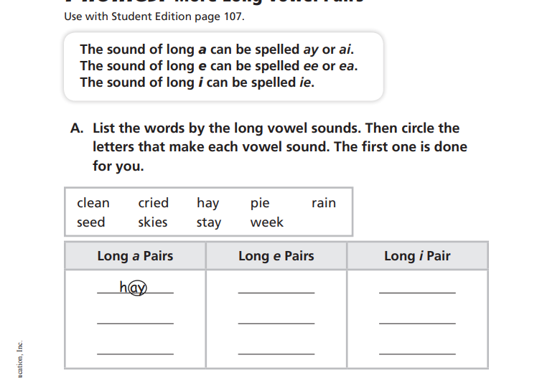
skies
pie
cried
seed
week
clean
stay
rain

Pronouns
English  Department | My name is:
 | Grade: 3

Outcomes:
➢ Students should be able to recognize subject pronouns.
➢ Students should be able to recognize object pronouns.
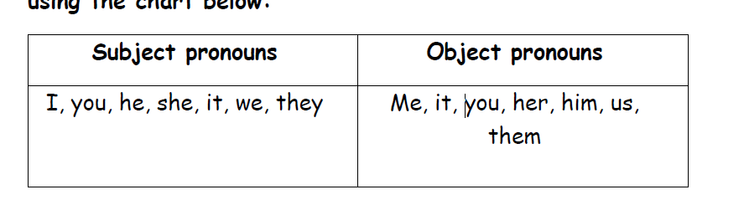
Circle the right pronouns
