Reading comprehension

 English  Department | My name is:
 | Grade: 3
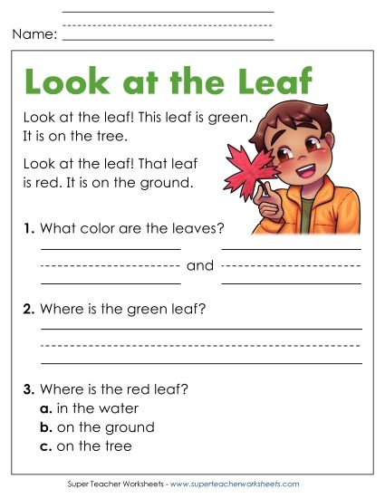
Outcome: Students should be able to read and answer the questions.
The green leaf is on the tree.
red
They are green

Key words+ academic words

English  Department | My name is:
 | Grade: 3

outcome: students should recognize the new vocabulary

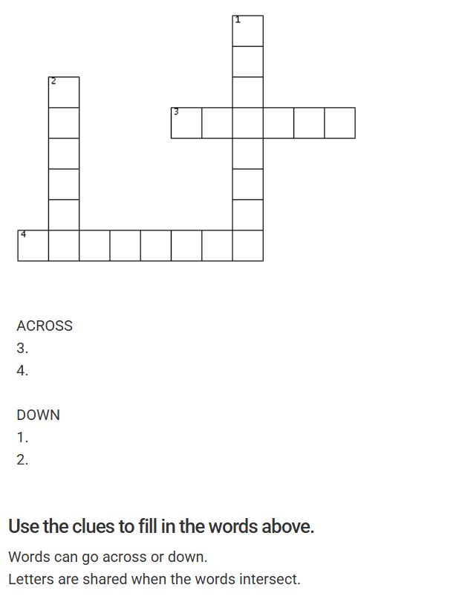
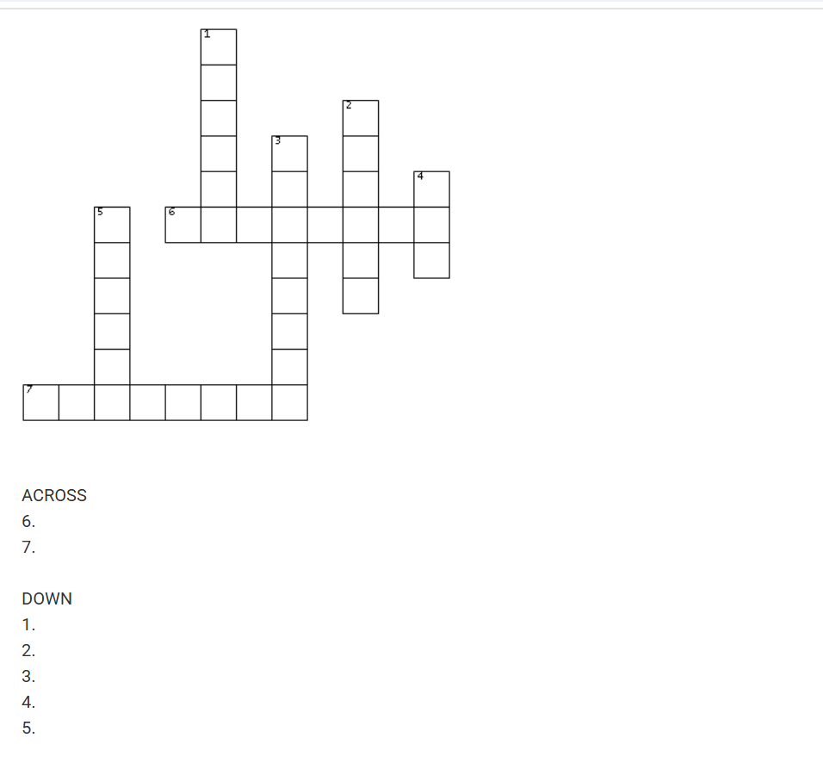
Spider / web/ clouds/ stronger/ brighter/ attitude/ affect
ACROSS
6. ATTITUDE
7. STRONGER
DOWN
- SPIDER
- BRIGHTER
- AFFECT
- WEB
- CLOUDS

Present simple

English  Department | My name is:
 | Grade: 3

Outcome: Students should be able to identify the use of the simple present tense.
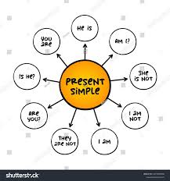
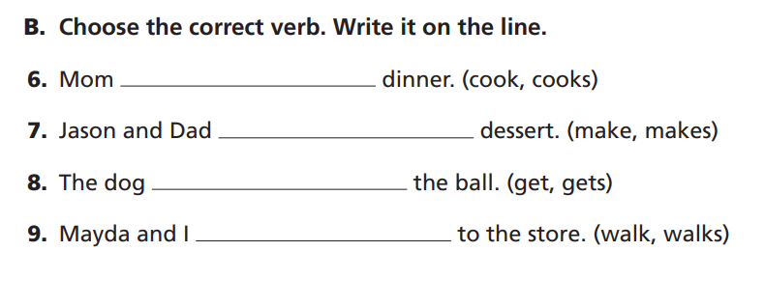
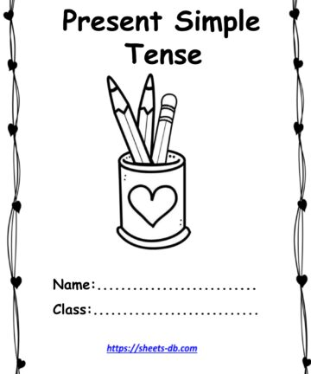

Reading comprehension

English  Department | My name is:
 | Grade: 3
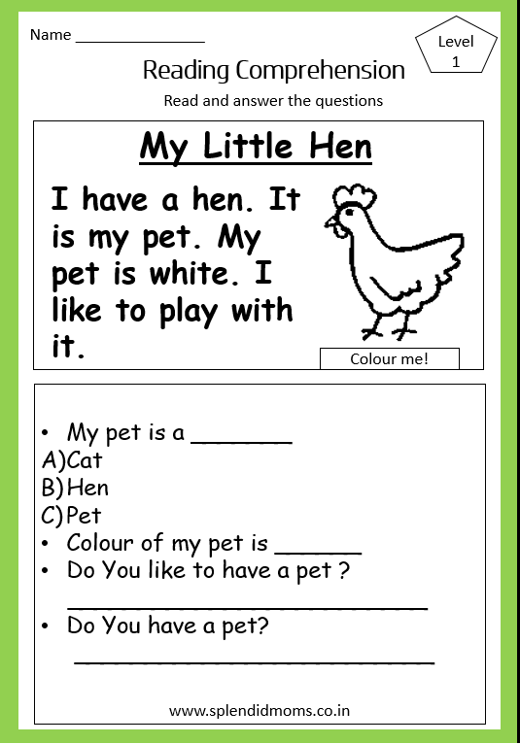
Outcome: Students should be able to read and answer the questions.
Yes, I do/ No, I don’t
Yes, I do.
white

