

Grade Three Enrichment Booklet
First Semester
2025-2026

Answer Key
Grade 3


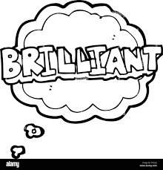

Read the following paragraphs and answer the questions below.

Going Shopping

Lisa and her mom go shopping every Saturday morning. Before they leave the house, they sit at the kitchen table and write a shopping list. They talk about what they need. Lisa says they need apples, and her mom adds milk and eggs. Lisa puts the list in her small bag and gets ready to go. She wears her red shoes and brings her favorite doll with her.

At the store, Lisa and her mom walk down the aisles. They look at the shelves and find the food they need. Lisa helps her mom pick the apples. She chooses the red ones because they are sweet. They also buy bread, cheese, and orange juice. Lisa pushes the shopping cart slowly while her mom reads the list. They smile and talk as they shop together.

When they finish shopping, they go to the cashier to pay. Lisa helps put the food on the counter. The cashier smiles and gives Lisa a sticker. After they pay, they put the bags in the car and drive home. At home, Lisa helps her mom put the food in the fridge and the cupboards. Then they sit at the table and eat a snack. Lisa feels happy because she helps her mom and has fun shopping.

Q1: True or False

1. Lisa and her mom go shopping every Saturday morning. – True

2. Lisa forgets to bring the shopping list to the store. – False

3. Lisa picks red apples because they are sweet. – True

4. Lisa and her mom do not talk while they shop. – False

5. The cashier gives Lisa a sticker at the end. – True


Q2: Critical Thinking:

Why do you think Lisa feels happy at the end of the shopping trip? Can you think of a time when you felt happy after helping someone? What made that moment special?

Lisa feels happy because she helped her mom during the shopping trip. She picked apples, pushed the cart, put food on the counter, and helped put everything away at home. She enjoyed spending time with her mom, and working together made her feel proud and joyful.

Read the following paragraph and answer the questions below.

A Trip to the Market

Every Saturday morning, Sam and his mother go shopping. They walk to the big market in their town. The market is busy and full of people. There are many colorful stalls with fruits, vegetables, clothes, and toys. Sam likes to look at all the things. His mother brings a list so they do not forget anything. She also carries a big bag to hold the items they buy.

First, they go to the fruit stall. They buy bananas, oranges, and apples. Sam picks the apples because he likes red ones. Then, they go to the vegetable stall. His mother buys carrots, potatoes, and green beans. Sam helps by putting the vegetables in the bag. After that, they buy some bread and milk from the dairy stall. Sam sees a toy car, but his mother says they cannot buy it today.

When they finish shopping, they walk home together. Sam feels tired but happy. At home, he helps his mother take the food out of the bag and put it on the kitchen table. His mother says, “You are a good helper!” Sam smiles and says he likes shopping days. He looks forward to going to the market again next week.


Q1:True or False
- Sam goes shopping every Sunday. → False
- Sam’s mother brings a list to the market. → True
- They buy bananas, apples, and oranges. → True
- Sam’s favorite fruit is banana. → False (He likes red apples.)
- They buy a toy car at the market. → False
- Sam helps his mother at home after shopping. → True
- Sam feels sad after shopping. → False (He feels tired but happy.)

Q2: Critical Thinking

Why do you think Sam’s mother didn’t buy the toy car, even though Sam wanted it? Do you think that was a fair decision? Why or why not?

Sam’s mother didn’t buy the toy car because they were only shopping for things they needed. Yes, it was fair because she wanted to spend money on important items first and teach Sam that they can’t buy toys every time.
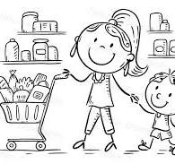

Phonics( Short Vowels)

A Fun Day at the Farm

Ben and Sam go to the farm. Ben has a red hat and a big bag. Sam has a map and a pen. They run to the barn to see the animals.

In the barn, they see a fat cat, a hen, and a duck. The cat naps on a mat. The hen pecks the net. The duck sits in the mud. “Yuck!” says Sam.

Next, they hop to the pond. A frog jumps on a log. A bug buzzes in the sun. Ben and Sam sit on a rock and hum a song. It is a fun day at the farm!

Q1: Comprehension Questions
1. Where do Ben and Sam go?
They go to the farm.
2. What does Sam bring?
He brings a map and a pen.
3. What animal naps on a mat?
The cat naps on a mat.
4. What does the duck sit in?
The duck sits in the mud.
5. What do Ben and Sam do at the pond?
They sit on a rock and hum a song.

Q2: Circle the words with short vowel sounds:
- cat (short a)
- sun (short u)
- pen (short e)
- log (short o)
- duck (short u)

Q3:Circle the words with the short vowel sounds in the previous text.

Phonics ( Long Vowels)

Jake’s Nice Day

Jake is a nice kid. He rides his bike to the lake. The sun is bright, and he takes his kite. Jake smiles as the kite flies high in the sky.

Then Jake sees a cake shop. He goes inside to get a slice. The cake is sweet and has a red stripe. He takes a bite and says, “Yum!”

After that, Jake goes home. He writes a note to his friend. The note says, “I had a fun day at the lake!” He puts the note in a blue tube. What a nice day!

Q1:Comprehension Questions
- Where does Jake ride his bike?
He rides his bike to the lake.
- What does Jake fly in the sky?
He flies a kite.
- What does Jake eat at the shop?
He eats a slice of cake.
- What color is the tube?
The tube is blue.
- Who does Jake write a note to?
He writes a note to his friend.

Q2: Circle the words that have long vowels with magic e (silent e):

The words with long vowels with magic e (silent e):
- kite
- lake
- cake
- tube

Q3:Circle the words with long vowels from the previous text

Q4: Critical Thinking

Jake did many fun things on his day out—riding his bike, flying a kite, and eating cake. If you were Jake, which part of the day would be your favorite, and why? Is there anything you would do differently?
If I were Jake, my favorite part of the day would be flying the kite because it would feel fun to watch it go high in the sky. I would enjoy the wind and the bright sun. I might do one thing differently—I would stay at the lake longer to relax or play more before going home.
Q5: Look at the words below. Circle the ones that have long vowel sounds.
Then, underline the words with short vowel sounds.
Words:
cake hat bike hop tape bed cube pet ride cup
Pick one long vowel word and one short vowel word. Write a sentence for each.

Cake: I ate a delicious piece of cake for dessert.
Hat: She wore a red hat to keep the sun out of her eyes.

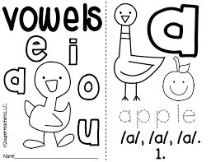

Grammar ( Verb to be is /am/are)

Meet Emma

Emma is a girl who loves animals. She is eight years old, and she is in grade three. Her favorite animal is a dog. She has a small dog named Max. Max is very friendly and playful. Emma and Max are best friends. Every day, they are happy to play in the yard. Emma’s parents are happy because she takes good care of Max.

Q1: Comprehension Questions
1. How old is Emma?
She is eight years old.
2. What is Emma's favorite animal?
Her favorite animal is a dog.
3. What is the name of her dog?
Her dog’s name is Max.
4. Why are Emma’s parents happy?
They are happy because Emma takes good care of Max.
5. Write 2 sentences using the verb "to be" in the present tense:
- I am happy today.
- Max is a playful dog.

Q2: Read each sentence and fill in the blank with the correct form of the verb to be: am, is, or are.
- Emma is a girl who loves animals.
- She is eight years old.
- Her favorite animal is a dog.
- Max is very friendly and playful.
- Emma and Max are best friends.
- Every day, they are happy to play in the yard.

Writing: Describe a Person

Question:
Think about someone you know well. It could be a friend, a family member, a teacher, or even a famous person.
Describe what they look like and what they are like as a person.
Write two paragraphs using the simple present tense.
is | tall | wear
brown | am | glasses
Curly hair | help | are
Straight hair | has | short
eyes | like | play
help | go | tall

Word Banks

📝 Writing Instructions
- Paragraph 1: Describe what the person looks like (their appearance).
- Paragraph 2: Describe what the person is like (their personality and what they do).


My friend Mia is tall and has curly brown hair. She is wearing glasses. Her eyes are brown.

Mia is very kind and helpful. She is fun to play with. She is always happy and friendly.

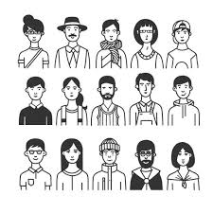

Read the following paragraphs and answer the questions below.
My Family
I live in a small house with my family. There are five people in my family—my mom, dad, two sisters, and me. We also have a pet dog named Max. Our house has three bedrooms, a kitchen, and a big living room where we all sit together in the evenings.
My mom is a nurse, and she works at a hospital. My dad is a teacher at a school near our home. My older sister helps me with my homework, and my younger sister likes to play with toys. On weekends, we go to the park, watch movies, or cook special meals together.
I love my family because we care for each other and have fun together. We talk, laugh, and help one another every day. My favorite time is when we eat dinner together and share stories about our day.
Q1: True or False
- There are six people in the family.
- Max is the family’s pet dog.
- The dad works in a hospital.
- The family likes to go to the park on weekends.
- The younger sister helps with homework.
Q2: Critical Question
Why do you think the writer's favorite time is dinner with the family? What is your favorite time with your family, and why?
____________________________________________________________________________________________________________________________________________________________________________________________________________________________________________

Grammar ( Singular and Plural Nouns)
A Busy Family Day
On Saturday, my family spends the day together. My mom makes pancakes in the kitchen. She uses eggs, bowls, and a spoon. My dad reads a newspaper and drinks two cups of coffee. My brother and I play with our toys in the living room. He has three cars, and I have five dolls.
In the afternoon, we visit our grandparents. Their house has many pictures on the walls. My grandma tells us stories, and my grandpa plays the guitar. We sit on the big sofa and eat fresh cookies and cold drinks.
At night, we return home. I put my shoes in the closet and brush my teeth. My parents read us two books before we go to bed. I love spending time with my family. They make every day special.
Q1: True or False
- The family spends Saturday together.
- Mom makes pancakes using eggs and a spoon.
- Dad drinks tea while reading the newspaper.
- The brother has five cars to play with.
- The grandparents’ house has many pictures on the walls.
- Grandpa plays the piano for the family.
- They eat cookies and drink cold drinks at the grandparents’ house.
- The family reads books before going to bed.
- The narrator puts their shoes in the kitchen.
10.The family loves spending time together.
Q2: Critical Thinking:
Why do you think spending time with family is important to the narrator? What activities do you enjoy doing with your own family, and how do they make you feel?
___________________________________________________________________________________________________________________________________________________________________________________________________________________________________________________________________________________________________________________________________________________________________________________________________________________________________________________

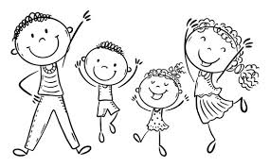

Writing
Describe a Family Celebration
Think about a special celebration you had with your family.
It could be a birthday, a holiday, or another happy event.
Write about what you celebrated, who was there, what you did, and how you felt.
Use describing words to help your reader imagine the celebration!

____________________
________________________________________________________________________________________________________________________________________________________________________________________________________________________________________________________________________________________________________________________________________________________________________________________________________________________________________________________________________________________
Read the following paragraphs and answer the questions below.

The Clever Fox and the Proud Bear
Once in a deep forest, a proud bear roared loudly every morning to show his strength. “I am the biggest and strongest animal in the forest!” he shouted. The other animals were afraid of him, even when he didn’t do anything to hurt them. The bear loved the attention and grew prouder each day.
One day, a clever fox had an idea. He told the bear, “There is another bear in the forest who says he is stronger than you!” The bear became angry. “Take me to him!” he demanded. The fox led the bear to a quiet lake and pointed at the water. The bear looked in and saw his own reflection. He thought it was another bear and began roaring and jumping, trying to scare it away.
After a while, the bear became tired and realized the “other bear” was just his own reflection. The fox smiled and said, “Sometimes the biggest one is not the wisest.” The bear felt silly and stopped showing off after that.

🌟 Moral of the Story:
Being proud can make you look foolish. Clever thinking is often stronger than loud words.
Q1: True or False Questions with Answers
- The bear roared every morning to show how strong he was.
- The other animals were not afraid of the bear.
- The fox told the bear that another bear said he was stronger.
- The fox took the bear to a real bear in the forest.
- The bear saw his own reflection in the lake.
✅ Tr
- The bear realized he had been tricked by the fox.
- After the trick, the bear kept showing off even more.
- The fox used clever thinking instead of strength.
Q2: Critical Thinking
Why do you think the fox used a trick instead of fighting the bear?
What does this tell you about the difference between being clever and being strong?
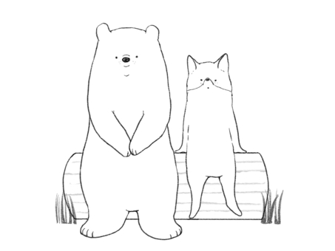
_______________________________________________________________________________________________________________________________________________________________________________________________________________________________________________________________________________________________________

Phonics (Long Vowel Pairs)
A Rainy Day Surprise
One rainy Tuesday, Chloe stayed inside to play. She looked at the grey road through the window and felt a little bored. Her brother Joey said, “Let’s make something fun!” Chloe smiled. She had an idea. “Let’s build a train out of boxes!”
They used tape, glue, and string to put the boxes together. Chloe painted the train blue and red. Joey made a seat for their dog, Max. They even added a rope so they could pull it around the house. “This is the best rainy day ever!” Joey said with glee.
Later, their mom made toast and hot chocolate as a treat. They sat at the table, shared a sweet cookie, and talked about their fun project. Even though it rained all day, Chloe and Joey had a great time using their brains and being creative.
Q1: True or False
- Chloe and Joey went outside to play in the rain.
- They built a train using boxes and tape.
- Joey made a seat for their dog, Max.
- They used a real train to ride around the house.
- Their mom made toast and hot chocolate as a treat.
- The story takes place on a rainy day.
- Chloe painted the train yellow and green.
- They felt bored all day and did nothing fun.
Q2: Critical Thinking
Chloe and Joey turned a boring, rainy day into something fun by using their imagination.
What would you do on a rainy day if you couldn't go outside?
How can being creative help you have fun, even when plans change?
_______________________________________________________________________________________________________________________________________________________________________________________________________________________________________________________________________________________________________
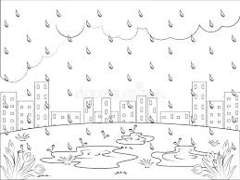

Grammar (Subject and Object Pronouns)
A Trip to the Farm
Last Saturday, we went to the farm. My dad drove us there in the morning. My mom packed snacks and juice, and she brought them in a basket. My brother and I were so excited! He couldn’t wait to see the animals, and I wanted to feed the goats.
At the farm, we met the farmer. He showed us the cows and chickens. They were eating their breakfast when we arrived. The goats ran to the fence when they saw me holding food. I gave them some grass, and they ate it happily. My brother took photos of the animals, and I helped him carry the camera.
Later, we sat under a tree and ate our snacks. My parents smiled at us and said they were proud. The trip was fun, and we can’t wait to visit the farm again!
Q1:Fill in the Blanks with the Correct Pronoun
(Use: he, she, they, we, it, us, him, her, me, them)
- My mom packed snacks and brought ______ in a basket.
- The farmer showed ______ the animals.
- My brother took pictures, and I helped ______.
- The goats were hungry, so I fed ______.
- My parents smiled at ______ and said they were proud.
- The farmer was kind. ______ gave us a tour of the farm.
- My brother and I were excited. ______ love going to the farm!
- The goat was hungry, and I gave ______ some grass.
- I wanted to feed the animals, so the farmer gave ______ some food.
10.My mom is helpful. I love helping ______ in the kitchen, too.

Q2: Critical Thinking
Why do you think the author used pronouns like “he,” “she,” “we,” and “them” instead of repeating names or nouns?
How do pronouns help make writing easier to read and understand?
________________________________________________________________________________________________________________________________________________________________________________________________________________________________________________________________________________________________________________________________________________________________________________________________________________________________________________________________________________________

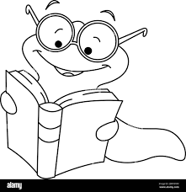

Writing
Describing an Event
Think about a special event you went to.
It could be a birthday party, a school play, a family trip, or any day that was fun or important to you.
Write about what the event was, where it happened, who was there, and what you did.
Be sure to include how you felt and why the event was special to you.

________________________

________________________________________________________________________________________________________________________________________________________________________________________________________________________________________________________________________________________________________________________________________________________________________________________________________________________________________________________
Read the following paragraphs and answer the questions below.
The Swan and the Crow
One sunny morning, a swan and a crow were sitting by a pond. The swan had smooth white feathers that shone in the sun. The crow, with his dark feathers, looked at the swan and said, “I wish I looked like you. Everyone stares at you, but no one notices me.”
The swan smiled and said, “But you can fly high and fast, and your feathers keep you safe in any weather.” The crow shook his head. “I’d rather be pretty than useful,” he said. So, the crow flew to a field and rolled in white dust to try to look like the swan. But when it rained, the dust washed away, and the crow looked even messier than before.
The swan saw the crow and said kindly, “It’s better to be proud of who you are than to try to be someone else.” The crow finally understood and flew back to the trees, happy to be himself again.
Q1: Complete each sentence using words from the story.
(Word Bank: swan, crow, feathers, rain, white, fly, trees, dust, pretty, gifts)
- The ______ had shiny white feathers that glowed in the sun.
- The ______ wanted to look like the swan.
- The crow rolled in white ______ to try to look different.
- When it started to ______, the dust washed away.
- The swan said, “You can ______ high and fast.”
- The crow said he wanted to be ______ instead of useful.
- After the rain, the crow looked even messier than ______.
- The swan told the crow to be proud of his own special ______.
- In the end, the crow flew back to the ______.
10.The swan had smooth white ______.
Q2: Critical Thinking
The crow tried to change how he looked because he thought the swan was better.
Do you think the crow made the right choice at first? Why or why not?
What lesson can you learn about being yourself from this story?
_______________________________________________________________________________________________________________________________________________________________________________________________________________________________________________________________________________________________________________________________________________________________________________________________________________________________________________________________________________________________________________________________________________________________________________________________________________________________________________

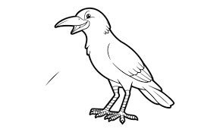

Prefixes and Suffixes
The Careless Cat and the Disobedient Dog
Milo the cat was very careless. He never paid attention to what he was doing. He would knock over vases, forget where he put his toys, and leave a big mess behind. His owner would sigh and say, “Milo, please be more careful!” But Milo didn’t listen. He thought it was fun to run around without thinking.
Rex the dog was disobedient. He didn’t follow the rules. When his owner told him to sit, he would run away. When she called him to come, he would hide under the table. Sometimes, he barked for no reason. “Rex, why won’t you obey?” she asked. But Rex just wagged his tail and kept doing whatever he wanted.
One day, their owner took them to the park. Because Milo was careless, he lost his collar. Rex ran too far and got lost because he didn’t listen. Their owner had to search all over. When she finally found them, she said, “Being careless and disobedient can lead to trouble!” After that day, Milo tried to be more careful, and Rex began to follow simple rules.

Q1: Fill in the Blanks with the Correct Word
(Use the words with dis- or -less from the story: careless, disobedient, lost, careless, disobedient, less)
- Milo was a ______ cat who didn’t pay attention.
- Rex was ______ and didn’t follow the rules.
- Because Rex didn’t listen, he got ______ in the park.
- Milo knocked things over because he was ______.
- The owner was upset with the pets for being ______ and ______.

Q2: Critical Thinking
Why is it important to be careful and listen to rules?
What could have happened if the owner didn’t find Milo and Rex at the park?
_____________________________________________________________________________________________________________________________________________________________________________________________________________________________________________________________________________________________________________________________________________________________________________________________________________________________

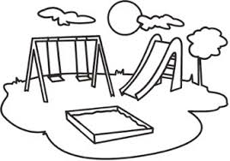
Grammar
Simple Present
Lena’s Morning Routine
Lena wakes up at 7:00 a.m. every day. She makes her bed and brushes her teeth. Then she puts on her school uniform. Her mom makes breakfast while Lena packs her bag. She always eats eggs and toast before she leaves the house. Lena walks to school with her best friend, Mia.
At school, Lena listens to her teacher and works hard in class. She likes reading and math the most. During break time, she plays games with her friends. Sometimes they play tag, and sometimes they draw pictures. Lena always shares her crayons and pencils with others.
After school, Lena goes home and does her homework. Then she helps her mom set the table for dinner. Her family eats together and talks about their day. After dinner, Lena reads a book or plays quietly before bed. She goes to sleep at 8:30 p.m.
Q1:Fill in the Blanks with the Correct Simple Present Verb
(Use: wakes, eats, plays, listens, brushes, walks, reads, helps)
- Lena ______ up at 7:00 a.m.
- She ______ her teeth before breakfast.
- Lena ______ to school with her friend Mia.
- At school, she ______ to her teacher.
- She ______ games during break time.
- Lena always ______ breakfast before she leaves.
- After school, she ______ her mom with the table.
- Before bed, Lena ______ a book.
Q2: Critical Thinking
Why is having a daily routine helpful for Lena?
What part of her routine do you think is the most important, and why?
________________________________________________________________________________________________________________________________________________________________________________________________________________________________________________________________________________________________________________________________________________________________________________________________________________________________________________________
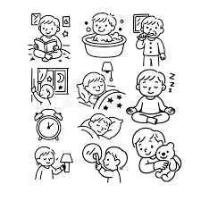

Writing
Daily Routine

My Daily Routine
Write about your daily routine.
Tell what you do in the morning, at school, and after school.
Use words like “I wake up,” “I eat,” and “I play.”
Don’t forget to say what time you do things and how you feel during your day!
_____________________
________________________________________________________________________________________________________________________________________________________________________________________________________________________________________________________________________________________________________________________________________________________________________________________________________________________________________________________
