

Selection No. 1

Student’s Name: ____________________________
Grade: 6 / Section: __________________________

*Reading:
Friendship and Cooperation in the Animal Kingdom >> p.158 - 161

*Vocabulary:
Key Words >> p.155
Academic Words >> p.156

*Grammar:
Agreement in Simple Sentences (Simple Present) >> p. 136

*Writing:
Friendly Letter >> pp. 78-79

*Vocabulary:

No. | Word/ Phrase | Meaning
 | arrangement (noun): | A plan or agreement that something will happen.
 | cooperate (verb): | To work together for a common benefit.
 | damage (noun): | Injury or harm to something or someone
 | gigantic (adjective): | Very large
 | intruder (noun): | A person or animal who goes somewhere they are not supposed to be.
 | tsunami (noun): | A very large forceful wave that causes a lot of damage when it hits the land.
 | attitude (noun): | The opinions and feelings that you usually have about someone or something.
 | comment (noun): | A stated opinion made about someone or something.
 | concept (noun): | An idea of how something is or how something should be done.
 | rely on (verb phrase): | Trust or depend on someone or something.
 | dog-eat-dog (adjective): | Very competitive.
 | coral reef (noun): | line of hard material formed by the skeletons of small ocean creatures that live in warm water.
 | tickle (verb): | Touch a person or animal lightly, often in order to make him or her laugh.

tsunami - gigantic - concept - rely on - cooperate - arrangement - damage - attitude - intruder - comment
- Complete the following sentences with the suitable word from the box below:
- Butterflies are not gigantic they are small.
- My boss and I have an arrangement I can wear jeans to work.
- The critic wrote a comment about the play.
- When we cooperate, our chores get done faster because everyone helps out.
- My attitude about broccoli changed when I tasted it.
- The intruder had left some clear footprints all over the place.
- Any crash will damage the car.
- Babies rely on their parents for all their needs.
- The tsunami looked like a wall of water crashing down on the village.
- The teacher explained the concept of supply-and-demand so that I could understand the idea.

******************************************************************
B- Write complete sentences using the following words.

gigantic ……………………………………………………………………………………………………...
intruder ………………………………………………………………………………………………………
rely on ………………………………………………………………………………………………………
******************************************************************
- Choose the correct option.
- My family have a good damage / attitude about moving to a new place.
- Farmers intrude / rely on rain for growing crops.
- In science, I study the concept / intruder of gravity.
- They made an arrangement / cooperate to meet at 3 in a café.

Use any five words from the list to write a short paragraph. Be creative!
______________________________________________________________________________________________________________________________________________________________________________________________________________________________________________________________________________________________________________________________________________________________________________________________________________________________________________________________________________________________________________________________________________________________________________________________________________

*Comprehension:

- Read the given text “Friendship and Cooperation in the Animal Kingdom” then answer the questions below.

Page 158
- What is symbiosis, and how does it help animals survive?
Symbiosis is when two types of animals depend on each other for survival.
- Quote the sentence that indicates animals of the same species help each other.
That’s why animals of the same species, or group, such as lions or blue jays, sometimes cooperate
- Find a word from the text page (158) that means “To work together for a common benefit”.
Cooperate
- Give one reason why life in the wild is difficult for animals?
It is not easy for them to find food and water and stay safe
- In your own opinion, why do you think the crocodile doesn’t eat the plover, even though it can?
Answers vary

Page 159
- Where did Owen the hippo live before he was separated from his mother?
Owen lived with his mother in a group of about twenty hippos along the Sabaki River near the small village of Malindi, in Kenya.
- Quote the sentence that indicates Owen was rescued by people.
It took hours for the villagers to rescue Owen from the coral reef.

- If Owen had not been rescued, what might have happened to him?
Answers vary

- Find a word from the text page (159) that means “Injury or harm to something or someone”.
Damage
- What natural disaster caused Owen to be separated from his mother?
A tsunami caused by a huge earthquake under the ocean floor near Indonesia.

Page 160
- Why couldn’t the people return Owen to the wild?
Because “Owen had not yet learned to take care of himself. Another hippo group would not accept him. Other hippos would think Owen was an intruder and probably attack him.
- Quote the sentence that shows Owen was scared and confused when he was taken to Haller Park.
"Owen was very angry, and he was also very frightened. He had lost his mother and his friends. He did not know where he was or where he was going."
- What does the pronoun “he” refer to in this sentence: “He must have escaped from the ship, maybe during a shipwreck, and come ashore somewhere on the eastern coast of Africa.”
Mzee

- Where did Mzee originally come from?
Mzee had originally come from Aldabra Island, which is part of the country of Seychelles in the Indian Ocean.

- Justify why the people of Malindi decided to send Owen to Haller Park instead of trying to find another hippo group for him.
Answers vary

Page 161
- What did Owen and Mzee do together after they became friends?
They spent all their time together “eating, swimming, sleeping, and playing.” Owen would also tickle Mzee’s neck, and at night they would cuddle next to each other.
- Quote the sentence that indicates the animals were emotionally close.
"Owen and Mzee soon refused to be separated."

- What does the pronoun “him” refer to in the sentence: “When Owen the hippo needed a friend, Mzee was there for him.”
Owen
- Why were scientists surprised by Owen and Mzee’s friendship?
Because “Owen is a mammal and Mzee is a reptile,” and despite being very different animals, “they surprised scientists with the strength of their friendship.”
- If animals are from different species, can they still form strong bonds? Why or why not?

Answers vary

*Unseen Text:

- Read the given text “Understanding Tsunamis” then answer the questions below.

Understanding Tsunamis
Have you ever heard of a tsunami? It’s a powerful and often devastating natural event that can have a huge impact on coastal areas. Let’s explore what tsunamis are and how they form.
A tsunami is a series of large ocean waves caused by a sudden and powerful disturbance under the sea. This disturbance can be due to an earthquake, volcanic eruption, or landslide. Most tsunamis are triggered by underwater earthquakes. When the earth shakes, it can push the sea floor up or down, displacing a large amount of water. This displacement creates waves that travel across the ocean at very high speeds.
In the deep ocean, these waves are not very tall, often less than a meter high. But don’t let their small size fool you! As the waves approach the shore, they start to grow taller and taller. This happens because the ocean gets shallower near the land, causing the waves to slow down and become much higher. When the waves finally reach the shore, they can be very tall and powerful, causing significant damage to everything in their path.
Tsunamis can be extremely dangerous. They can flood coastal areas, destroy homes, and even cause loss of life. That’s why it’s important to have early warning systems in place. These systems use buoys and sensors in the ocean to detect changes in sea level and can send out alerts if a tsunami is on the way.
If you ever hear a tsunami warning, it’s important to act quickly. Move to higher ground as soon as possible and follow any instructions from local authorities. Tsunamis can come in multiple waves, with the second or third wave sometimes being the largest, so it’s crucial to stay away from the coast until you are told it is safe.
By understanding tsunamis and being prepared, we can help keep ourselves and our communities safe from these powerful ocean waves.

- What is a tsunami?
A tsunami is a series of large ocean waves caused by a sudden and powerful disturbance under the sea, such as an earthquake, volcanic eruption, or landslide.

- What happens to tsunami waves as they approach the shore?
As tsunami waves approach the shore, they grow taller because the ocean becomes shallower, which slows down the waves and causes them to increase in height.

- Critical Thinking: Answers vary
- What if a tsunami were to hit a coastal area without an early warning system—how might the impact differ compared to a place with proper warning systems in place?
________________________________________________________________________________________
________________________________________________________________________________________
- In your opinion, what is the most important step communities can take to prepare for a tsunami, and why?
__________________________________________________________________________________________________________________________________________________________________________________
- Quote the sentence that indicates what causes most tsunamis.
A tsunami is a series of large ocean waves caused by a sudden and powerful disturbance under the sea.
- What are some of the dangers associated with tsunamis?
Tsunamis can flood coastal areas, destroy homes, and cause loss of life.

- What should you do if you hear a tsunami warning?
If you hear a tsunami warning, you should move to higher ground as soon as possible and follow instructions from local authorities. It's also important to stay away from the coast until it is confirmed to be safe.

- What does the pronoun they refer to in the sentence: 'They can be very tall and powerful, causing significant damage to everything in their path'?"
the waves
- Suggest a title of the text. Answers vary
_______________________________________________________________________________________

**************************************************************************************

B) True or False.
- In the deep ocean, tsunami waves are often less than a meter high. True / False
- The first wave of a tsunami is always the largest and most dangerous. True / False
- Early warning systems for tsunamis use buoys and sensors to detect changes in sea level.
True / False
- It is not necessary to move to higher ground if a tsunami warning is issued because tsunamis do not come in multiple waves. True / False

*Grammar:
Subject-Verb Agreement (Simple Present)
Form:
Affirmative: She/ He/ It/ Singular noun+ verb → (base form+ s/ es)
Negative: She/ He/ It/ Singular noun+ doesn’t+ verb→ (base form without s)
Interrogative (question): Does+ she/ he/ it/ singular noun+ verb→ (base form without s)

Affirmative: They/ We/ You/ I/ Plural noun+ verb → (base form without s)
Negative: They/ We/ You/ I/ Plural noun + don’t+ verb→ (base form without s)
Interrogative (question): Do+ they/ we/ you/ I/ plural noun + verb→ (base form without s)

When adding "s" or "es" to a verb, it's usually done in the third-person singular form in the present tense. Here are the basic rules for when to add "s" or "es":
1. Add "s" to most verbs:
• For most verbs, simply add "s" to the base form of the verb.
Examples:
• He walks to school.
• She plays the guitar.

2. Add "es" to verbs ending in -sh, -ch, -x, -s, -z, and -o:
• If the verb ends in -sh, -ch, -x, -s, -z, or -o, you add "es" to make it agree with the third-person singular subject.
Examples:
• He washes the dishes.
• He goes to the gym every day.

Keywords:
always, usually, often, sometimes, never, rarely, seldom, every day/ month ..., daily/ weekly/ yearly …, once/ twice a week/ day …, on Fridays/ Wednesdays ...

Uses:
• Things in general/ facts: The sun rises in the east.
• Timetables: The plane flies to London every Monday.
• Instructions: Open your books at page 34.
• With special verbs - (These verbs express states, possessions, feelings etc.) be, believe, belong, hate, like, love, mean, prefer, seem, think, understand, want, wish He doesn't like fish.

A. Correct the verbs between brackets.
- I live (live) in Amman-the capital city of Jordan.
- These men always drink (drink) coffee in the break.
- My cousin goes (go) to the gym three times a week.
- She has (have) a training course every Thursday.
- Do your kids visit (your kids/ visit) their aunt on holidays?
- Your daughter is (be) usually very motivated!
- Sugar is not (not/ be) necessary for this recipe.
- Her children often play (play) games in the afternoon.
- Mohammad studies (study) for the exams daily.
- He usually do (do) his job without any help.
- Do you post (post) these images regularly?
- Does Rania post (post) these images regularly?

B. Rewrite the following sentences correctly.
- He prefers cappuccino.
Negative: He does not prefer cappuccino.
Question: Does he prefer cappuccino?
- They prefer cappuccino.
Negative: They do not prefer cappuccino.
Question: Do they prefer cappuccino?

Writing Creativity: Write a paragraph talking about your weekend routine as well as the routine of one of your siblings.
_____________________________________________________________________________________________________________________________________________________________________________________________________________________________________________________________________________________________________________________________________________________________________________________________________________________________________________________________________________________________________________________________________________________________________________________________________________________________________________________________________________________________________________________________________________________________________________________________________________________________________________________________________________________________________________________________________________________________________________________________________________________________________________________________________________________

*Writing:

What is a friendly letter?
A personal, informal letter written to someone you know well, such as a friend, family member or classmate.
What is the purpose of a friendly letter?
The purpose of a friendly letter is to communicate in a casual and warm manner, often to share news, express feelings, ask questions, or simply keep in touch.
What are the parts of a friendly letter?
Parts of a friendly letter

Heading
The date (and sometimes the writer’s address).

Greeting
A Salutation like “Dear [Name],”

Body
The main content of the letter where the writer shares their thoughts, news or questions.

A sign-off such as “Sincerely,” “Your friend, “or “Love”.
Closing

Signature
The writer’s name.
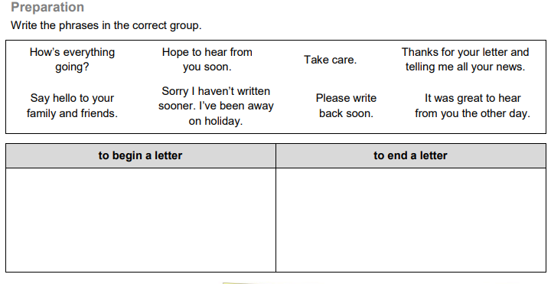

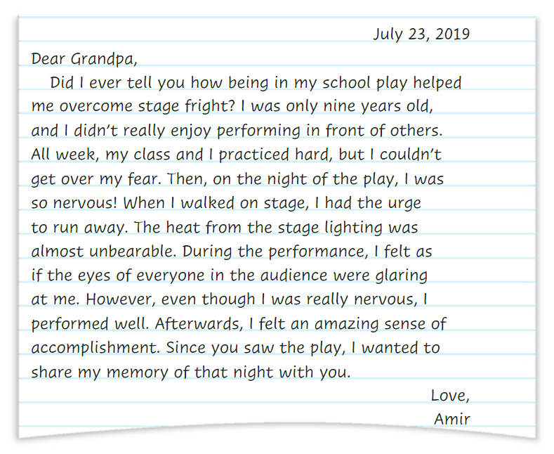

Writing task
Write a friendly letter to an older family member. Tell a story about an event that happened when you were younger.

 | Success Criteria | Content & Ideas  (2) | Lay out & Organization  (1) | Structure  (2) | Handwriting, Spelling & punctuation (2) | Diction  (Vocabulary Used)  (2) | Total (9)
 | Success Criteria | ________ | ________ | ________ | ________ | ________ | ________
Success Criteria |  | Content & Ideas  (2) | Lay out & Organization  (1) | Structure  (2) | Handwriting, Spelling & punctuation (2) | Diction  (Vocabulary Used)  (2) | Total (9)
 |  | ________ | ________ | ________ | ________ | ________ | ________

