


Grade 2
Science Booklet
1st Semester
2025-2026
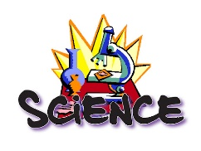
Science York B
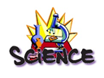

My name is : __________________________
Grade 2 ( )

Lesson 1: How do you group objects? P.6
Outcome: students will be able to sort and group objects based on their characteristics such as color, size, shape, and use.

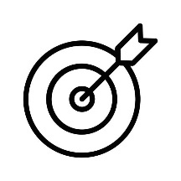

Q1) Write True or False:
- We can group objects by their color, size, or shape. ( )
- Sorting objects makes it easier to find them. ( )
- All objects can only belong to one group. ( )
- We cannot group objects by the way they feel. ( )
Q2) Answer the following questions:
A. Can one object belong to more than one group? Give an example.
___________________________________

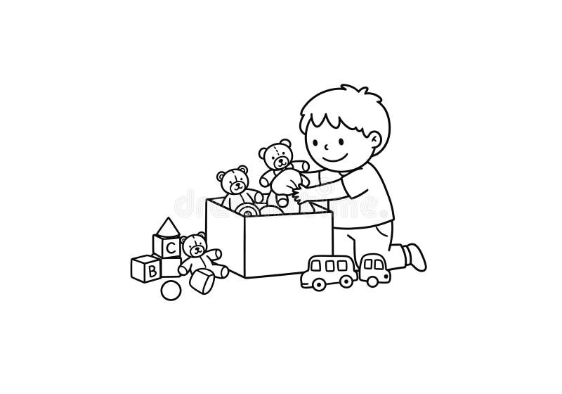
B. If you had to group your toys at home, what ways could you use (color, size, type)?

Using a Balance P.8
Outcome: students will be able to use a balance to compare the weights of objects.

Q1) Write True or False:
- A balance helps us compare the weight of objects. ( )
- The heavier object makes the balance go up. ( )
- If both sides of the balance are level, the objects have the same weight. ( )
- Big objects are always heavier than small objects. ( )
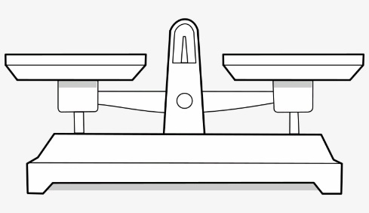
- We can use a balance to find out how many small objects equal one heavy object. ( )
Q2) Circle the correct answer:
- What does a balance show us?
a) color of objects
b) weight of objects
- c) size of objects
- If one side of the balance goes down, that side is:
a) lighter
b) heavier
c) empty
Q3) If the balance does not move, what can you say about the objects on both sides?

Lesson 2 : What is light & what is heavy? P.10
Outcome: students will be able to identify and compare objects as light or heavy

Q1) Fill in the blanks with heavy / light:
- _____________ objects: Objects that weigh a lot.
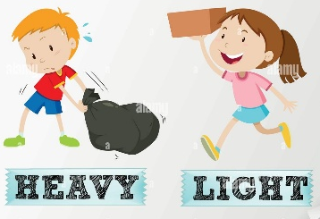
- _____________objects: Objects that don’t weigh much.

Q2) Circle the correct answer:
Why do shopkeepers use a balance?
a) to count fruits
b) to compare the weight of things
c) to play games

Q3) Can a small object be heavier than a big object? Give an example.

Lesson 1: What sounds might you hear? P18
Outcome: students will be able differentiate between the loud sounds and soft sounds.

Q1) Fill in the blanks with soft / loud:
- _____________sounds: Sounds that are strong and easy to hear.
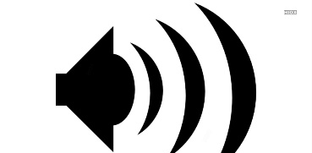

- _________sounds: Sounds that are quiet and not easy to hear.

Q2) Write True or False next to each statement.
- A drum can make a loud sound. _______
- A whisper is a soft sound. _______
- Loud sounds are easy to hear from far away. _______
- Soft sounds can be hard to hear if the room is noisy. _______
5.All sounds are the same volume. _______

Q3) If you tap a table gently and then strongly, what changes about the sound?
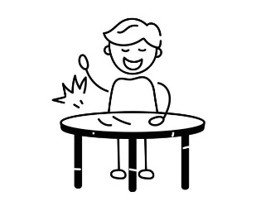
Lesson 2: What is hot & what is cold? P.20
Outcome: students will be able to students will be able differentiate between the hot objects and cold objects.

Q1) Fill in the blanks with hot / cold:
- ______ objects: Things that feel very warm when you touch them.
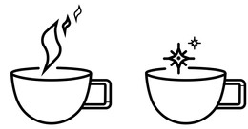
- _______objects: Things that feel cool when you touch them.

Q2) Write True or False next to each statement.
- Ice is a cold object. _______
- The sun feels hot. _______
- Hot objects are always dangerous to touch. _______
- All objects feel the same temperature. _______
Q3) Can the temperature of an object change during the day? Give an example.

Lesson 1: How do things move? P.32
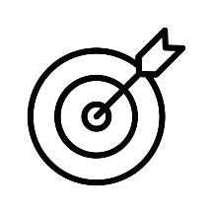
Outcome: students will be able to identify how do things move.

_{Q1) How these things move?}
rolling sliding spinning bouncing

 | 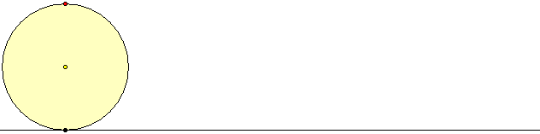 | 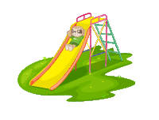 | 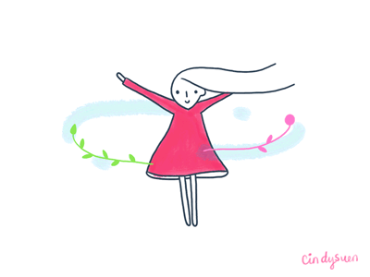

_{Q2) How do our bodies move?}
marching tiptoeing running jumping

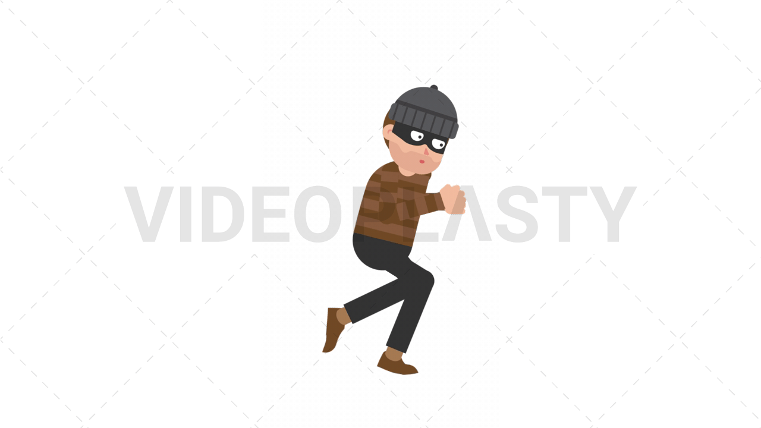
 | 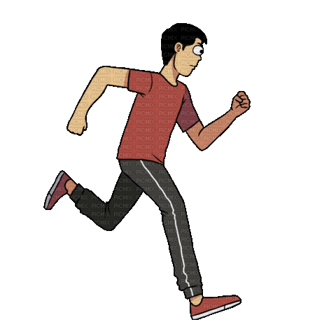 | 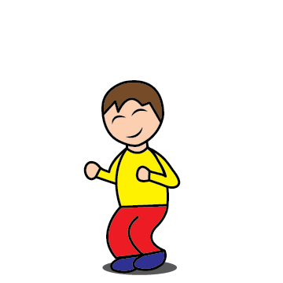 | 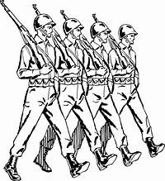

Lesson 2: What will float & what will sink? P.34
Outcome: students will be able to identify the objects that float and the objects that sink.

Q1) Fill in the blanks with float / sink:
- _______objects: Objects that go under the water when you put them in.
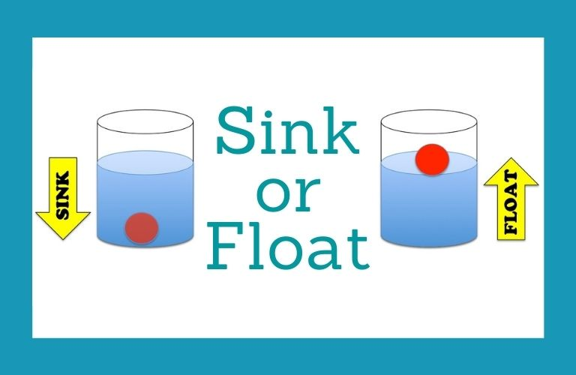
- _______objects: Objects that stay on top of the water and don’t go under.

Q2) Write True or False next to each statement.
- All heavy objects sink in water. ( )
- Wood usually floats in water. ( )
- A metal spoon always floats. ( )
- All objects that float are light. ( )
Q3) If a plastic bottle floats, can you make it sink? How?

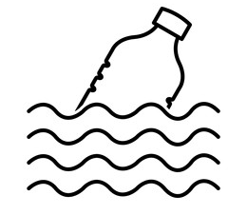
Lesson 3: What will a magnet attract? P.36
Outcome: students will be able to identify objects that are attracted to a magnet (magnetic objects) and those that are not.

Q1) Color this magnet and write the name of each pole:
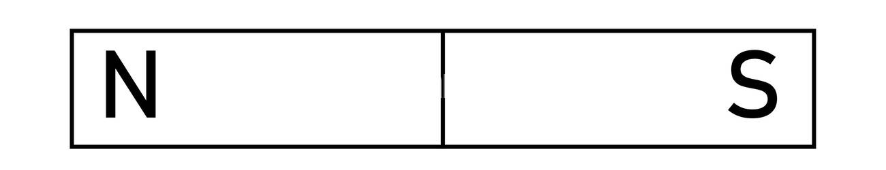

Q2) Write True or False next to each statement.
- A magnet can attract plastic objects. ( )
- Wood is attracted to magnets. ( )
- Magnets have a north pole and a south pole. ( )
- Magnets have two ends called poles: north and south. ( )
- Opposite poles of magnets will push each other away. ( )
Q3) How can you test whether an object in your classroom is
magnetic or not?
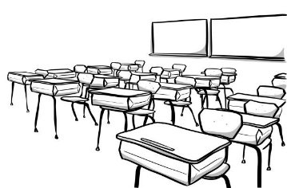
Lesson 1: What is Earth like? P. 48
Outcome: students will be able to identify the landforms.

Q1) Write the name of each land form:
valley hill mountain plain desert

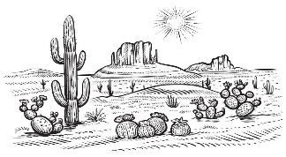
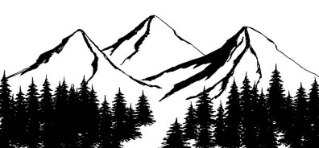


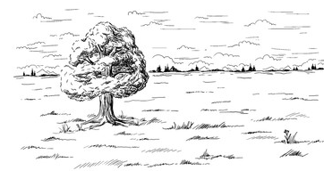
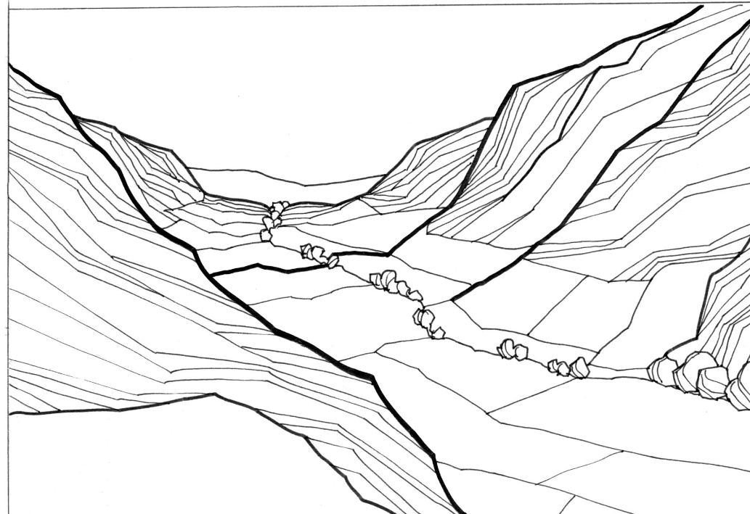

Q2) Write True or False next to each statement.

- Mountains are very high landforms. ( )
- Valleys are low areas between mountains or hills. ( )
- Rivers are landforms made of dry land only. ( )
- Plains are flat areas of land. ( )
- Hills are taller than mountains. ( )
Lesson 2: What do you see in the daytime sky? P50
Outcome: students will be able to tell what do they see in the daytime sky.

Q1) Write the names of the things you see:
day time moon nighttime stars sun light

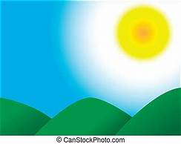

Q2) Why do we sometimes see airplanes or birds in the sky during the day?
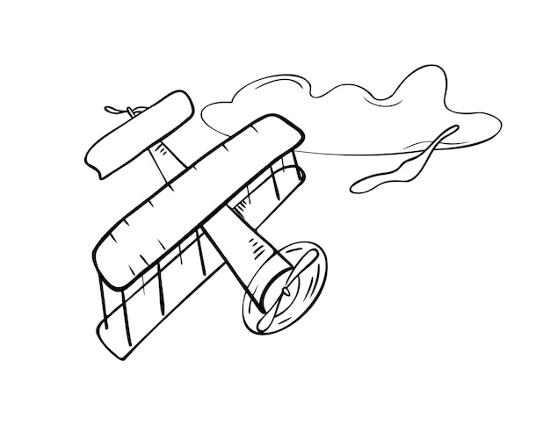

Lesson 3: What do you see in the nighttime sky? P.54
Outcome: students will be able to tell what do they see in the nighttime sky
Q1) Write the names of the things you see:

Q1) Write the names of the things you see:
day time moon nighttime stars sun light

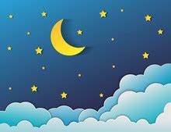

Q2) Why do we see stars and the moon at night but not during the daytime?
