


English Language
1st Semester 2025/2026
Grade (8)
Unit (1) Early Inventions Handout

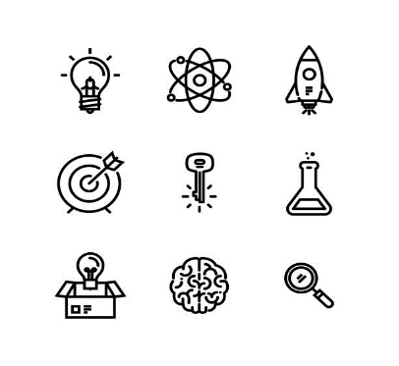
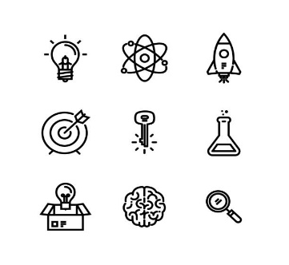
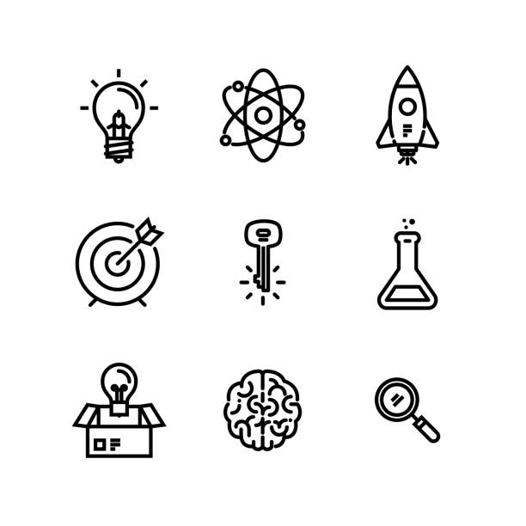

Name:
Grade:

1. Unit’s Content:
Topic : | Pages:
Topic : | Students’ Book
1. The Big Question | 20
2. Vocabulary (key words, academic words) | 21-22
3. Reading Early Inventions | 24-25-26-27
4. Grammar:
- Past Simple (regular and irregular verbs)  - Past Continuous | 30-31
5. Writing: Descriptive essay (describe an experience or an event ) | 18-19

2. Vocabulary:
Page 21- Keywords
NO. | Word | Meaning | Example
1 | Device (n.) | a thing made for a special purpose | The iron is a device for pressing clothes.
2 | Emergency (n.) | a serious or dangerous situation | You must stay calm in case of emergency.
3 | Idea (n.) | a thought or suggestion | How did Wilson react to your idea?
4 | Identical (adj.) | exactly the same as something else | We are identical in our views of what should be done.
5 | Invention (n.) | something new that is made for the first time | The light bulb was one of the most important inventions of the 19th century.
6 | Patent  (n.) / (v.) | a document that says you have the right to make or sell an invention | The inventor received a patent for her new robot.

Page 22- Academic Words
NO. | Word | Meaning | Example
1 | Created (v.) | Made or invented | Alexander Graham Bell created a new device for people to communicate with each other—the telephone.
2 | Function  (n.) / (v.) | The purpose of something | The function of a washing machine is to clean clothes.
3 | Significant (adj.) | Noticeable or important | The invention of the computer had a significant impact on society.
4 | Technology (n.) | All the knowledge and equipment used in science. | As technology has improved, scientists have been able to develop many new products.

Pages 24-27
NO. | Word | Meaning | Example
1. | Ice skating | shoes with sharp blades attached to move smoothly on ice | Ice skating was great fun and fairly easy to learn, which really surprised me.
2 | General anesthesia | Placing patients in a sleeplike state during surgery | He used general anesthesia to perform the surgery
3 | Manufacturer (n.) | Someone who makes goods to sell. | They're one of the country's leading manufacturers of children's clothing.
4 | Fireproof (adj) | Able to resist fire or great heat | Remember to store valuable papers in a fireproof box.
5 | Windshield (n) | A window at the front of a car or other vehicle | The windshield needs to be cleaned daily as to allow clear vision.
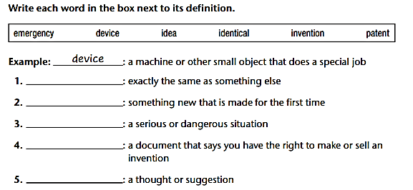
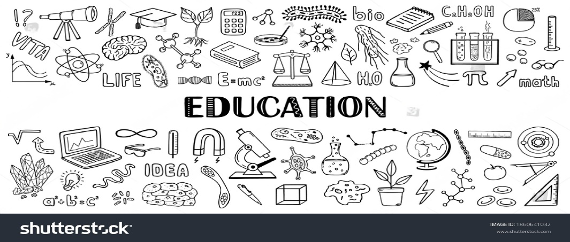

B. Fill in the gaps with the most suitable answer:
patent / technology / manufacturers/ windshield / significant / fireproof

1. There has been a significant increase in car accidents because of the snow storm.
2. The latest technology advancements have improved the way we communicate.
3. The manufacturers of Tesla cars have warned people against careless driving.
4. The building's fireproof materials ensured the safety of its occupants during fire.
5. You should clean your windshield before you start driving.
6. The company applied for a patent to protect its creative invention from being copied.

C. Choose the best answer, and write the part of speech in brackets :
- The skilled surgeon is about to (performance /make / perform) a delicate surgery. verb
- Inventors are excited about (invention/ inventing / invent) new technologies that make life easier gerund
- This machine is incredibly (function / functional) and user-friendly adjective
- The world changed rapidly after the (invent / invention / inventor) of the phone. noun
- They used (creative/ creation/ creatively) methods to impress investors. adjectives
- They are the most (technologically / technology / technological) advanced nation in the world. adjective
- I'm so tired today, I can barely (function( n.) / function ( verb ) /functional)
Writing Task (1)
Imagine you were a journalist for a science magazine. Write a paragraph about a new invention that you found interesting. Describe the invention, explain what it does, and why you think it is important. Use academic words and key words in your description.
A groundbreaking invention has recently been created that promises to revolutionize emergency healthcare. The device is designed to automatically detect critical health conditions and alert medical personnel in real time. Its primary function is to monitor vital signs and predict potential emergencies before they become life-threatening, making it a significant advancement in medical technology. The idea for this device originated from observing the limitations of existing emergency response systems, and it has already been submitted for a patent to protect its unique design. Interestingly, multiple units are identical in structure and function, ensuring consistent performance across different settings. This device not only demonstrates innovative engineering but also has the potential to save countless lives, highlighting the importance of continuous scientific invention in modern society.

3. Reading Comprehension:
After reading the text in p.24-27, answer these extra reading comprehension questions

- He introduced it by showing his roller skates at a fancy party.
- He lost control, crashed into a mirror, and got hurt.
- It allowed patients to feel no pain during surgery.
- He trained and taught many students.
- The soldiers in the army.
- In 1813.
- They are very similar, almost the same as her design.
- They had only flat wooden boards, which were unsafe in emergencies.
- She made them stronger, safer, and able to fold for storage.
- Yes, because her rafts saved many people in shipwrecks.
- She got the idea while watching drivers struggle to clean their windows in the rain.
- At first, people thought it was unnecessary, but later it became standard in every car.
- Streetcars and trains.
- An adjustable wrench and a magnetic hair curler.
- Because he invented color television, which changed how people watched TV.
- By pouring hot water over the dried noodles and waiting a few minutes.
17. Find the words that has the same meaning of these words :
1. Improve  p.24 | enhance | 2. Barriers  p. 25 | obstacles
3. A street market selling second-hand goods  p. 27 | flea market | 4. A radio or television program  p. 25 | broadcast


Critical thinking
What do these historical inventors and their innovations tell us about the role of creativity and problem-solving in advancing technology and improving everyday life? Connect your answer to your own life with examples.
Historical inventors show that creativity and problem-solving are important. They saw problems and found smart solutions. For example, Mary Anderson invented the windshield wiper to help drivers in the rain, and Maria Beasley improved life rafts to make them safer. Their inventions made life easier and safer.
In my life, I solved a problem by using a planner app to organize my homework and study schedule. Like the inventors, I used creativity and practical thinking to make life better. This shows that solving problems can improve everyday life.

Writing Task (2)

Think about an invention that has not been created yet but that you hope to invent in the future. What would this invention be, and how would it work? Write a paragraph explaining your invention and how it could help people, making sure to include words from the reading.

In the future, I hope to invent a fireproof smart helmet for cyclists and motorbike riders. The idea came to me after seeing many accidents in the city where riders were injured because their helmets offered limited protection. This helmet would be made from a fireproof material, include a small windshield to protect the face from rain or dust, and have built-in sensors that can alert emergency services in case of a crash. The manufacturer could produce identical helmets to ensure safety for all users. I believe this invention would save lives and make riding much safer, combining creativity and problem-solving to improve everyday life.



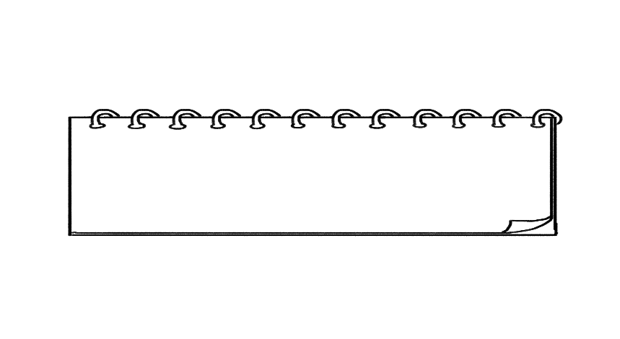
4. Grammar:

A. Past Simple (regular and irregular verbs)

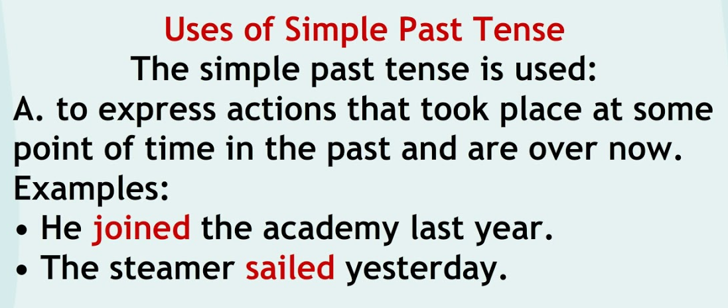

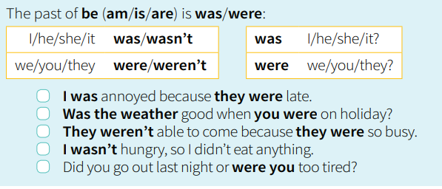

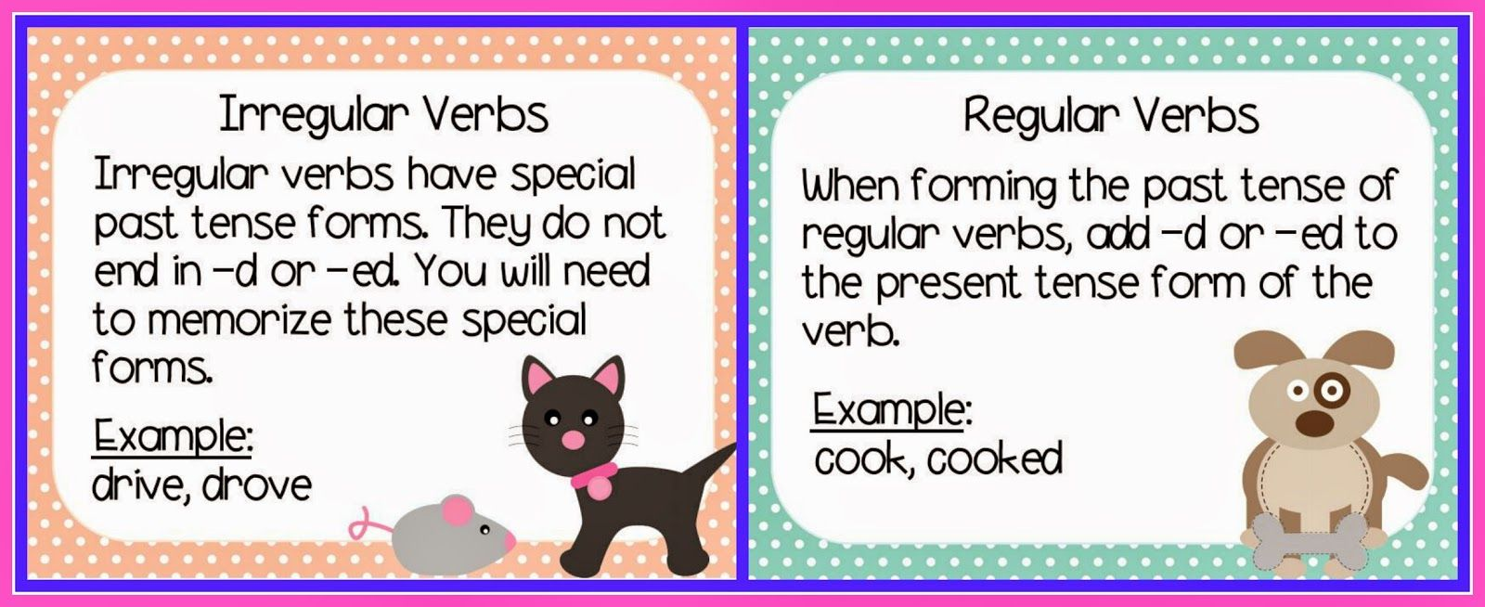

A. Write the Past Simple of each verb in the correct column:
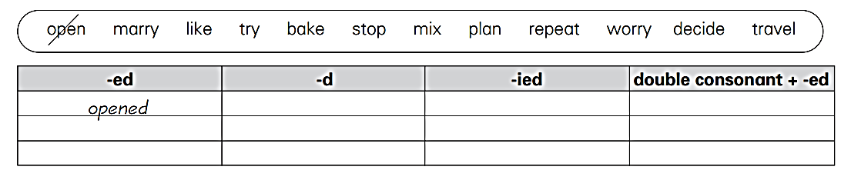
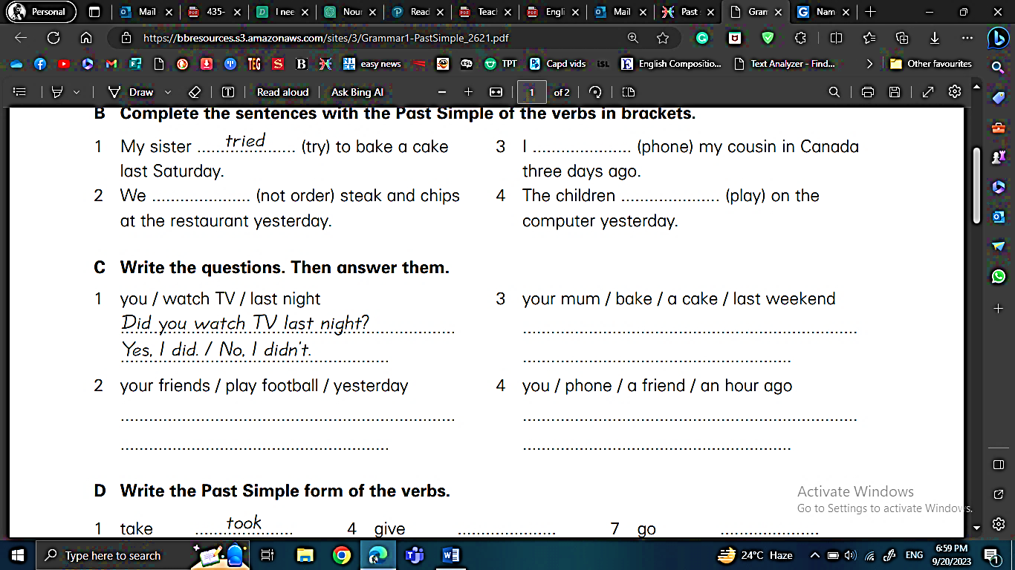
B. Complete the sentences with the Past Simple of the verbs in brackets:

C. Write questions with the words below. Then answer the questions according to the pictures.
Use the Past Simple:
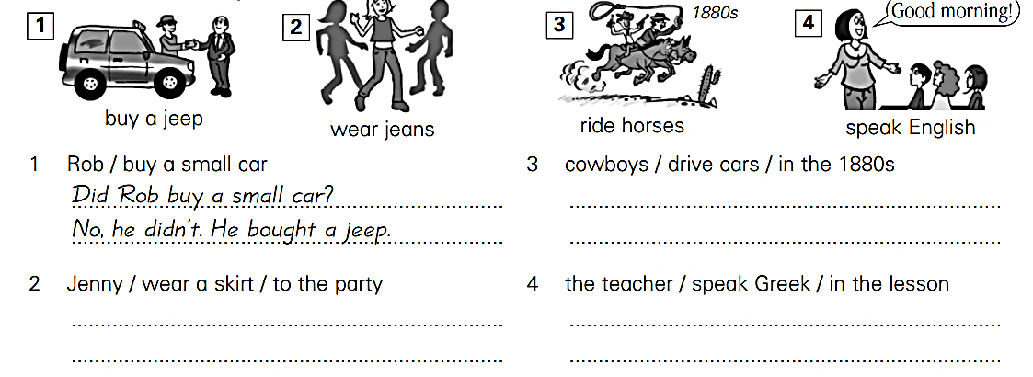

D. Fill in the gaps with correct form of the verb. Use the Past Simple:

- Before the invention of smartphones, people rarely communicated (communicate) through text messages.
- Last summer, they travelled (travel) to five different countries in Europe.
- When he was young, he dreamt (dream) of becoming an astronaut.
- She didn’t study (not / study) at the library, she spent the day studying at home.
- Did you learn (learn) to speak a foreign language when you were in school?
- How did they manage (manage) to escape the police?
- Why did you call (call) me earlier? I wasn’t (not/be) awake.

B. Past Continuous

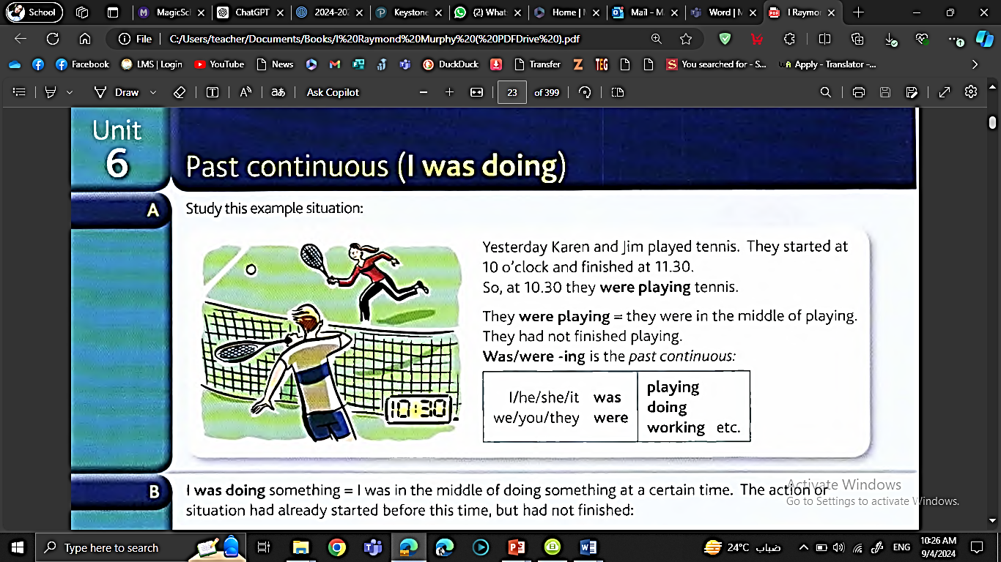

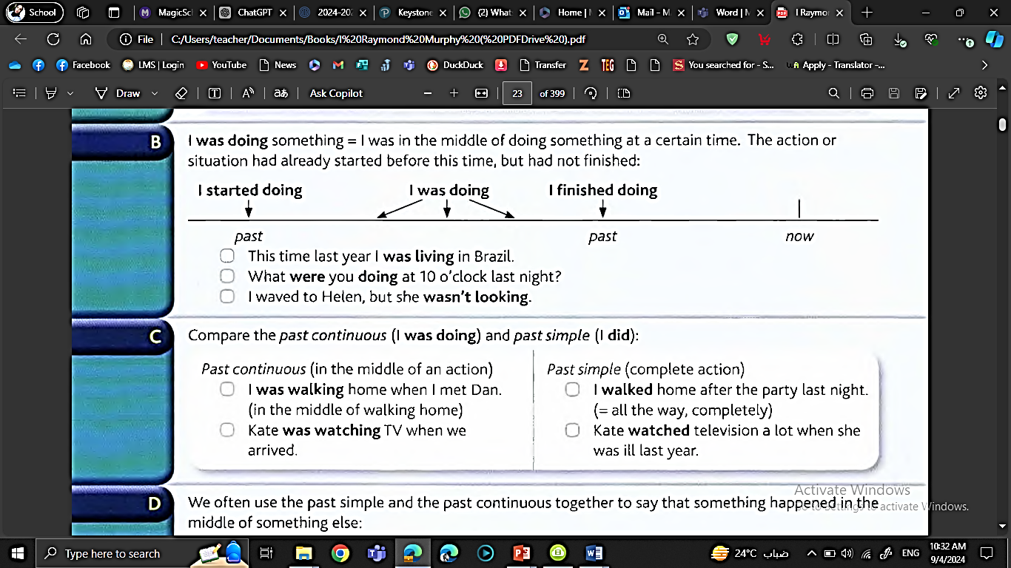

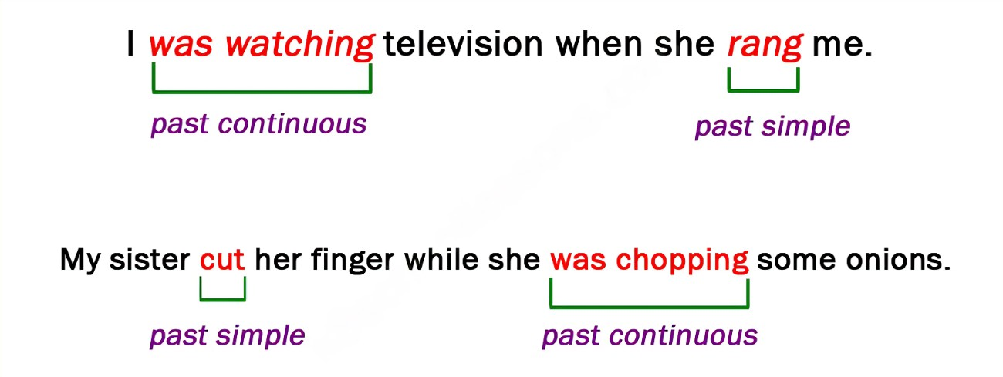

- Complete the following sentences with the past continuous of the verbs in the brackets :
1. Alice hurt herself while she was skating (skate).
2. I met my neighbor while I was walking (walk) home.
3. Sally saw a friend while she was riding (ride) her bicycle along Park St.
4. Peter fell asleep while he was studying (study).
5. Mary was reading (read) in bed when she heard (hear) a strange noise downstairs.

- Circle the correct verb form in each of the following sentences:
- Mary (prepared / was preparing) lunch when they (arrived / were arriving).
- Tom was very unlucky. It (rained / was raining) during his holidays.
- Last weekend Susan (fell / was falling) and (broke/ was breaking) her leg.
- When I (entered / was entering) the cafeteria, Mary (had / was having) lunch.
- We (drove/ were driving) to Berlin in Robert´s new car.
- The sun (shone / was shining) brightly when I ( got up / was getting up) this morning.
- Ann finally (told / was telling) us the whole story about Peter.

- Put the verb into the correct form, using past continuous or past simple.
- Jenny was waiting (wait) for me when I arrived (arrive).
- “What were you doing ( do) at this time yesterday?” “I was (be) asleep.”
- Did you go (go) out last night? ‘No, I was too tired.’
- How fast were you driving (drive) when the accident happened (happen)?
- Sam took (take) a picture of me while I wasn’t looking (not / look).
- We were in a very difficult position. We didn’t know (not / know) what to do.
- I haven’t seen Alan for ages. When I last saw (see) him, he was trying (try) to find a job.
- I was walking (walk) along the street when suddenly I heard (hear) footsteps behind me. Somebody was following (follow) me. I was scared, and I started (start) to run.
- When I was young, I wanted (want) to be a pilot.
- Last night, I dropped (drop) a plate while I was doing (do) the washing-up. Fortunately it didn’t break (not / break)


Writing Task (3)
Imagine you are an inventor looking back on your greatest invention. Write a paragraph telling people how you came up with the idea, the challenges you faced, and how you finally succeeded. Include a flashback to a specific moment that was crucial to the invention process. Focus on using the past simple, past continuous, and past perfect.
My Greatest Invention

Looking back, my greatest invention was a fireproof smart backpack designed to keep students safe in emergencies. I had always dreamed of creating something useful, but the idea truly came to me one rainy afternoon while I was watching the news. I remembered a story about a school fire that had caused panic, and I thought, “I need to invent something that could prevent this.” At first, I faced many challenges; the materials I tested either melted or were too heavy. I had tried dozens of prototypes before I finally discovered the perfect fireproof fabric. I still remember the moment I attached the emergency alert system—it was working perfectly, and I knew my invention could really save lives. After months of testing, I finally succeeded, and my backpack was ready to be manufactured.

5. Unseen Text:

Read the text and answer the questions that follow.

The Remarkable Life and Contradictions of Thomas Edison

Thomas Edison, in full Thomas Alva Edison, (born February 11, 1847, Milan, Ohio, U.S.—died October 18, 1931, West Orange, New Jersey), American inventor who held a world-record 1,093 patents. In addition, he created the world’s first industrial research laboratory.
Edison was the quintessential American inventor in the era of Yankee ingenuity. He began his career in 1863, in the adolescence of the telegraph industry, when virtually the only source of electricity was primitive batteries putting out a low-voltage current. Before he died, in 1931, he had played a critical role in introducing the modern age of electricity.
From his laboratories and workshops emerged the phonograph, the carbon-button transmitter for the telephone speaker and microphone, the incandescent lamp, a revolutionary generator of unprecedented efficiency, the first commercial electric light and power system, an experimental electric railroad, and key elements of motion-picture apparatus, as well as a host of other inventions. It was a revolutionary invention.
Edison’s career, the fulfillment of the American dream of rags-to-riches through hard work and intelligence, made him a hero to his country. He was a celebrity everywhere and had an exceptional charismatic personality. On the other hand, some say that he was an oppressor at his workplace with his employees. Also, he wasn’t a good family man and he neglected his family responsibility. Perhaps, this is the price of being a great memorable inventor.
By the time he was in his middle 30s Edison was said to be the best-known American in the world. When he died he was venerated and mourned as the man who, more than any other, had laid the basis for the technological and social revolution of the modern electric world.
- 1. Who was Thomas Edison, and what is he known for?
Thomas Edison was an American inventor, known for holding a world-record 1,093 patents and creating the world’s first industrial research laboratory.
- How many patents did Thomas Edison hold, and what were some of his most significant inventions? He held 1,093 patents. Some of his significant inventions include the phonograph, the incandescent lamp, the carbon-button transmitter for telephones, an experimental electric railroad, and key elements of motion-picture apparatus.
- Who is described as the quintessential American inventor in the era of Yankee ingenuity?
Thomas Edison is described as the quintessential American inventor in the era of Yankee ingenuity.

4. What were some of the inventions that were created in Edison's laboratories and workshops?
In his laboratories and workshops, Edison created the phonograph, the incandescent lamp, a revolutionary generator, the first commercial electric light and power system, an experimental electric railroad, and elements of motion-picture apparatus.

5. How was Thomas Edison perceived by the public during his lifetime?
He was seen as a hero, a celebrity, and an exceptional charismatic personality. He was famous worldwide and venerated for his contributions to modern technology.

6. What do you think Thomas Edison’s personality. Give justification.
Edison was hardworking, intelligent, and innovative, but he could be harsh with employees and neglected family responsibilities. This shows he was a complex person with both positive and negative traits.
7. Find a word from the text that means “for the first time” Experimental
8. What does the underlined pronoun “it” refer to? the revolutionary invention

Critical thinking
In your opinion, should Edison be primarily remembered for his inventions or for the controversies and complexities surrounding his life? Explain your answer?
In my opinion, Edison should be primarily remembered for his inventions because they changed the world and laid the foundation for modern technology. While his personal flaws and controversies are important to acknowledge, his innovations, like the electric light and phonograph, had a lasting impact on society and improved everyday life.

Answers of the listening will be sent through an individual sheet.

6. Listening:
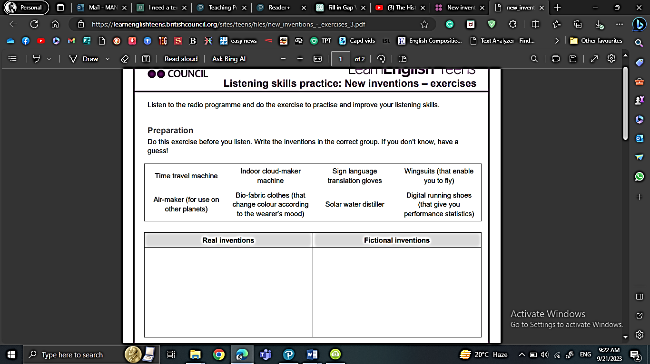


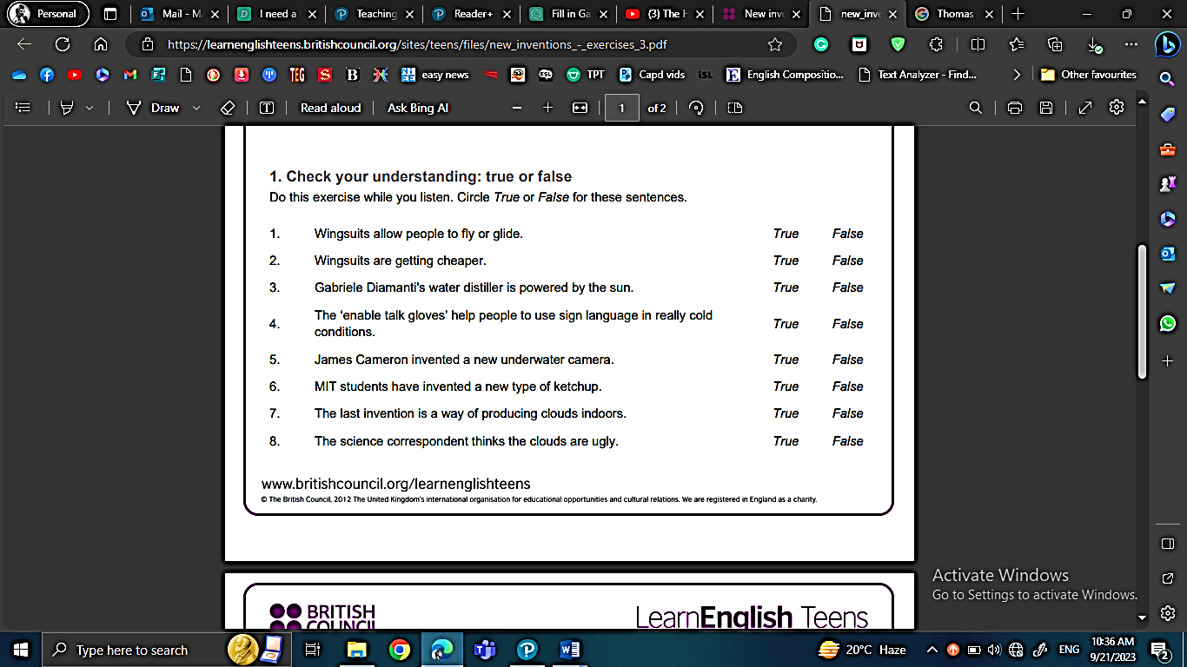

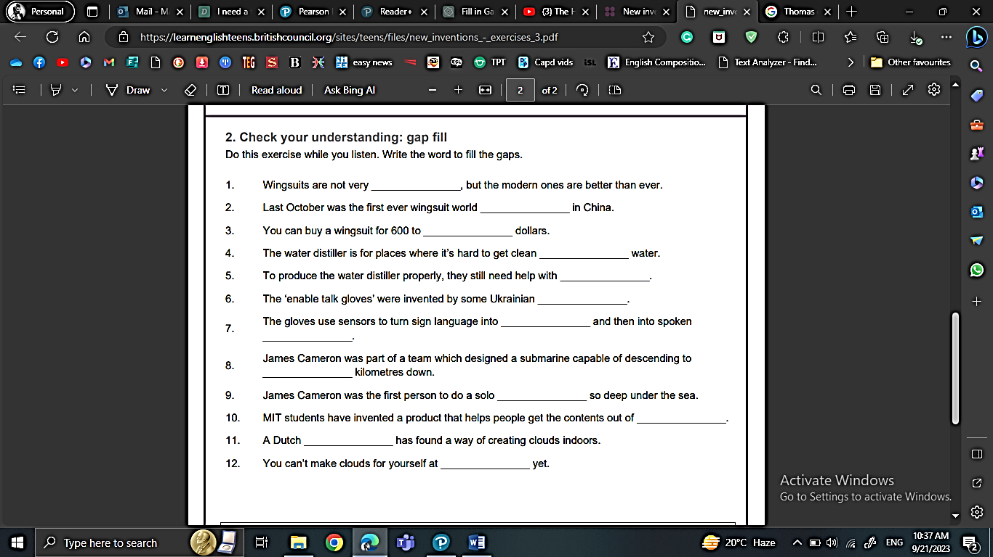


Discussion
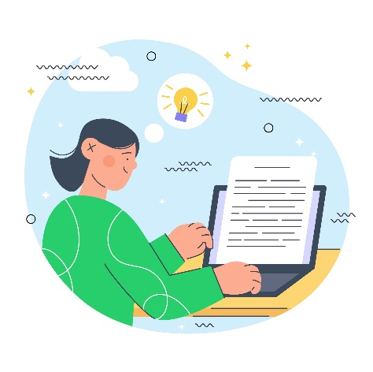
Which of these new inventions would you most like to try out? Scan the QR code to find the audio: https://learnenglishteens.britishcouncil.org/skills/listening/b2-listening/new-inventions x


7. Writing:
Descriptive essay
(describe an experience or an event )
Read the following example
Attending a football match in Madrid is an unforgettable experience filled with vibrant colors and electrifying sounds. As I arrived at the stadium, the air buzzed with anticipation. Fans in team jerseys created a sea of colors, and the aroma of delicious street food, especially churros, added to the festive atmosphere.
Upon entering, I was struck by the packed stands and the palpable energy. The sound of drums and chants echoed around me, and I felt the ground shake as the crowd jumped in unison. When the players took the field, the bright floodlights illuminated the pitch, and the excitement intensified.
The game was nonstop action, with players sprinting and skillfully dodging each other. Each time a player approached the goal, tension filled the air. The exhilarating sound of the ball hitting the net was music to our ears, and when the home team scored, the stadium erupted in celebration.
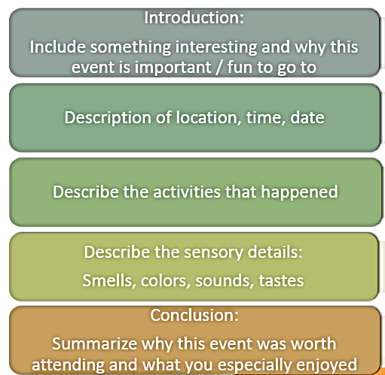
As the final whistle blew, I left the stadium with unforgettable memories. The cheers of the crowd and the vibrant colors of the jerseys lingered in my mind. Attending that match in Madrid was not just about watching a game; it was about experiencing the passion and excitement of football.
Structure:

Outline:
Introduction
1. Hook – Write a sentence that grabs the reader’s attention:
Example: “Have you ever had a moment that changed everything?”
✎ _________________________________________________________________________________________
2. Background – Briefly explain what the event is and why it matters:
✎ _________________________________________________________________________________________
3. Thesis Statement – What is the main idea of your essay?
Example: “This essay describes the day I overcame my fear of public speaking.”
✎ _________________________________________________________________________________________
Body Paragraph 1: Setting the Scene
Where and when did the event happen? What was the atmosphere like?
✎ _________________________________________________________________________________________
Use sensory details (sight, sound, smell, touch, taste):
✎ _________________________________________________________________________________________
✎ _________________________________________________________________________________________
Body Paragraph 2: What Happened
Describe the event in order. What did you do? Who was there?
✎ _________________________________________________________________________________________
How did you feel during the event?
✎ _________________________________________________________________________________________
✎ _________________________________________________________________________________________

Body Paragraph 3: The Most Important Moment
What was the most exciting or meaningful part of the event?
✎ _________________________________________________________________________________________
Why was it important to you?
✎ _________________________________________________________________________________________
Conclusion
What did you learn or realize from the event?
✎ _________________________________________________________________________________________
Final thought or message to the reader:
Example: “That day taught me that courage grows when we face our fears.”
✎ _________________________________________________________________________________________

Introduction
1. Hook – Write a sentence that grabs the reader’s attention:
✎ “Have you ever faced a challenge that seemed impossible to overcome?”
2. Background – Briefly explain what the event is and why it matters:
✎ Last year, I participated in my school’s annual science fair. It was important because it gave me a chance to present my ideas and test my creativity.
3. Thesis Statement – What is the main idea of your essay?
✎ This essay describes the day I successfully completed my science project and gained confidence in my abilities.

Body Paragraph 1: Setting the Scene
Where and when did the event happen? What was the atmosphere like?
✎ The science fair took place in the school gym last spring. The room was crowded with colorful displays, excited students, and curious parents.
Use sensory details (sight, sound, smell, touch, taste):
✎ I could see bright posters and glittering models everywhere. I heard students explaining their projects loudly, and smelled the faint scent of glue and paint. My hands were slightly sweaty from nervousness, and the smooth surface of my project model felt comforting.

Body Paragraph 2: What Happened
Describe the event in order. What did you do? Who was there?
✎ I set up my project on renewable energy and explained it to the judges. My friends were cheering from the side, and my teacher gave me encouraging smiles.
How did you feel during the event?
✎ I felt nervous at first, my heart pounding, but as I explained my work, I became more confident. I also felt proud when the judges asked thoughtful questions about my project.

Body Paragraph 3: The Most Important Moment
What was the most exciting or meaningful part of the event?
✎ The most exciting moment was when the judges announced the winners and called my name for first place.
Why was it important to you?
✎ It was important because it showed me that hard work and preparation really pay off, and it boosted my self-confidence.

Conclusion
What did you learn or realize from the event?
✎ I realized that even when something seems scary or challenging, determination and preparation can help me succeed.
Final thought or message to the reader:
✎ That day taught me that courage and effort go hand in hand, and facing challenges can be rewarding.

Now Let’s write! Choose a remarkable event that you attended. Organize your ideas, and then write a descriptive essay. Check your final work against the rubric provided.
A Night at the Science Fair

Have you ever experienced a moment that made you feel both nervous and excited at the same time? Last year, I attended my school’s annual science fair, an event that brings together students, parents, and teachers to celebrate creativity and innovation. This day was unforgettable because it tested my preparation, confidence, and ability to present my ideas clearly.
The fair took place in the school gym, a large space filled with colorful posters, glittering models, and buzzing excitement. Students were explaining their projects loudly, while parents walked from display to display, asking questions and taking pictures. I could smell the faint scent of glue and paint, and hear the low hum of conversation mixed with occasional laughter. My hands felt slightly sweaty as I arranged my project, but touching the smooth surface of my model gave me a small sense of comfort.
As the event began, I set up my project on renewable energy. My friends cheered from the side, and my teacher walked past, giving me encouraging nods. I explained my work to the judges, answering their questions with as much confidence as I could. At first, my heart pounded, and my voice trembled, but as I spoke, I felt more confident. I realized that all the hours of preparation had paid off.
The most exciting moment came at the end of the day when the judges announced the winners. My name was called for first place! I felt a surge of joy and pride. Winning the prize was more than just recognition—it was proof that hard work, creativity, and determination truly matter. That moment made all my nervousness and effort worthwhile.
From this event, I learned that preparation and courage are key to overcoming challenges. I also realized that taking part in such events helps build confidence and teaches the value of persistence. That night taught me that facing challenges can be both rewarding and inspiring, and I will always remember the thrill and pride of the science fair.

After you finish your first draft, check for mistakes using the
following checklist

- Adding a topic sentence to the introduction
- Writing the title
- Including details about the event in all paragraphs.
- Answering all 5 WH questions.
- Using lots of adjectives or phrases that draw pictures in readers’ minds
- Using sequence words
- Clear handwriting
- Accurate spelling
- Using correct tense
- Using correct punctuation marks and avoiding capitalization mistakes.



