


English Language
1st Semester 2025/2026
Grade (8)
Unit (1) Early Inventions Handout

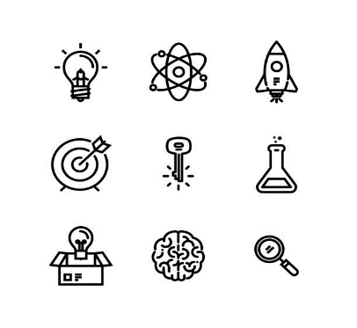
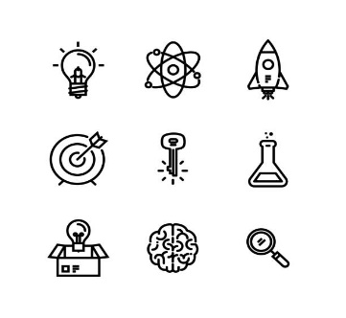


Name:
Grade:

1. Unit’s Content:
Topic : | Pages:
Topic : | Students’ Book
1. The Big Question | 20
2. Vocabulary (key words, academic words) | 21-22
3. Reading Early Inventions | 24-25-26-27
4. Grammar:
- Past Simple (regular and irregular verbs)  - Past Continuous | 30-31
5. Writing: Descriptive essay (describe an experience or an event ) | 18-19

2. Vocabulary:
Page 21- Keywords
NO. | Word | Meaning | Example
1 | Device (n.) | a thing made for a special purpose | The iron is a device for pressing clothes.
2 | Emergency (n.) | a serious or dangerous situation | You must stay calm in case of emergency.
3 | Idea (n.) | a thought or suggestion | How did Wilson react to your idea?
4 | Identical (adj.) | exactly the same as something else | We are identical in our views of what should be done.
5 | Invention (n.) | something new that is made for the first time | The light bulb was one of the most important inventions of the 19th century.
6 | Patent  (n.) / (v.) | a document that says you have the right to make or sell an invention | The inventor received a patent for her new robot.

Page 22- Academic Words
NO. | Word | Meaning | Example
1 | Created (v.) | Made or invented | Alexander Graham Bell created a new device for people to communicate with each other—the telephone.
2 | Function  (n.) / (v.) | The purpose of something | The function of a washing machine is to clean clothes.
3 | Significant (adj.) | Noticeable or important | The invention of the computer had a significant impact on society.
4 | Technology (n.) | All the knowledge and equipment used in science. | As technology has improved, scientists have been able to develop many new products.

Pages 24-27
NO. | Word | Meaning | Example
1. | Ice skating | shoes with sharp blades attached to move smoothly on ice | Ice skating was great fun and fairly easy to learn, which really surprised me.
2 | General anesthesia | Placing patients in a sleeplike state during surgery | He used general anesthesia to perform the surgery
3 | Manufacturer (n.) | Someone who makes goods to sell. | They're one of the country's leading manufacturers of children's clothing.
4 | Fireproof (adj) | Able to resist fire or great heat | Remember to store valuable papers in a fireproof box.
5 | Windshield (n) | A window at the front of a car or other vehicle | The windshield needs to be cleaned daily as to allow clear vision.
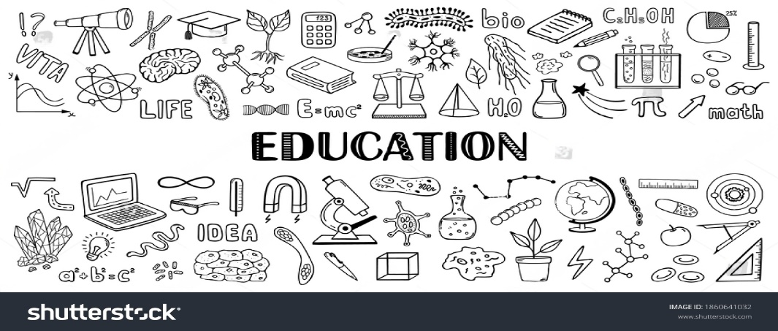
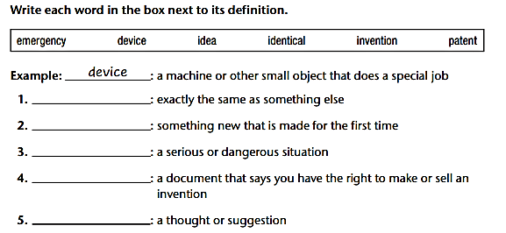

B. Fill in the gaps with the most suitable answer:
patent / technology / manufacturers/ windshield / significant / fireproof
- There has been a _______________________ increase in car accidents because of the snow storm.
- The latest ________________advancements have improved the way we communicate.
- The _________________________ of Tesla cars have warned people against careless driving.
- The building's _____________materials ensured the safety of its occupants during fire.
- You should clean your ___________________ before you start driving.
- The company applied for a _____________to protect its creative invention from being copied.
C. Choose the best answer, and write the part of speech in brackets :
- The skilled surgeon is about to (performance /make / perform) a delicate surgery. (………)
- Inventors are excited about (invention/ inventing / invent) new technologies that make life easier.(……)
- This machine is incredibly (function / functional) and user-friendly (………)
- The world changed rapidly after the (invent / invention / inventor) of the phone. (………)
- They used (creative/ creation/ creatively) methods to impress investors. (………)
- They are the most (technologically / technology / technological) advanced nation in the world. (………)
- I'm so tired today, I can barely (function( n.) / function ( verb ) /functional)

Writing Task (1)
Imagine you were a journalist for a science magazine. Write a paragraph about a new invention that you found interesting. Describe the invention, explain what it does, and why you think it is important. Use academic words and key words in your description.
____________________________________________________________________________________________________________________________________________________________________________________________________________________________________________________________________________________________________________________________________________________________________________________________________________________________________________________________________________________________________________________________________________________________________________________________________________________________________________________________________________________________________________
____________________________________________________________________________

3. Reading Comprehension:
After reading the text in p.24-27, answer these extra reading comprehension questions:

1. How did John Merlin introduce his invention?
……………………….………………………………………………………………………………………………………………………………………………

2. How did John Joseph Merlin's invention for dry land ice skating go wrong at the fancy party?
……………………………………………………………………………………………………………………………………………………………………….
3. What was the advantage of using general anesthesia in surgery?
…………………………………………………………………………………………………………………………………………………………………………
4. Besides performing operations, what else did Seishu Hanaoka do in his career?
………………………………………………………………………………………………………………………………………………
5. Who were the first people to consume canned food? …………………………………………………………
6. In what year were the first canned foods produced for Great Britain's Royal Navy? ………………..………………
7. How do the paper bags used in many grocery stores today compare to Margaret Knight's original designs?
………………………………………………………………………………………………………………………………………………………………………..
8. What was the problem with boats before Maria Beasley’s invention?
……………………………………………………………………………………………………………………………………………………….………………
9. What improvements did Maria Beasley make to life rafts compared to the previous wooden boards used on boats?
……………………………………………………………………………………………………………………………..…………………………………………
10. Was Maria Beasley’s invention lifesaving? Explain. ……………………………………………………………………………………………………………………………………………………………………...
11. How did Mary Anderson get her inspiration for the windshield wipers?
………………………………………………………………………………………………………………………………………………………………………..
12. What was ironic about the invention of the windshield wiper?
………………………………………………………………………………………………………………………………………………………………………..
13. What type of vehicles would eventually use Victor Ochoa's improved electric brake? …………………………….
14. Mention two other inventions invented by Ochoa. ………………………………………………………………………………….
15. Why was Camarena invention groundbreaking?
………………………………………………………………………………………………………………………………….…………………………………….
16. How are instant noodles prepared, according to the text?
……………………………………………………………….………………………………………………………………………………………………………
17. Find the words that has the same meaning of these words :
1. Improve  p.24 | …………………………… | 2. Barriers  p. 25 | ……………………………
3. A street market selling second-hand goods  p. 27 | …………………………… | 4. A radio or television program  p. 25 | ……………………………

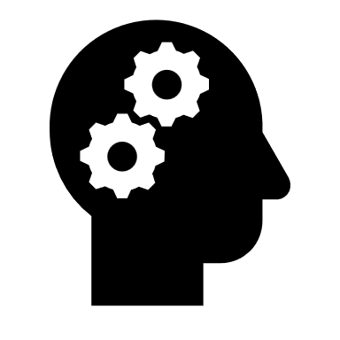
Critical thinking
What do these historical inventors and their innovations tell us about the role of creativity and problem-solving in advancing technology and improving everyday life? Connect your answer to your own life with examples.
………………………………………………………………………………………………………………………………………………
………………………………………………………………………………………………………………………………………………
………………………………………………………………………………………………………………………………………………

Writing Task (2)

Think about an invention that has not been created yet but that you hope to invent in the future. What would this invention be, and how would it work? Write a paragraph explaining your invention and how it could help people, making sure to include words from the reading.
________________________________________________________________________________________________________________________________________________________________________________________________________________________________________________________________________________________________________________________________________________________________________________________________________________________________________________________________________________________________________________________



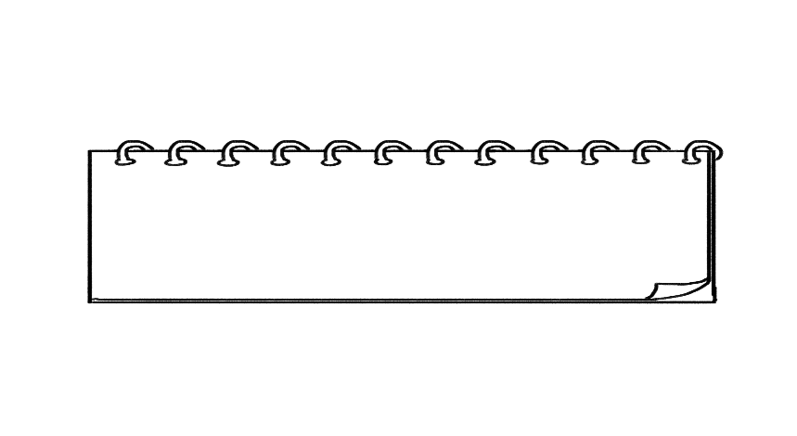
4. Grammar:

A. Past Simple (regular and irregular verbs)

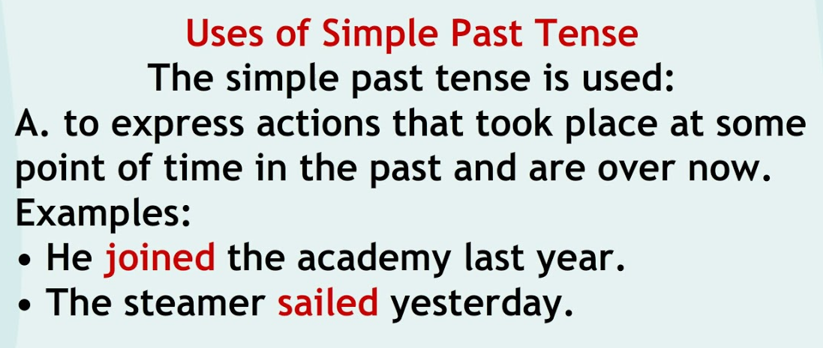

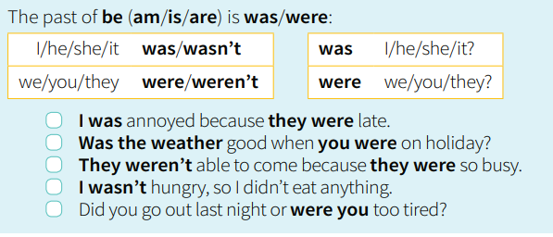

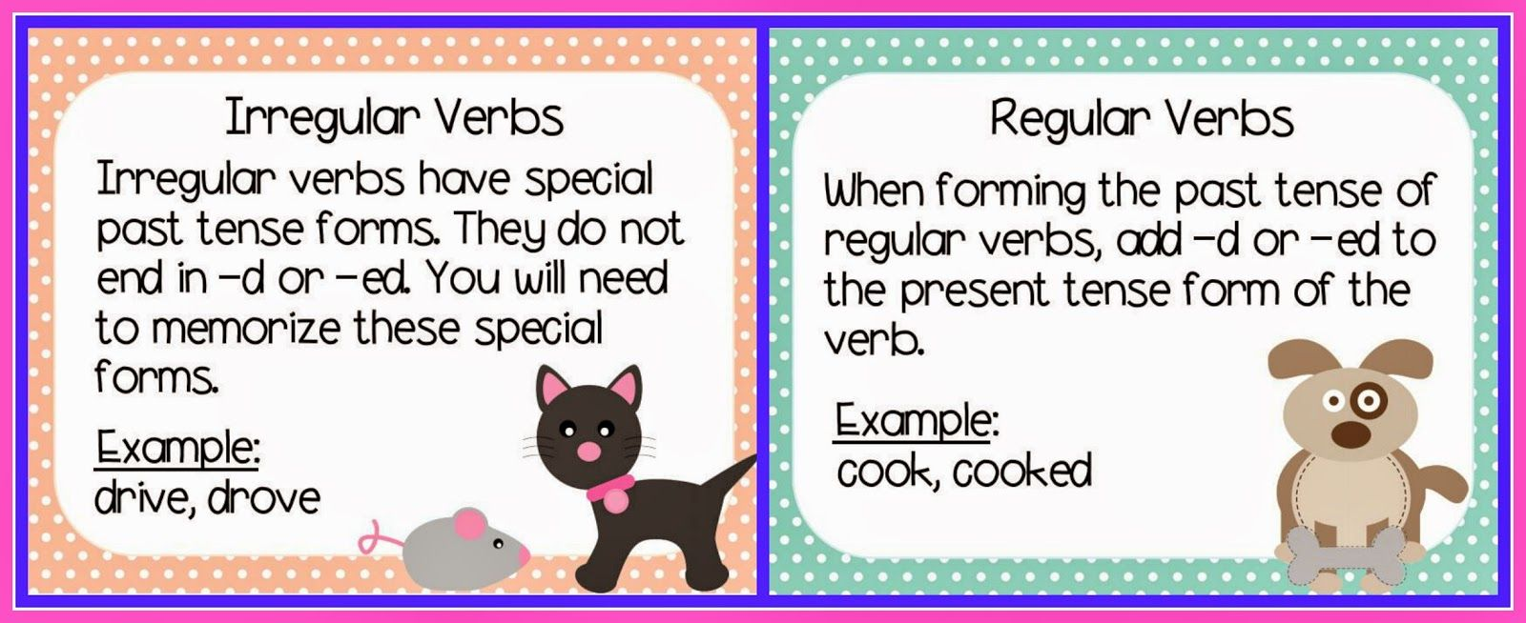

A. Write the Past Simple of each verb in the correct column:
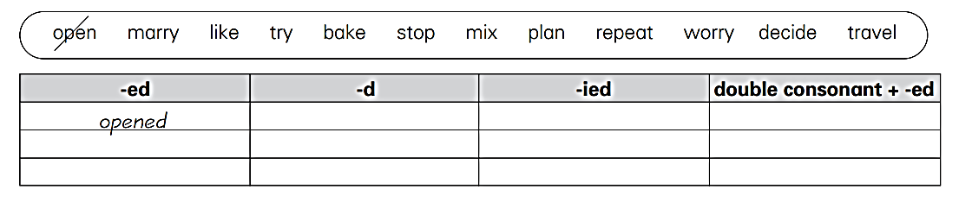
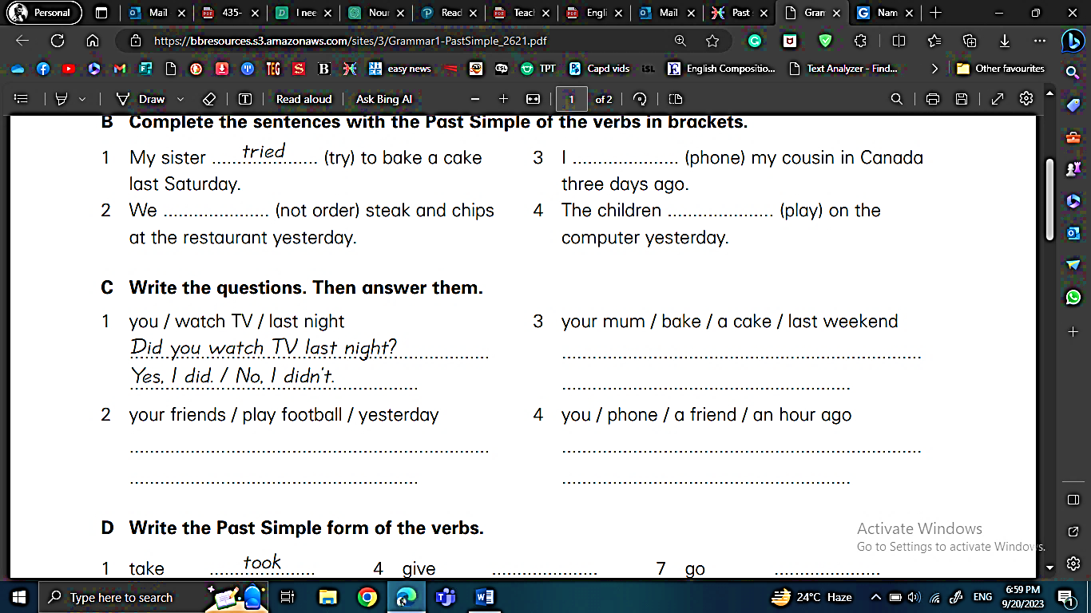
B. Complete the sentences with the Past Simple of the verbs in brackets:

C. Write questions with the words below. Then answer the questions according to the pictures.
Use the Past Simple:
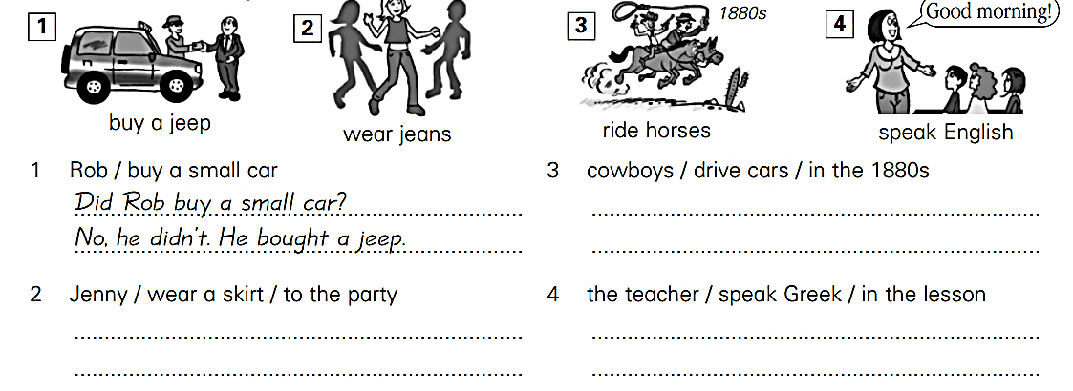

D. Fill in the gaps with correct form of the verb. Use the Past Simple:

- Before the invention of smartphones, people rarely ____________ (communicate) through text messages.
- Last summer, they __________________ (travel) to five different countries in Europe.
- When he was young, he __________________ (dream) of becoming an astronaut.
- She __________________ (not / study) at the library, she spent the day studying at home.
- ______ you ______________ (learn) to speak a foreign language when you were in school?
- How _______they_______________( manage) to escape the police?
- Why _______ you_________(call) me earlier? I ________(not/be) awake.

B. Past Continuous

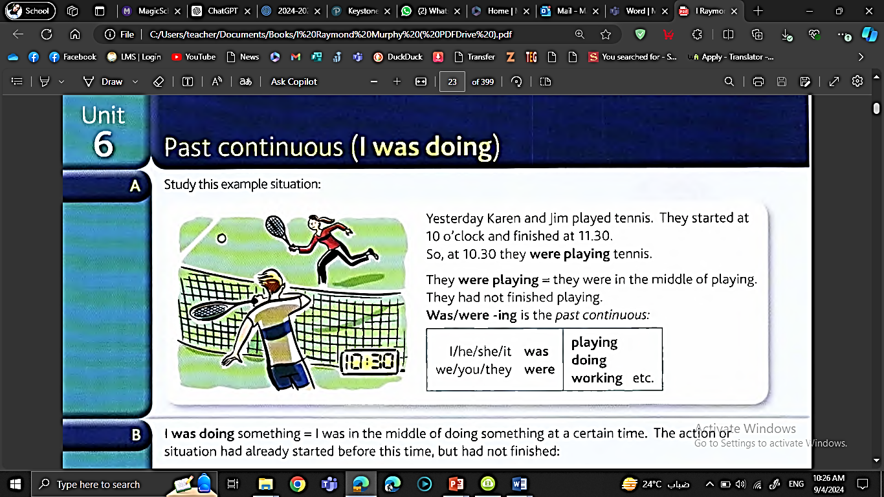

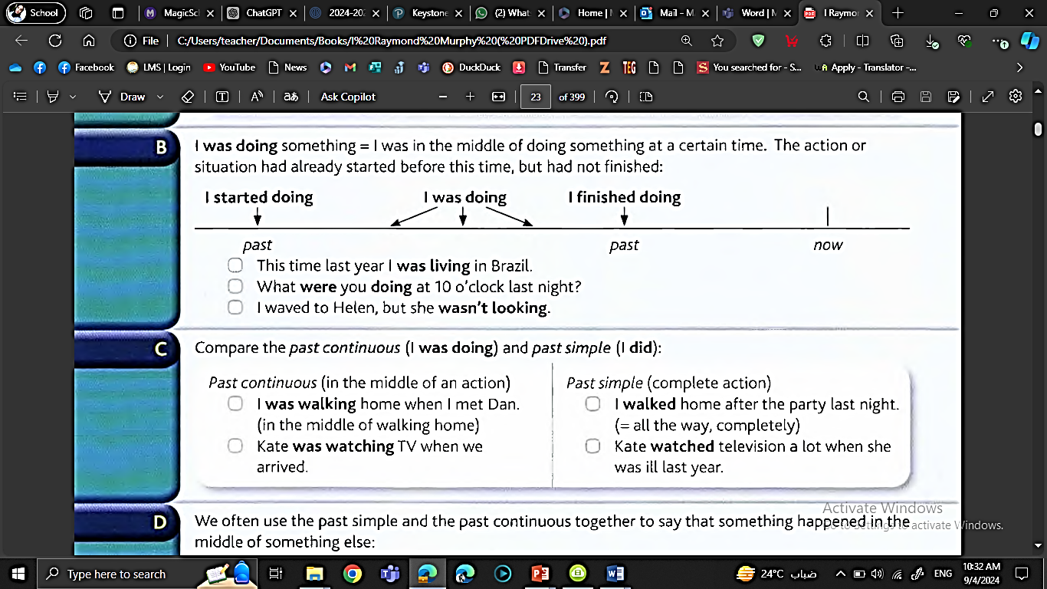

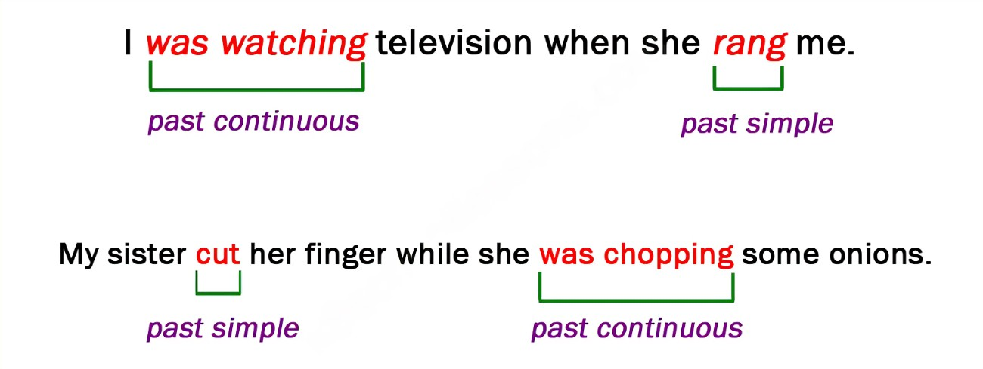

- Complete the following sentences with the past continuous of the verbs in the brackets :
1. Alice hurt herself while she _________________ (skate).
2. I met my neighbor while I ________________ (walk) home.
3. Sally saw a friend while she ________________ (ride) her bicycle along Park St.
4. Peter fell asleep while he ________________ (study).
5. Mary _______________ (read) in bed when she _____________ (hear) a strange noise downstairs.

- Circle the correct verb form in each of the following sentences:
- Mary (prepared / was preparing) lunch when they (arrived / were arriving).
- Tom was very unlucky. It (rained / was raining) during his holidays.
- Last weekend Susan (fell / was falling) and (broke/ was breaking) her leg.
- When I (entered / was entering) the cafeteria, Mary (had / was having) lunch.
- We (drove/ were driving) to Berlin in Robert´s new car.
- The sun (shone / was shining) brightly when I ( got up / was getting up) this morning.
- Ann finally (told / was telling) us the whole story about Peter.

- Put the verb into the correct form, using past continuous or past simple.
- Jenny __________ (wait) for me when I __________ (arrive).
- “What _______you_______ ( do) at this time yesterday?” “I ______(be) asleep.”
- __________ you____( go) out last night? ‘No, I was too tired.’
- How fast _________you_____( drive) when the accident ____________ (happen)?
- Sam __________ (take) a picture of me while I _______________ (not / look).
- We were in a very difficult position. We __________ (not / know) what to do.
- I haven’t seen Alan for ages. When I last _______ (see) him, he __________ (try) to find a job.
- I __________ (walk) along the street when suddenly I __________ (hear) footsteps behind me. Somebody ______________ (follow) me. I was scared, and I _________ (start) to run.
- When I was young, I __________ (want) to be a pilot.
- Last night, I ___________ (drop) a plate when I __________ (do) the washing-up. Fortunately it __________ (not / break)


Writing Task (3)
Imagine you are an inventor looking back on your greatest invention. Write a paragraph telling people how you came up with the idea, the challenges you faced, and how you finally succeeded. Include a flashback to a specific moment that was crucial to the invention process. Focus on using the past simple, past continuous, and past perfect.
My Greatest Invention
_______________________________________________________________________________________________________________________________________________________________________________________________________________________________________________________________________________________________________________________________________________________________________________________________________________________________________________________________
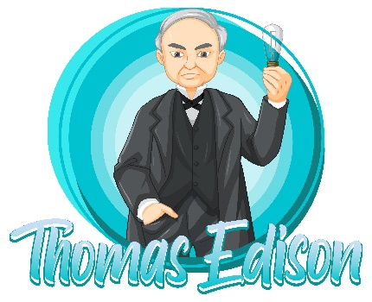
_______________________________________________________________________________________________________________

5. Unseen Text:

Read the text and answer the questions that follow.

The Remarkable Life and Contradictions of Thomas Edison

Thomas Edison, in full Thomas Alva Edison, (born February 11, 1847, Milan, Ohio, U.S.—died October 18, 1931, West Orange, New Jersey), American inventor who held a world-record 1,093 patents. In addition, he created the world’s first industrial research laboratory.
Edison was the quintessential American inventor in the era of Yankee ingenuity. He began his career in 1863, in the adolescence of the telegraph industry, when virtually the only source of electricity was primitive batteries putting out a low-voltage current. Before he died, in 1931, he had played a critical role in introducing the modern age of electricity.
From his laboratories and workshops emerged the phonograph, the carbon-button transmitter for the telephone speaker and microphone, the incandescent lamp, a revolutionary generator of unprecedented efficiency, the first commercial electric light and power system, an experimental electric railroad, and key elements of motion-picture apparatus, as well as a host of other inventions. It was a revolutionary invention.
Edison’s career, the fulfillment of the American dream of rags-to-riches through hard work and intelligence, made him a hero to his country. He was a celebrity everywhere and had an exceptional charismatic personality. On the other hand, some say that he was an oppressor at his workplace with his employees. Also, he wasn’t a good family man and he neglected his family responsibility. Perhaps, this is the price of being a great memorable inventor.
By the time he was in his middle 30s Edison was said to be the best-known American in the world. When he died he was venerated and mourned as the man who, more than any other, had laid the basis for the technological and social revolution of the modern electric world.
- Who was Thomas Edison, and what is he known for?
………………………………………………………………………………………………………………………………………………
- How many patents did Thomas Edison hold, and what were some of his most significant inventions?…………………………………………………………………………………………………………………………………
- What is described as the quintessential American inventor in the era of Yankee ingenuity?
………………………………………………………………………………………………………………………………………………
- What were some of the inventions that were created in Edison's laboratories and workshops?
………………………………………………………………………………………………………………………………………
- How was Thomas Edison perceived by the public during his lifetime?
………………………………………………………………………………………………………………………………………………
7. What do you think Thomas Edison’s personality. Give justification.
………………………………………………………………………………………………………………………………………………
8. Find a word from the text that means “for the first time” ………………
9. What does the underlined pronoun “it” refer to? ……………….

Critical thinking
In your opinion, should Edison be primarily remembered for his inventions or for the controversies and complexities surrounding his life? Explain your answer?
………………………………………………………………………………………………………………………………………………
………………………………………………………………………………………………………………………………………………

6. Listening:
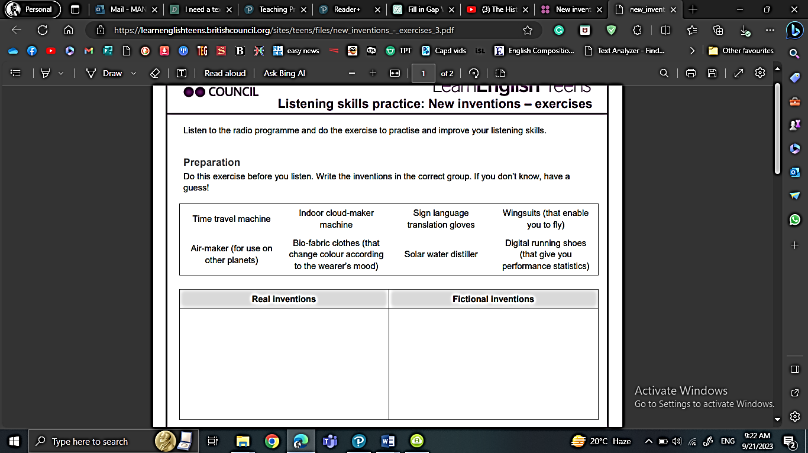

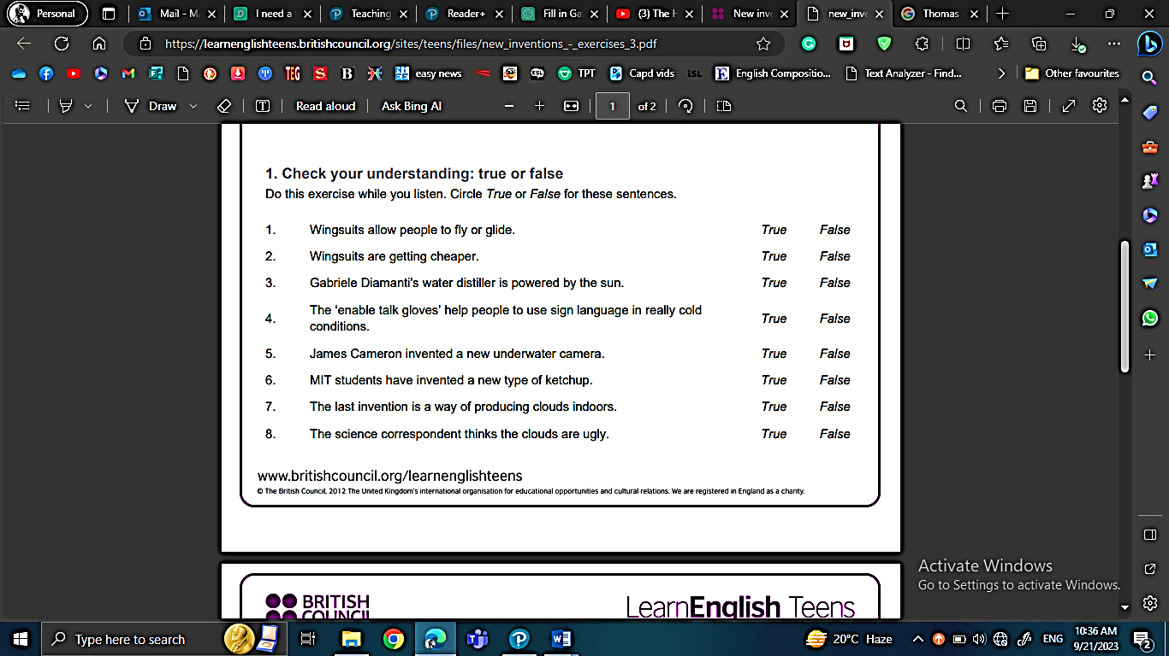

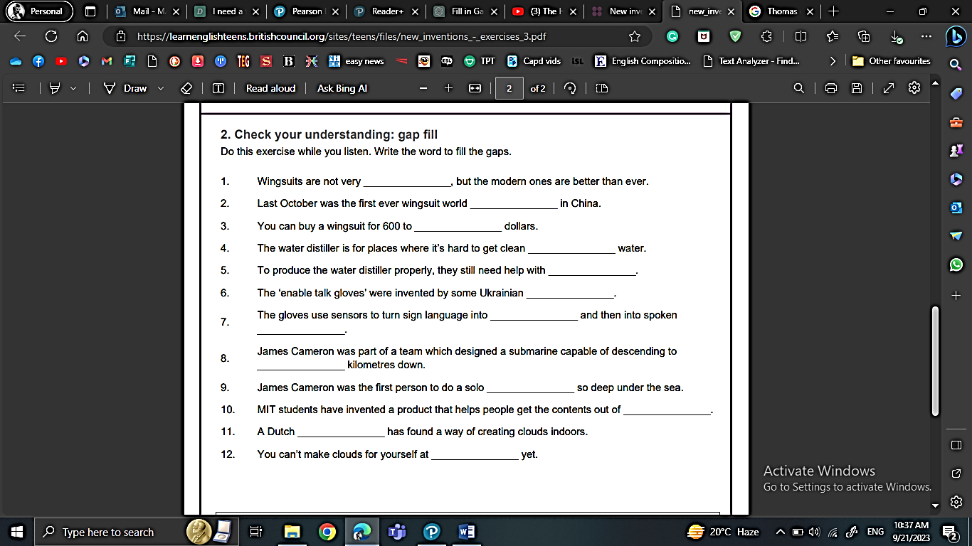


Discussion
Which of these new inventions would you most like to try out?
Scan the QR code to find the audio:
https://learnenglishteens.britishcouncil.org/skills/listening/b2-listening/new-inventions

x


7. Writing:
Descriptive essay
(describe an experience or an event )
Read the following example
Attending a football match in Madrid is an unforgettable experience filled with vibrant colors and electrifying sounds. As I arrived at the stadium, the air buzzed with anticipation. Fans in team jerseys created a sea of colors, and the aroma of delicious street food, especially churros, added to the festive atmosphere.
Upon entering, I was struck by the packed stands and the palpable energy. The sound of drums and chants echoed around me, and I felt the ground shake as the crowd jumped in unison. When the players took the field, the bright floodlights illuminated the pitch, and the excitement intensified.
The game was nonstop action, with players sprinting and skillfully dodging each other. Each time a player approached the goal, tension filled the air. The exhilarating sound of the ball hitting the net was music to our ears, and when the home team scored, the stadium erupted in celebration.
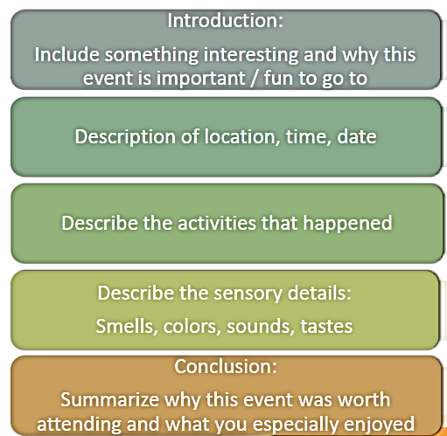
As the final whistle blew, I left the stadium with unforgettable memories. The cheers of the crowd and the vibrant colors of the jerseys lingered in my mind. Attending that match in Madrid was not just about watching a game; it was about experiencing the passion and excitement of football.
Structure:

Outline:
Introduction
1. Hook – Write a sentence that grabs the reader’s attention:
Example: “Have you ever had a moment that changed everything?”
✎ _________________________________________________________________________________________
2. Background – Briefly explain what the event is and why it matters:
✎ _________________________________________________________________________________________
3. Thesis Statement – What is the main idea of your essay?
Example: “This essay describes the day I overcame my fear of public speaking.”
✎ _________________________________________________________________________________________
Body Paragraph 1: Setting the Scene
Where and when did the event happen? What was the atmosphere like?
✎ _________________________________________________________________________________________
Use sensory details (sight, sound, smell, touch, taste):
✎ _________________________________________________________________________________________
✎ _________________________________________________________________________________________
Body Paragraph 2: What Happened
Describe the event in order. What did you do? Who was there?
✎ _________________________________________________________________________________________
How did you feel during the event?
✎ _________________________________________________________________________________________
✎ _________________________________________________________________________________________

Body Paragraph 3: The Most Important Moment
What was the most exciting or meaningful part of the event?
✎ _________________________________________________________________________________________
Why was it important to you?
✎ _________________________________________________________________________________________
Conclusion
What did you learn or realize from the event?
✎ _________________________________________________________________________________________
Final thought or message to the reader:
Example: “That day taught me that courage grows when we face our fears.”
✎ _________________________________________________________________________________________
Now Let’s write! Choose a remarkable event that you attended. Organize your ideas, and then write a descriptive essay. Check your final work against the rubric provided.
____________________________________
________________________________________________________________________________________________________________________________________________________________________________________________________________________________________________________________________________________________________________________________________________________________________________________________________________________________________________________________________________________________________________________________________________________________________________________________________________________________________________________________________________________________________________________________________________________________________________________________________________________________________________________________________________________________________________________________________________________________________________________________________________________________________________________________________________________________________________________________________________________________________________________________________________________________________________________________________________________________________________________________________________________________________________________________________________________________________________________________________________________________________________________________________________________________________________________________________________________________________________________________________________________________________________________________________________________________________________________________________________________________________________________________________________________________________________________________________________________________________________________________________________________________________________________________________________________________

After you finish your first draft, check for mistakes using the
following checklist

- Adding a topic sentence to the introduction
- Writing the title
- Including details about the event in all paragraphs.
- Answering all 5 WH questions.
- Using lots of adjectives or phrases that draw pictures in readers’ minds
- Using sequence words
- Clear handwriting
- Accurate spelling
- Using correct tense
- Using correct punctuation marks and avoiding capitalization mistakes.




