

_{2025/2026}
Writing Worksheet (can / can’t)
Read about Salah and his abilities, then connect the sentences together to make a paragraph. Don’t forget the title, indentation, capitalization and the correct punctuation.
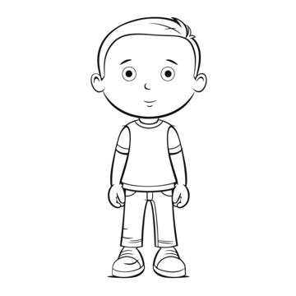
I am Mustafa.
- I can play tennis.
- I can play football.
- I can’t skate.
- I can play the piano.
- I can’t sing.
- I can speak English.
- I can speak Arabic.
- I can’t speak French.

----------------------------------
--------------------------------------------------------------------------------------------------------------------------------------------------------------------------------------------------------------------------------------------------------------------------------------------------------------------------------------------------------------------------------------------------------------------------------.
_{2025/2026}
Writing Worksheet (Can / Can’t)
Read about Salma and her abilities. Then, write about your own abilities:
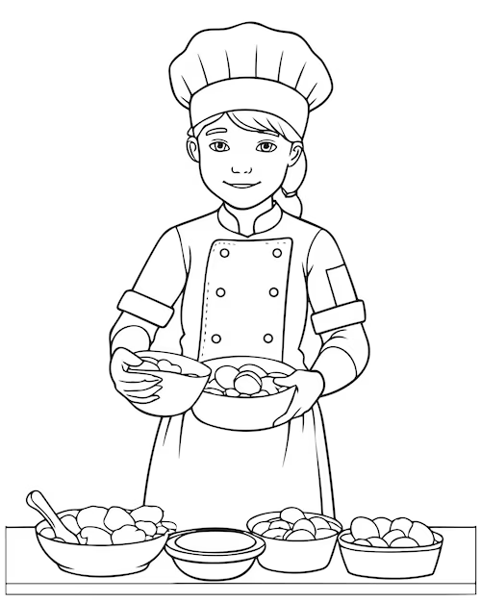
Don’t forget the title, indentation, capitalization and the correct punctuation.
My Abilities
Hello! My name is Salma. I’m 7 years old. I like sport. I can play tennis and basketball, but I can’t play football. I can cook. I can make pizza, pasta and Mansaf.
What about you? What can you do?

----------------------------------
--------------------------------------------------------------------------------------------------------------------------------------------------------------------------------------------------------------------------------------------------------------------------------------------------------------------------------------------------------------------------------------------------------------------------------.

