





Worksheet Number ( 2 )
Grade & Section: 6th grade ( ) Unit: 1
Student's Name: Date: / /____

Lesson: Periodic Table (pages 20 + 21)
Educational Outcome: Identify Periodic Table
*********************************************************************************************************************

Outcome: Define the main terms (periodic table and group)
Periodic Table : is a table where elements are arranged based on their atomic number and their properties.
Group: is the vertical column on periodic table.
Activity 1: look at the following figure and answer the following
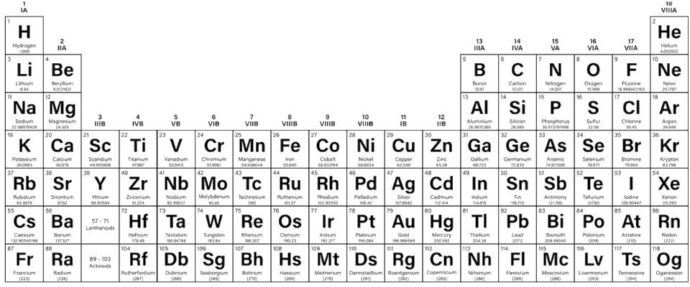
- What is the name of this figure?………………………………………………..

- What is the number of group that has Sodium ( Na)?…………………………

- Name an element that exist in the same group of Helium (He)……………….

- True or false
1. Sodium and Potassium are in the same group
2. Elements is the same group do not have similar properties

Outcome 2: compare between sodium and potassium
Use the following link to use an interactive periodic table that shows each elements properties, symbol and the uses of it.
https://elements.wlonk.com/ElementsTable.htm
Activity 2: Compare between Sodium and Potassium

 | Sodium | Potassium
Latin name
Symbol
Color
Shiny / dull
Group number
Metal / non metal

Outcome 3: Identify the following metals (Gold – Chromium and Tin)
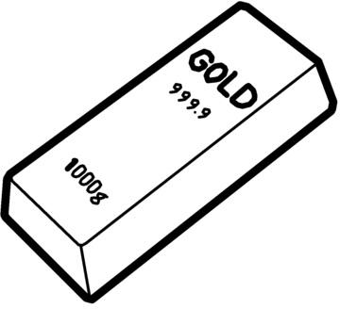


Gold is a shiny metal that is often
made into ……………………….. The symbol of Gold is …………..

Chromium is a metal that is used
to metal surfaces such as the trim of cars
The symbol of Chromium is …………..

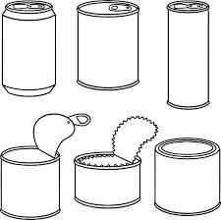
Tin is a that used in
……………………………………. The symbol of Tin is …………..

Outcome 4: Describe Sulphur and Neon Watch the next 2 videos then answer https://www.youtube.com/shorts/htbVB6ILHPI https://www.youtube.com/watch?v=bj55Y9ERvgs

activity 4 :
- Is Sulphur a metal or no-metal?
- What is the color of Sulphur?

- What is the symbol of Sulphur?
- Identify the state of matter of neon.
- What is the symbol of Neon?
- Explain, Neon can glow?

=======================



