

Worksheet Number (2)
Grade & Section: 5th ( ) Unit: 2 Student's Name: Date: / /2025 Skill/Lesson: How are traits passed along?
Educational Outcomes:
- Define the inherited traits.
- List different inherited traits in humans.
- Recognize inherited traits in fireflies.
*********************************************************************************************************************
Activity 1: Inherited traits:
According to the next picture answer the questions.
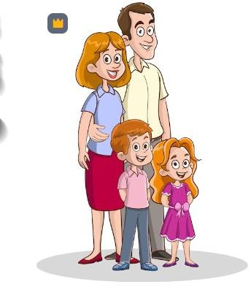
Q1) What are the common characteristics that passed from parents to their offspring ?

Q2) Do hair color and skin color passed from parents to their offsprings?

Q3) Define the inherited traits?

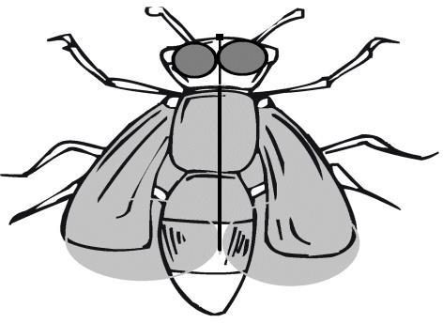

Activity 2:
Inherited traits: traits that passed from parents to their offsprings

Q1) Circle the inherited traits

Reading | Eye color
Two wings | Swimming
Running | Curly Hair
Riding a bike | Dimples
Curling tongue | Widow s peak

Activity 3: firefly inherited traits

Look at the next picture and answer the following

Q1) label the firefly parts:

Q2) Explain how a firefly can give off light.

