

Worksheet Number ( )
Grade & Section: 6th ( ) Unit: 3 Student's Name: Date: __/ /_____ Skill/Lesson: Classifying matter
*********************************************************************************************************************
Educational Outcomes:
- Define physical properties.
- Classify and describe matter according to their physical properties.
- Identify: Texture, mass, elasticity, odor, melting point, hardness and magnetism of matter.
Activity 1: Hardness
Hardness is how hard or soft something is
Watch the following video then answer the following question https://www.youtube.com/watch?v=xZUgWzRpA-4
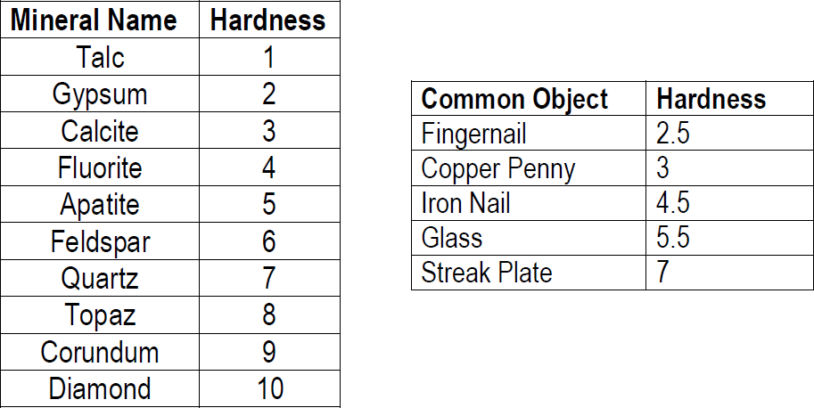

Q1. What is the hardest material in the previous table? Q2. What is the hardness of Iron nail?
Q3. Name two minerals on the Mohs scale that can scratch Topaz. Q4.Which mineral is harder, Topaz or Quartz?

Activity 2: Texture
Texture is the feel or the appearance of the surface.
Words used to describe texture: (smooth, soft, hard, shiny or dull).
This is the link of an interactive worksheet of describing texture
https://www.liveworksheets.com/w/en/life-experience/1714980

Question 1 : Describe the following picture use the word from the list
Hairy – smooth – sharp – bumpy – rough – fuzzy - soft

 | 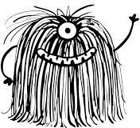 | 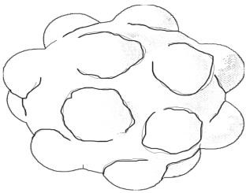
 |  | 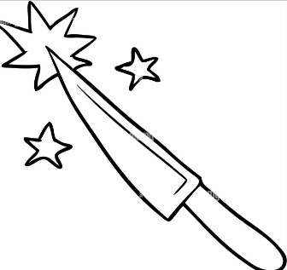

Question 2: Practice drawing an object with rough texture on the shape below



Activity 3: Mass
Mass: is how heavy something is
Question 1: Choose the best estimate for each object or animal shown.
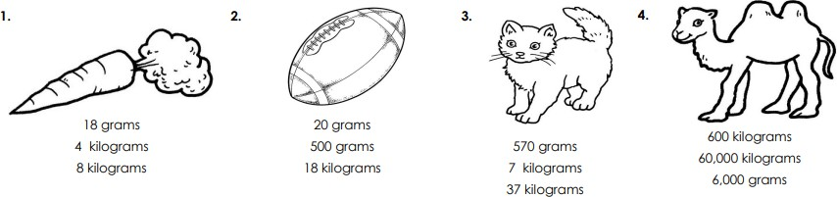

Question 2: Circle the heavy objects and cross out the light ones.

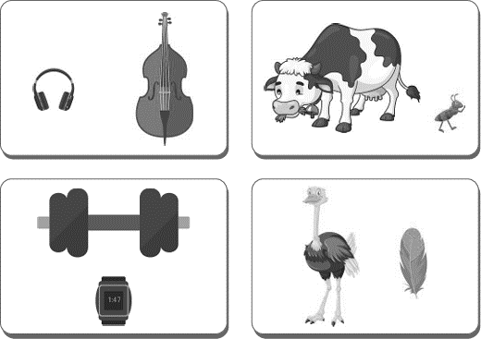

Activity 4: Magnetism
Magnetism is the ability to be attracted to magnet Watch the following video then answer the following https://www.youtube.com/watch?v=yXCeuSiTOug

Question 1 : Draw a line from the magnet to the things it will attract.
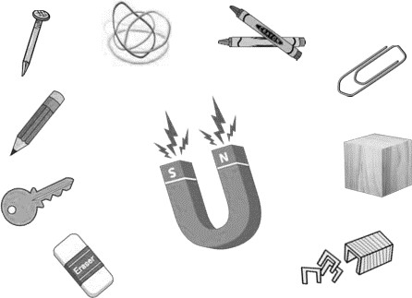

Activity 5: Elasticity
Elasticity is how much will stretch or bend before breaking The following link shows a live worksheet https://www.liveworksheets.com/w/en/science/2174603

Question 1: identify the following as elastic or inelastic
Rubber band – wool string - wooden stick – trampoline - Spring Toys – glass cup

Elastic | inelastic

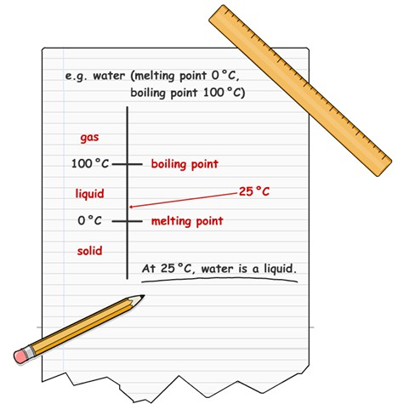
Activity 6: Melting point
The following link is an interactive game https://www.liveworksheets.com/w/en/science/715863

Q1: look at the next table and answer the following
Substance | Melting point
water | 0° C
Iron | 1535° C
gold | 1063° C
mercury | -39° C

Q1: What is the melting point of Iron? Q2: What is the melting point of Ice?
Q3: which material has the lowest melting point?

ــــــــــــــــــــــــــــــــــــــــــــــــــــــــــــــــــــــــــــــــــــــــــــــــــــــــــــــــــــــــــــــــــــــــــــــــــــــــــــــــــــــــــــــــ
Activity 7: Odour
Odour is the smell of something
Question 1 : describe the odour of the following

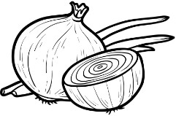
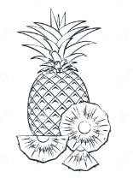
Sweet – rotten – sharp

============================
Good luck ●•^-

