
Listening Practice
Student’s Name: ______________ Date: ____________ Skill/Lesson: Listening Grade: ___________
Outcome: to listen for details

How to Grow a Bean Plant?
- Watch the video for details and write the words under the pictures.
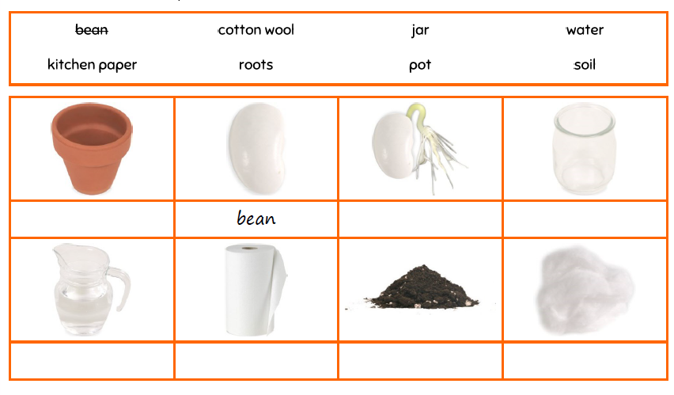

- Circle True or false for the statements below.
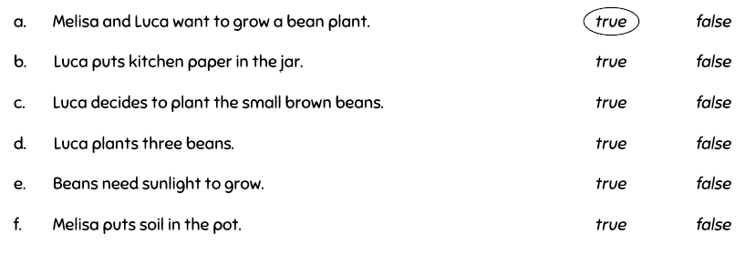

- Put the sentences below in the correct order.
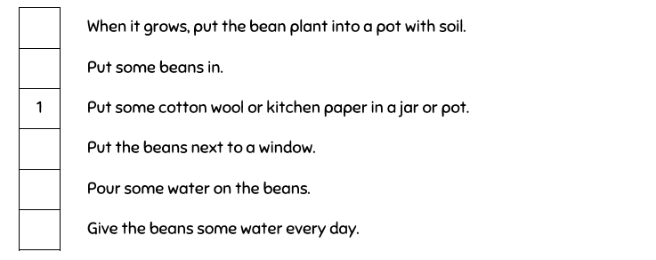

- What plant would you like to grow? Write about it then draw a picture.

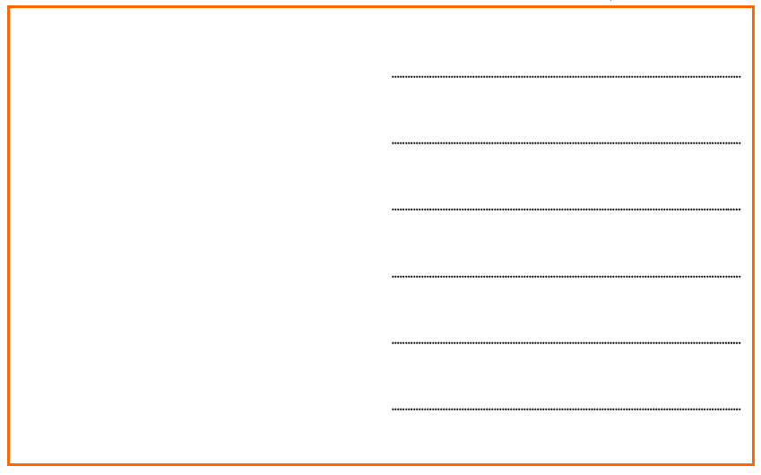

The End!

