
Worksheet Number (1)
Grade & Section: 5 ( ) Unit: 2
Student's Name: _________________________ Date: ______ / ___ /2025
Skill/Lesson: What are Flowering Plants ?
Educational Outcomes:
1-Define flowering plants.
2- List different flowering plants.
3- Compare between monocot and dicot plants.
*********************************************************************************************************************
Activity 1: Flowering plants
Watch the following video , then answer the following questions .
Flowering and Non-flowering Plants (youtube.com)
Q1) Do all plants have flowers , if not explain your answer.
____________________________________________________________________________

Q2) Name three flowering plants
____________________________________________________________________________

Q3) What is the reproductive part of a plant?
__________________________________________________________________________________

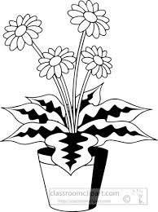

Activity 2: Comparing between monocot and Dicot.
Scientists grouped flowering plants according to their seed leaves into monocots and dicots.
Watch the following video then answer the following questions.
Monocots vs Dicots (youtube.com)
Q1: Fill in the table .
 | Leaves | Roots | Flower parts | Seed leaf
Monocots
Dicots

Question 2 : Name two examples of :
- Monocots -----------------------------------------------------

- Dicots ----------------------------------------------------------
Activity 3:Label the seed parts .

Look at the next picture and answer the following
Q1) Which part protects the seed?
-------------------------------------
Q2) Label the seed parts .

GOOD LUCK

