


Booklet 2

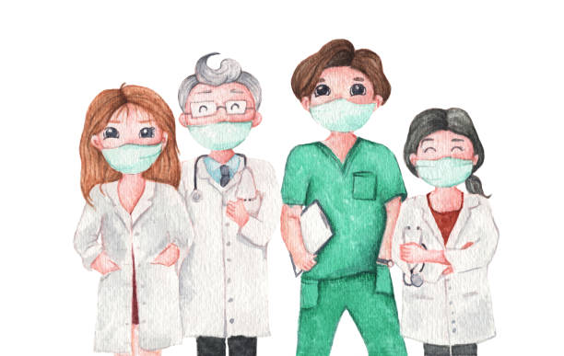

Grade 5 ( )
Name: ………………………………. .

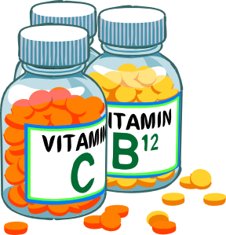

Subject: Vocabulary List #2

Word | Part of speech | Definition | Example | Picture
1.emergency | noun | something dangerous or serious, such as an accident. | If you have an accident, you need to call the police because it is an emergency. | 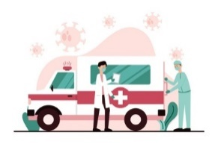
2. courageous | adjective | having or showing courage | He rescued the girl, so he is courageous. | 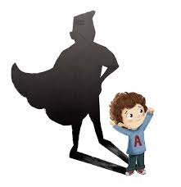
3. teamwork | noun | working together in a group with other people | Teamwork helps students finish the tasks. | 
4. training | noun | the process of learning the skills you need to do a particular job or activity | We had a training session yesterday. | 
5. intervene | verb | to be part of a difficult situation in order to improve it or prevent it from getting worse | If you see your friends fighting, you need to call your teacher to intervene. | 
6. refugee | noun | a person who has escaped from his/her own country for political, religious, or economic reasons or because of a war | Syrian and Palestinian refugees traveled all around the world. | 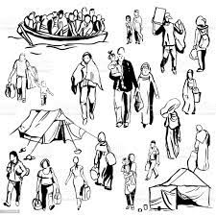
7. aid | noun  verb | - Help  - to help | Giving aid to poor people is necessary.  Doctors aid those who need help. | 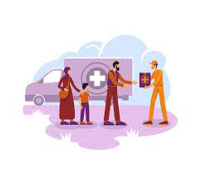
8. commit | Verb | use time, money, etc., to do something | If you are a good student, you will commit time and effort to studying. | 
9. sufficient | adjective | enough for a particular purpose | Having sufficient food is everyone’s right. | 

Question one: Read each sentence. Fill in each blank with the most suitable word
emergency, courageous, teamwork, training, intervene, refugees, aid, commit, sufficient

- Many wars made people leave their homes. So, many -------------------- moved to other countries.

- Being a police officer needs you to be brave and --------------------.

- You must -------------------- time to practice sports.

- The nurses ------------------ the boy when he hurt his knee.

- Teachers -------------------- to help students solve problems.

- We cannot cook today; we do not have ------------------ amounts of ingredients.

- Unlike our team, the other team won because they made use of -----------------.

- I think having a ------------------------session with this coach will let us win the competition.

- In cases of ---------------------, you need to call the police.

Question Two: Read the sentence and circle the part of speech of of the underlined word.

- We distribute food to aid those in need.
- Noun b. verb c. adjective

- He did not give a sufficient reason for being late, and the coach got angry.
- Noun b. verb c. adjective

- Cooperation and teamwork helped the people rebuild their village.
- Noun b. verb c. adjective

- Doctors who work in unsafe places are courageous.
- Noun b. verb c. adjective

Question Three: Make sure you understand the meaning and part of speech of each of the following words, and use each word in a complete and meaningful sentence.

- emergency (noun):
__________________________________________________________
- sufficient(adjective)
__________________________________________________________
- aid (verb): __________________________________________________________
Question Four: Answer the questions.
- If you saw two friends arguing, how could you intervene in a fair way?
___________________________________________________________

- How is a refugee different from a traveler or a tourist?
__________________________________________________________
Genre: Informational Text
What is an informational text?
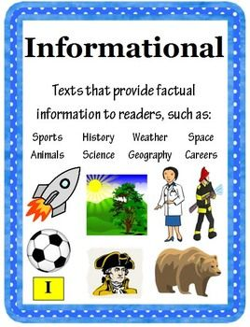
It is nonfiction writing, written with the intention of informing the reader about a specific topic.
Examples:
- newspapers
- online articles
- informational brochures
- encyclopedias
- scholarly journals
- textbooks

Elements of informational text include:
- facts
- table of contents
- pictures
- captions
- bold print
- glossary

Bees
Bees are incredible insects that play a big role in our world! There are over 20,000 different species of bees, and they can be found on every continent except Antarctica. The most common type of bee is the honeybee, known for making delicious honey!

What Do Bees Do?
Bees are best known for their role in pollination. Pollination is when bees transfer pollen from one flower to another, helping plants grow and produce fruits and seeds. This is important because many of the foods we eat—like apples, almonds, and strawberries depend on bees to help them grow.

What is the genre of the text? Write two elements. __________________________________________________________________________________________________________________________
Subject: Problem- Solving

Read the following paragraphs then fill each graphic organizer with the problem and its solution.

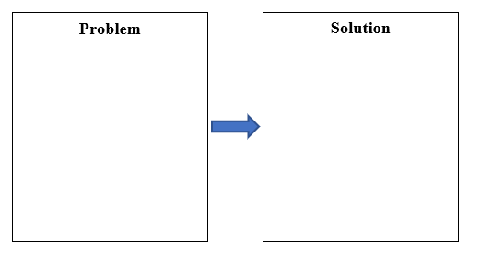
Having a cold is no fun. Coughing makes it hard to fall asleep. A sore throat is painful. Try some tea with honey in it. The honey will soothe your throat. There may be no cure for the common cold. You can treat the symptoms though.

What other solutions can you think of to help someone with a cold? Which solution do you think works best, and why? __________________________________________________________________________________________________________________________
A sprain is a tear in a muscle. Sprains happen when a muscle is twisted or overstretched. They can be painful. If you sprain a muscle, you should ice it immediately. Putting ice on a sprain will reduce swelling and pain. It may help stop internal bleeding too.

Can you think of other ways to help a sprain besides using ice?
__________________________________________________________________________________________________________________________
Subject: Unseen Text

In the quiet town of Willow Creek, there lived a clever boy named Sam. One day, during a big storm, a tree fell on the town’s only bridge, cutting off access to the neighboring village. This worried everyone, especially because a sick child needed medicine from the other side. Sam knew he had to do something. He gathered his friends and brainstormed ideas. Some suggested waiting for the town workers, but Sam believed they could take action. They decided to build a temporary bridge using planks and ropes from the town’s supply shed. After hours of teamwork and careful planning, they constructed a sturdy enough bridge for someone to cross. With a brave volunteer, they sent someone over to fetch the medicine. The plan worked! The child received the medicine just in time, and the townsfolk celebrated the children’s resourcefulness.

Read the following story then the answer the questions below.

- How would the story change if it were set in a different time?

If it would change if it were in clear, sunny weather, the situation might feel less dangerous, but the children’s speed and determination would still matter since the sick child needed help urgently.
- If you were one of the villagers what is other way could you do to solve the problem?

Use a boat or raft: If the river wasn’t too dangerous, villagers could make a simple raft or use an old boat to cross and get the medicine.

- What qualities would help them solve the problem?

Teamwork, creativity, bravery, and determination.

- The pronoun “they” in the sentence “They decided to build a temporary bridge” refers to __Sam and his friends___

- From the text, find a word that means “get or bring”. ___fetch __
Subject-Verb Agreement (Simple Present)

Q1: Correct the verbs between brackets.

- I _________________ sixteen years old. (be)

- Tommy _________________ at 107 Pine Lane. (live)

- Juana and Sara________________________ lunch at 12:00. (eat / not)

- Nina ______________________ medicine every day. (take / not)

- I ______________________chocolate. (like / not)

- Samer ______________________ a smart boy. (be)

- Mr. Anderson __________________ chemistry at Hill High School. (teach)

- Hassan ______________________ English at school. (study)

10. Dan ______________________ three brothers. (have)

11. _______________ they_________________ pasta once a week? (eat)

- ________________it _________________ here in December? (snow)

13. When ______________Dax _________________ a shower? (take)

- Mary always ______________________ her hair. (wash)

Q2: Read the statements, then form WH questions.

- My brothers play musical instruments.

What ___________________________________________________

- Ahmad usually reads books in the evening.

When ____________________________________________________

- The woman in the black dress is my Friend Rita.

Who ____________________________________________________

Q3: Answer the following questions.

- How do teachers help students?

_____________________________________________________________

- How does a family solve problems together?

_____________________________________________________________

Best Wishes

