


Booklet 3

A Robot’s Smile

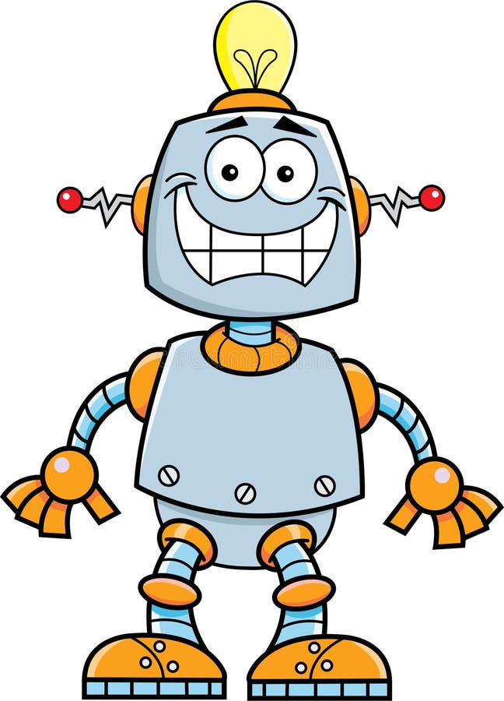

Name: ……………………………….

Grade 5 ( )

Subject: Vocabulary List #2

Word | Part of speech | Definition | Example | Picture
1.sighed | verb  (past tense) | - to take or let out a long loud breath | -Suzan sighed in relief when she got her toy back. | 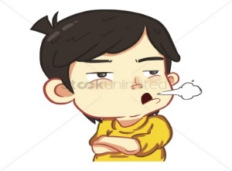
2. program | noun | - A series of instructions that can be put into a computer in order to make it perform an operation | -We learned how to write a program that deals with numbers. | 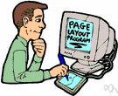
3. emotions | noun | - strong feelings (such as love, anger, joy, hate, or fear) | - The emotions I feel before the game are excitement and confusion. | 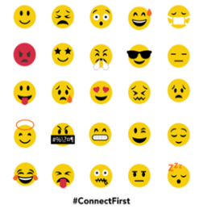
4.features | noun | - interesting or important parts, qualities, abilities, etc. | - Wide classrooms and smart screens are some of the features of our school. | 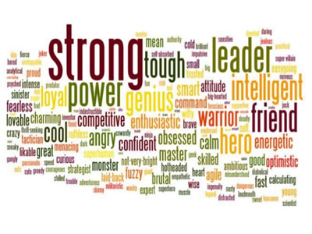
5.adjustable | adjective | - able to be changed to suit particular needs | - This plan is adjustable, don’t worry about time. | 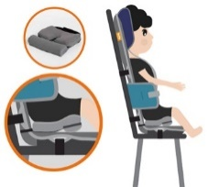
6. resident | noun | - one who lives in a place | - Mr. Jack is one of this building’s residents. | 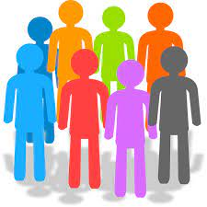
7.circumstanes | noun | -conditions or situations | - Having no food and having no water are the circumstances that made them leave their houses. | 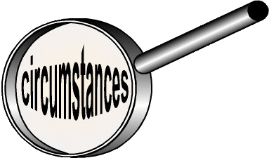
8. capable | adjective | - having the ability to do something | -We are capable of solving the problem. | 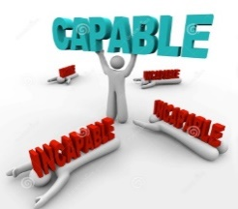

Question one: Read the sentence and circle the part of speech of the underlined word.

- Having brown eyes is one of Ahmad’s features.

- noun b. verb c. adjective

- I have learned how to work on two programs.

- Noun b. verb c. adjective

Qu Question two: Make sure you understand the meaning and part of speech of each of of the following words, and use each word in a complete and meaningful sentence.

- sighed (past tense):----------------------------------------------------------------------
- program (noun):---------------------------------------------------------------------------
3. capable (adj): ----------------------------------------------------------------------------
Critical thinking questions
- Why is it important to understand other people’s emotions? How can this help in friendships?

--------------------------------------------------------------------------------------------------

--------------------------------------------------------------------------------------------------

- A new phone has many features. If you could design a device for kids, what special features would it have, and why?

--------------------------------------------------------------------------------------------------

--------------------------------------------------------------------------------------------------

Question three: Read each sentence. Fill in each blank with the most suitable word.
sighed, program, emotions, features, adjustable, resident, circumstances, capable

- If you want to pass the exam, you need to be --------------- of answering at least half of its questions.

- We offer on our plane---------------- seats that are comfy.

- One of the --------------- you feel in exams is sadness.

- She ----------------- after seeing her broken PC.

- I learned about a ----------------- that predicts natural disasters and earthquakes.

- Not studying regularly is one of the ----------------- that led to his failure.

- Strong, presentable and smart are some of my best friend’s -------------.

- Living in our neighborhood needs you to be a good ---------------.
Subject: Main Idea and Details

Main Idea is the most important thought of a paragraph. It tells the reader what the text is about.

Details are the facts, reasons, descriptions, and examples that support the main idea. They help the reader understand the main idea.

- Read each paragraph and choose the main idea.

The main idea of this paragraph is:
a. Boots is my dog.
b. Boots can sit.
c. Boots is very smart.
d. Most dogs can't dance.
I have a dog named Boots. I taught him lots of tricks. When I tell him to, Boots will sit or lie down. He can also wave his paw to greet people. When I say, Dance, Boots”, he will stand up on two legs and walk. I don't know of many dogs that can do such amazing tricks.

Yesterday was my birthday. When I woke up, I noticed my brother Todd hung up a big sign that said, “Happy Birthday, Joey!” Mom made spaghetti for dinner. It's my favorite food in the whole world. My friend Dave came over and handed me a wrapped gift. I wondered what it was. It was a new basketball! I had a great day.
The main idea of this paragraph is:
a. Todd had a great birthday.
b. Joey had a great birthday.
c. Todd got lots of gifts.
d. Joey got lots of gifts.

The main idea of this paragraph is:
a. Peter cannot go in the living room.
b. Peter's parents don't like the carpet.
c. Peter likes to make a mess.
d. Peter's parents made new rules so
the new carpet stays clean.

Peter's parents bought a new carpet for the living room. Now, he has to take his shoes off when he enters the house. He's also not allowed to eat or drink in the living room any more. Peter's furry dog isn't allowed to play ball in there either. When his parents got the new carpet, there were lots of new rules.

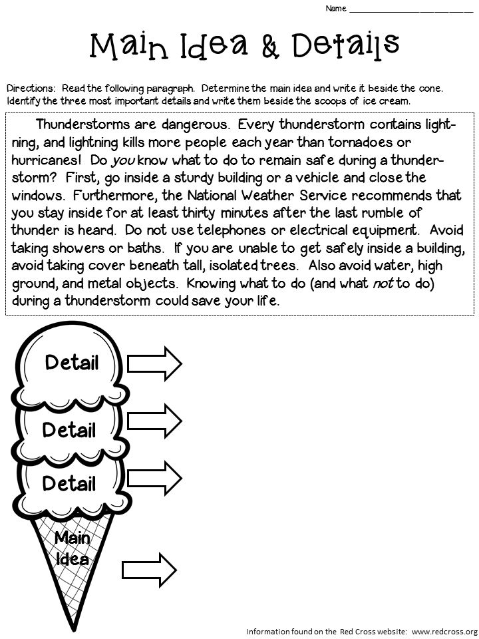
Directions: Read the following paragraph. Determine the main idea Identify the two most important details and write them.

Thunderstorms are dangerous. Every thunderstorm contains lightning, and lightning kills more people each year than tornadoes or hurricanes! Do you know what to do to remain safe during a thunderstorm? First, go inside a sturdy building or a vehicle and close the windows. Furthermore, the National Weather Service recommends that you stay inside for at least thirty minutes after the last rumble of thunder is heard. Do not use telephones or electrical equipment. Avoid taking showers or baths. If you are unable to get safely inside a building, avoid taking cover beneath tall, isolated trees. Also avoid water, high ground, and metal objects. Knowing what to do (and what not to do) during a thunderstorm could save your life.

Main idea:
--------------------------------------------------------------------------------------------------
Details
--------------------------------------------------------------------------------------------------

--------------------------------------------------------------------------------------------------

1. If you were outside during a thunderstorm, which safety step from the passage would you do first, and why?

--------------------------------------------------------------------------------------------------

--------------------------------------------------------------------------------------------------

Subject: Unseen Text

Lena was having trouble with her science project. She needed to create a presentation about the solar system, but she didn’t know where to start. She looked at her messy desk filled with books and notes and sighed sadly. Just then, her older brother Sam walked in. "Hey, Lena! Why don’t you use the tablet? It can help you with your project." Lena looked at him. "But I don’t know how it can help me with space stuff." Sam smiled and handed her the tablet. "It’s easy. You can find videos, facts, and even create a slide show all in one place." Lena tapped the tablet, and soon she was watching a video about the planets. She learned that Jupiter is the biggest planet and that Mars might have had water a long time ago. She then used a special app to organize her slides, adding pictures of planets and fun facts. In no time, Lena had a full presentation ready. She was amazed at how much easier the tablet made everything. The next day, Lena gave her presentation in class. Her teacher, Mr. Anderson, was impressed. "Lena, you did a great job using technology to help explain the solar system," he said. "Just remember, it's important to understand the information, not just copy it from the screen." Lena smiled. She realized that while the tablet helped her find the information quickly, she had learned a lot by reading, watching, and thinking about what she found. Technology was great, but her own effort made the project truly special.
- What problem was Lena facing in the beginning of the story?
__________________________________________________________________________________________________________________________

- If you were Sam what other suggestions would you give Lena to solve her problem?
__________________________________________________________________________________________________________________________

- What did Lena learn about Jupiter and Mars while using the tablet?
__________________________________________________________________________________________________________________________

4. What was Mr. Anderson’s feedback after Lena's presentation?
__________________________________________________________________________________________________________________________
5. What is the main idea of the story?
__________________________________________________________________________________________________________________________
6. What does the pronoun “she” line 10 refer to?
___________________________________________________

7. From the text find a word that means “to take or let out a long loud breath”.
___________________________________________________

8. Do you think Lena would have been able to complete her project without the tablet?
Why or why not?
_____________________________________________________________

___________________________________________________________

- What can we learn from Lena’s experience about the best way to use technology for learning?
_____________________________________________________________

_____________________________________________________________

Grammar: Future

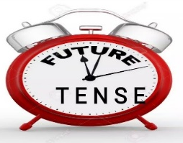

The simple future tense is used to describe actions that will happen in the future.

Will: Used to express future actions or decisions made at the moment of speaking.

Form: Subject + will+ base form of the verb
Example: I will call you later.
Shall- might- could are also used to express future actions.

Explanation:
- Shall: Often used with "I" or "we" for formal suggestions, offers, or to express a future action.
- Might: Used to express possibility, uncertainty, or a suggestion.
- Could: Used to express ability in the past or polite requests. It also expresses possibility.
- Will: Used for future actions or decisions. "Will not" (won't) is used to express refusal or inability.
Example:
- We shall meet at the restaurant at 7 PM.
- She could join us for dinner if she finishes her work early.
- I might go for a run this evening if it stops raining.

- “Will- shall- could- might and the negative form will not – shall not – might not – cold not are modal auxiliary verb. They are always followed by the base form of the verb.

I will leave later.
You could leave later.
He / she might leave later.

  Modal verb
  negative
  Short form
Will | Will not | won’t
might | Might not
  mightn't (informal British)
Shall | Shall not | shan't (informal British)
could | Could not | couldn’t

- To make the question form, change the word order:

Modal Verb | Affirmative | Question
Will | I will go to the party.
  Will you go to the party?
might | He might join us later. | Might he join us later?
Shall | We shall start now. | Shall we start now?
could | You could pass the salt | Could you pass the salt?

Exercises

Fill in the Blanks with the Simple Future Tense.

- I __________ (visit) my grandmother next Saturday.

- They __________ (finish) their project by the deadline.

- She __________ (not/go) to the concert if she feels sick.

- We __________ (have) a picnic if the weather is nice.

- He __________ (call) you later this evening.

- It __________ (rain) tomorrow, so take an umbrella.

Complete the sentences in the future simple (will).

- It (rain/not) tomorrow.
_________________________________________________

- I promise I (be/not) late.
_________________________________________________

- The bus (wait/not) for us.
_________________________________________________

What do you think schools will look like in 20 years? Why?

_____________________________________________________________

Imagine you are 18 years old. What are some things you think you will be able to do that you cannot do now?

_____________________________________________________________

Write questions in the future simple (will).

- (What/learn/they)
_________________________________________________

- (it/snow)
_________________________________________________

- (When/you/get/home)
_________________________________________________

4. (What/say/he)
_________________________________________________

Best Wishes

