

English Language
1st Semester 2025/2026
8th Grade
Unit (3) Aguinaldo Handout

Name:

Section:

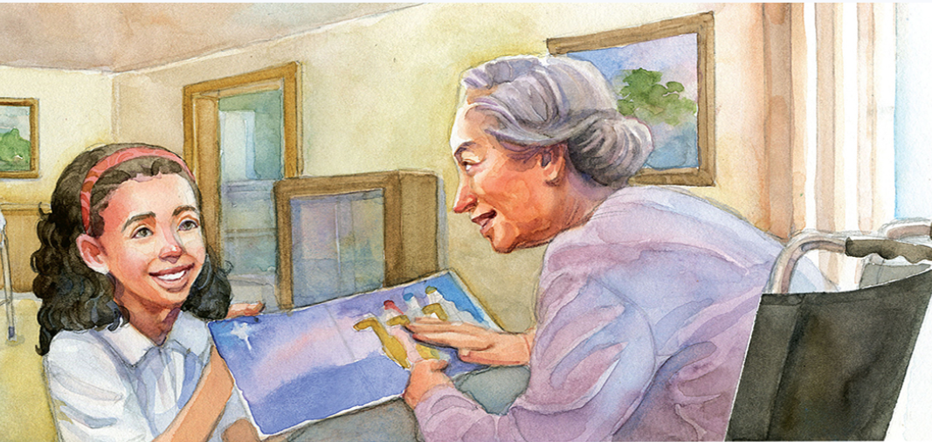

1. Unit’s Content:
Topic : | Students’ Book Pages:
1. The Big Question | 126
2. Vocabulary (Literary words, academic words) | 127-128
3. Reading Aguinaldo | 130-137
4. Grammar:
Comparison Structure : Adjectives | 46
5. Writing: Compare and Contrast essay | 174+175

1. The Big Question:
How are relationships with others important??
Writing Task (1)
There is an old saying that when you help someone, you are really helping yourself. What do you think that means? Do you think it is important to reach out to others?

The saying suggests that when you help someone else, you also benefit—by feeling good about your actions, building stronger connections, gaining perspective, and growing as a person. Reaching out to others is important because it strengthens relationships, reduces loneliness, and helps create a more caring and supportive community.

2. Vocabulary:
NO. | Word | Meaning | Example
 | Distribute | (v.) Give something to different people | The teacher will distribute the books to the students tomorrow.
 | positive | (adj.) Good or useful | She always tries to stay positive even when things go wrong.
 | Residents | (n.) people who live in a place | The residents of the town were all invited to the meeting.
 | Reluctant | (adj.) feeling uncomfortable about doing something | He was reluctant to leave the party early.
 | Field trip | (n.) trip students take with their classmates and teacher | The class is going on a field trip to the museum next week.
 | Firmly | (adv.) strictly | She held the book firmly in her hands.
 | Infirm | (adj.) sick or weak | The infirm man needed help crossing the street.
 | Concern | (n.) / (v.) to worry | There was concern about the weather during the outdoor event.
 | Dizzy | (adj.) unsteady or shaky | After spinning in circles, he felt dizzy and had to sit down.
10 | mumbled | (v.) speak quietly and unclearly | She mumbled her answer when the teacher asked her a question.
11 | Scattered | (v.) / (adj.) spread out | The leaves were scattered all over the yard after the storm.
12 | Vivid | (adj.) very clear and specific | The painting had vivid colors that made it stand out.
13 | Caressed | (v.) touch in a gentle way | He gently caressed the puppy’s soft fur.
14 | Mischievously | (adv.) playfully | The boy smiled mischievously as he hid the cookies.
15 | gestured | (v.) made a motion | She gestured toward the door, signaling that it was time to leave.
16 | Suitors | (n.) men who want to marry a woman | The suitors were all waiting for her answer to the proposal.
17 | Collage | (n.) work of art made by sticking pictures, photographs, cloth, etc. onto a surface | She created a beautiful collage of family photos for the wall.

Academic Words

A. Read the paragraph below. Pay attention to the underlined Academic Words.:
There is a non-profit organization in our town that distributes free lunches to the elderly. Volunteers bring the lunches to elderly residents’ homes every day at noon. No elderly person who requests a free lunch is ever turned down, although some feel reluctant to ask for help. Both volunteers and the elderly find delivering and receiving free lunches a very positive experience
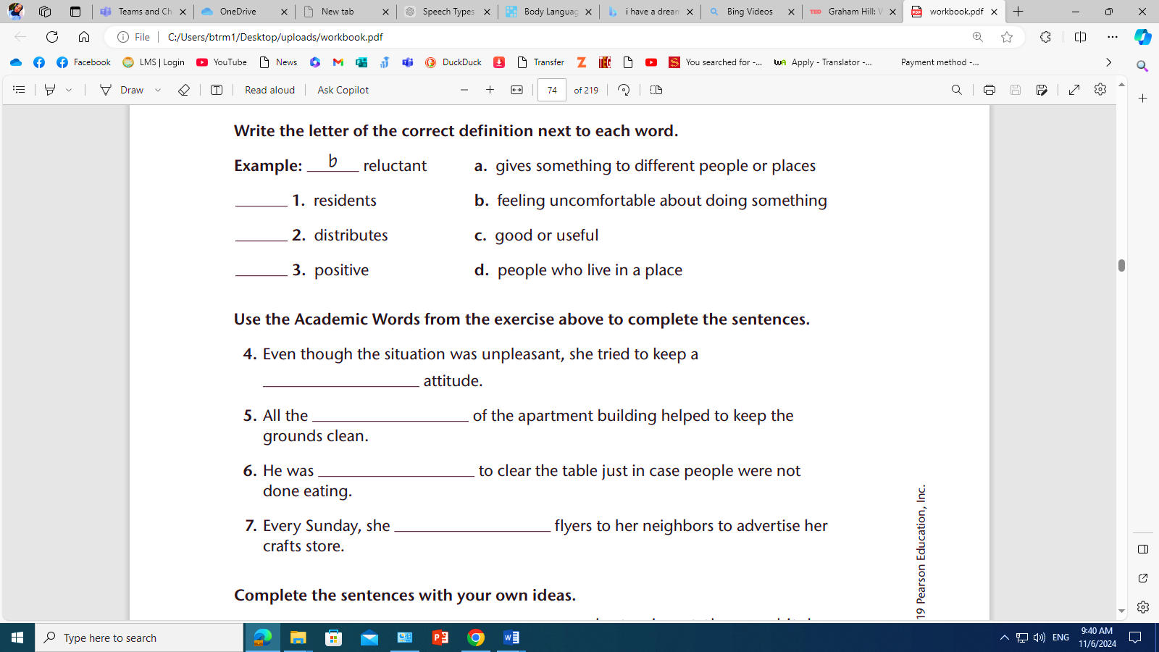
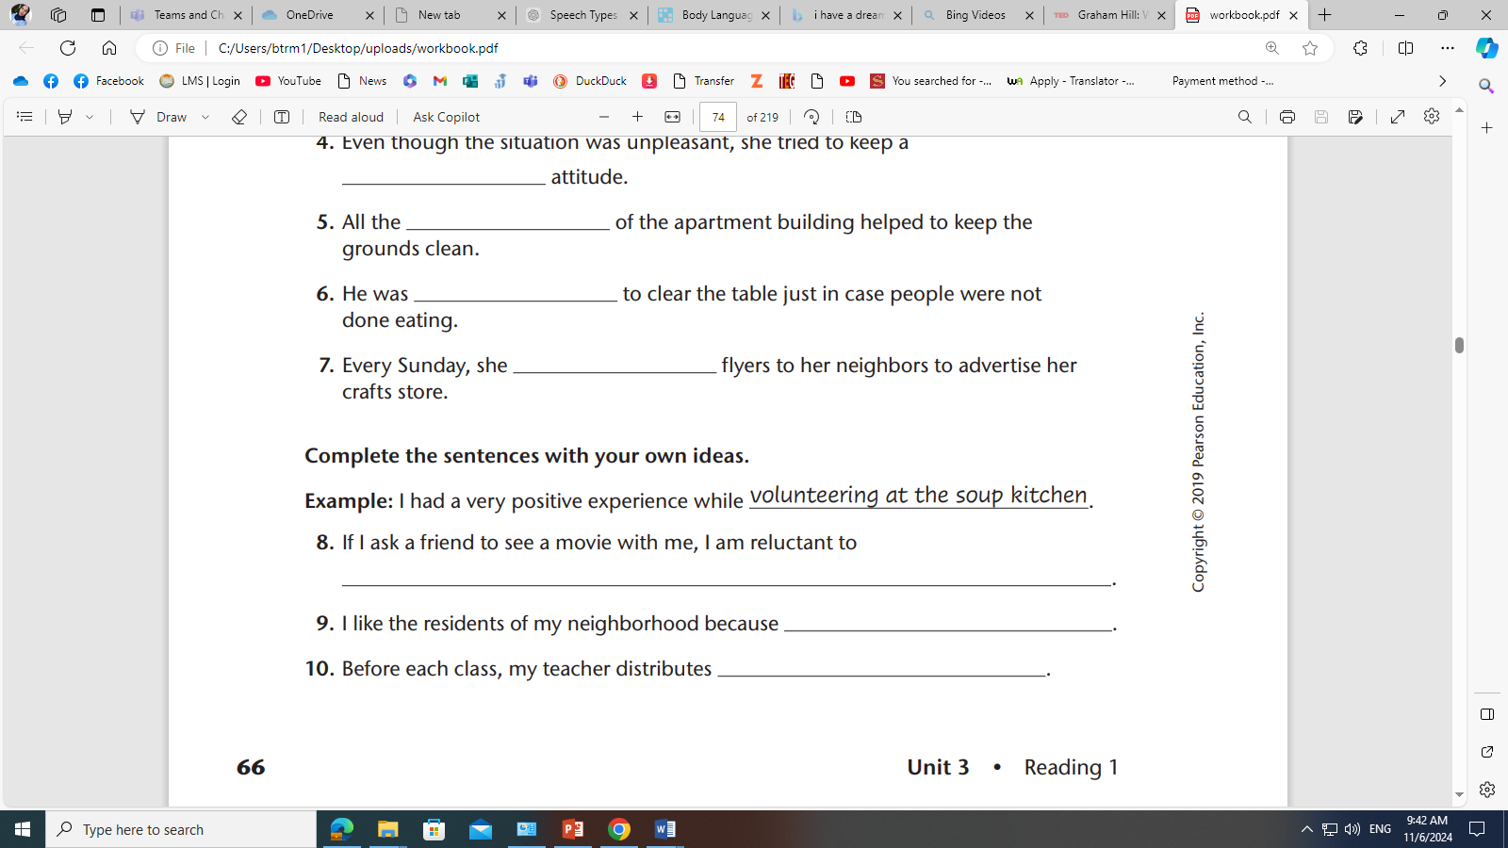

Answers:
1. d
2. a
3. c
4. positive
5. residents
6. reluctant
7. distributes
8. invite him to my house.
9. they are very cooperative
10. sheets to revise us with the previous class.

B.Fill in the gaps with the most suitable answer:
reluctant / vivid / infirm / concern / residents / distribute / positive

- The teacher will distribute the worksheets to the students after lunch.
- He has a positive attitude that makes everyone feel better.
- She was reluctant to try the new food because she didn't like its smell.
- Despite feeling worried, the infirm elderly woman caressed her cat gently, finding comfort in its warmth.
- The residents of the neighborhood were reluctant to change their old traditions.
- She gave a vivid description of her vacation to her friends, making them feel like they were there.
- Her primary concern was making sure everyone arrived safely to the event.

B. Choose the best answer and write the part of speech of each :
- He was (reluctant/ reluctantly/ reluctance) to speak in front of the large crowd, even though he had prepared his speech.(adjective)
- Her (positive/ positively/ positivity) attitude helped the team overcome many challenges. .(adjective )
- The teacher will (distribute/ distributing/ distributed) the worksheets to the students in class. .(verb )
- The artist used (vivid/ vividly/ vivacity) colors in the painting to bring the landscape to life. .(adjective)
- The child smiled (mischievously/ mischief/ mischiefs) as he hid the gift under his bed, planning a surprise for his parents. .(adverb)

3. Literary Words:
- Irony: is the difference between what the reader expects to happen and what actually happens in a story. Writers include ironic situations in stories to create surprise and amusement.


A. Read these examples and identify the irony:

1. Samantha always dreamed of being a writer, but she was terrified of public speaking.
She enrolled in a creative writing class, thinking it would be a quiet, solitary experience. However, at the first session, the teacher handed out a form for everyone to present their work in front of the class. Samantha’s heart raced. A month later, after presenting her story with trembling hands, she realized she loved the attention and started signing up for more public speaking events.

Samantha thought a writing class would be quiet and private, yet she ended up loving public speaking—the very thing she feared.

2. Ethan hated running, but he joined the track team to impress his friends.
On the first day of practice, he found himself gasping for breath after just a few laps around the field. He spent the entire practice thinking how ridiculous it was to join something he didn’t even enjoy. By the end of the season, Ethan had won two races and was disappointed when the season ended, wishing it had lasted longer.

Ethan joined track even though he hated running, but he unexpectedly became good at it and ended up loving the sport.’

3. Katie wasn’t interested in the new coffee shop opening in town, thinking it was just another trend.
Her friend insisted they go for coffee, but Katie was certain she would hate the place. She’d rather stay home with a cup of tea. Three weeks later, Katie was there every morning before work, ordering the same coffee as her friend and chatting with the baristas like an old regular.

Katie was sure she’d dislike the new coffee shop, but she became one of its most enthusiastic regulars.

B. Foreshadowing is the author’s use of clues to hint at what might happen later in a story. Writers use foreshadowing to engage readers in wondering about what might happen and to create suspense.
- Determine if the following examples are foreshadowing or irony:


- Sarah wore her favorite white dress… confident it would be a perfect day.
Irony – Her confidence contrasts with the likely messy or imperfect outcome.

- The sky turned dark and thunder rumbled…
Foreshadowing – This hints that something bad (a storm) is coming.

- Mark spent hours perfecting his recipe… only to burn it.
Irony – The outcome is the opposite of what his hard work intended.

- Character sees a black cat… “What a great way to start my day.”
Irony – Black cats are traditionally seen as bad luck, so her positive comment contradicts the omen.

- Lisa overhears a nurse whisper, “Let’s hope today isn’t like last Tuesday.”
Foreshadowing – Suggests something went wrong before and might again.

- Jake studied all night for math, but it was a history exam.
Irony – He prepared intensely for the wrong subject.

- Villain says, “I’ll never get caught,” right before police arrive.
Irony – His confidence is immediately proven wrong.

- Peter mentioned perfect weather, not realizing a storm was approaching.
Foreshadowing – His comment hints that the opposite (bad weather) is coming.

- Lucy’s mom says “break a leg”—and she actually sprains her ankle.
Irony – The figure of speech becomes literal.

- Tom jokes nothing can scare him… then screams minutes later.
Irony – His claim is quickly contradicted.

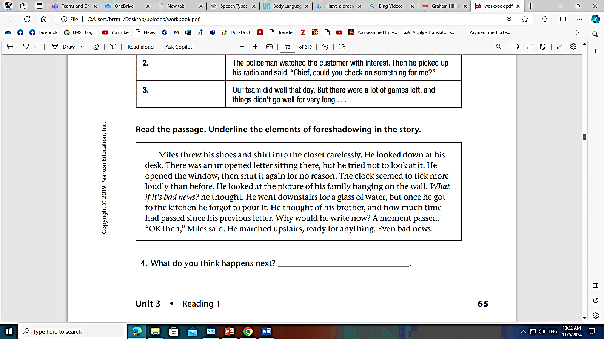

• “There was an unopened letter sitting there, but he tried not to look at it.”
(Suggests he is afraid of what it might say.)
• “The clock seemed to tick more loudly than before.”
(Creates tension, hinting something important is coming.)
• “He looked at the picture of his family… What if it’s bad news? he thought.”
(Directly suggests the letter may contain troubling news.)
• “He thought of his brother, and how much time had passed since his previous letter.”
(Hints something unusual or concerning might have happened.)
• “Ready for anything. Even bad news. ”
(Strongly foreshadows that the letter may contain something troubling.)


4. Reading Comprehension:

After reading the text in p. 130-137, answer these reading comprehension questions

1. The story is told from: First Person point of view.
2. Who are the characters? And what is the setting?
• Marilia (Tía Marilia as a child)
• Sister Antonia
• Margarita (her friend)
• Señora Collazo (the librarian)
• Mami (her mother)
• Elenita (the blind resident at the nursing home)
Setting:
- A Catholic girls’ school in Puerto Rico
- The nursing home in Santurce
- Marilia’s home

3. What is the tradition they follow every year?
They visit the nursing home in Santurce every December to bring Christmas cheer to the residents.
4. How does she feel about visiting the nursing home? Why?
She feels sad, afraid, and unwilling to go because her grandmother had died in a nursing home, and the memory makes her uncomfortable.

5. What were her 3 plans to avoid the field trip?
• Ask the librarian to let her stay and help in the library.
• Ask Sister Antonia to let her stay at school to do an extra book report.
• Eat too much food and drink hot water to try to make herself sick.

6. What are Aguinaldos? Surprise gifts.

7. What was her mother reaction to Marilia’s plan.
Mami realized she was pretending to be sick, explained that she might enjoy the visit, and reminded her that she had already promised to bring trays of tembleque for the residents—so Marilia had to go.
8. What did the students do to cheer the residents?
They sang carols, gave them handmade cards, and passed out sweets.
9. What aguinaldos does Marilia’s class distribute to the residents of the nursing home?
Besitos de coco (coconut sweets) and tembleque (a coconut dessert).
10. Why did she describe the card to Elenita? How did that make her feel?
She described the card because Elenita was blind and couldn’t see it.
Doing so made Marilia feel connected, warm-hearted, and happy to have made Elenita smile.

11. Quote a sentence that shows that Elenita liked the aguinaldo Marilia brought.
“The best aguinaldo,” Elenita said, “was your visit, Marilia.”
OR “I’ll keep this card to remember you by.”
13. What is the irony of Marilia’s trip to the nursing home?
She spent the whole time trying to avoid going, but once she arrived, she ended up loving the visit, making a new friend, and wanting to return.
14. What aguinaldos she is planning on giving next year?
She plans to make a collage with different textures so Elenita can feel the picture even though she is blind, possibly a collage of Elenita dancing.

Critical thinking
Is it important to have traditions that bring people together? Explain your answer

Yes, traditions that bring people together are important because they strengthen family and community connections, create shared memories, and encourage kindness and empathy. These traditions help people feel a sense of belonging and can teach values such as generosity, gratitude, and compassion—just as Marilia learned through her visit to the nursing home.

5. Grammar:

Comparative and superlative adjectives

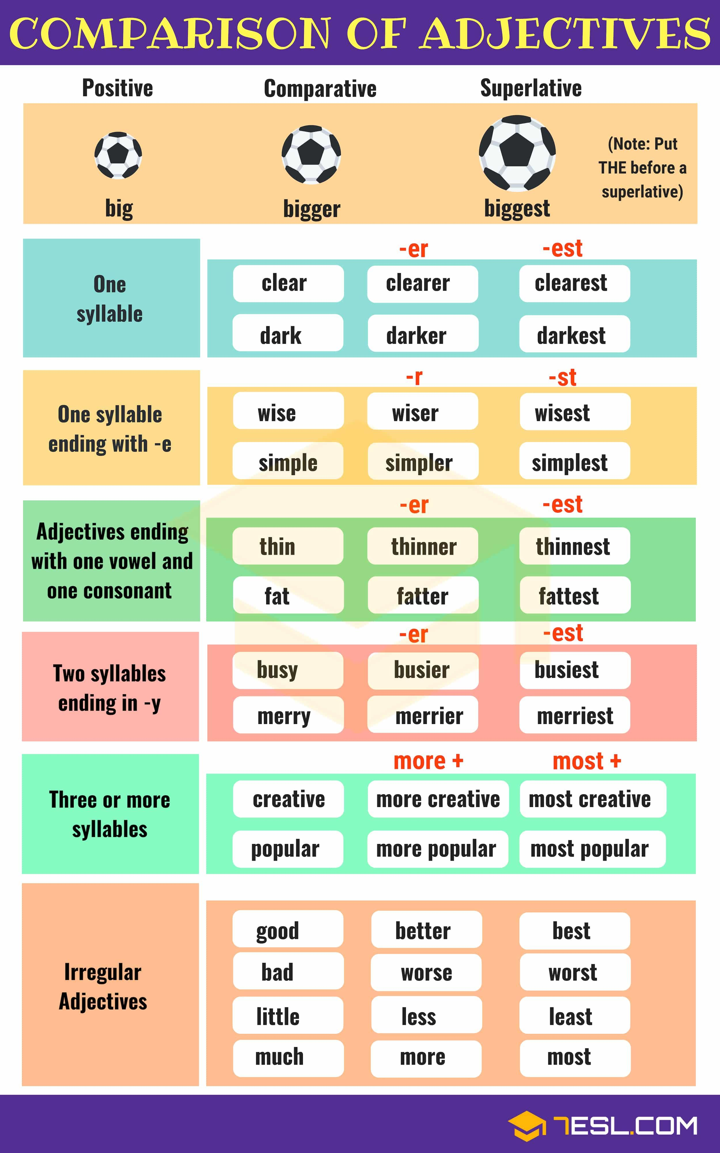

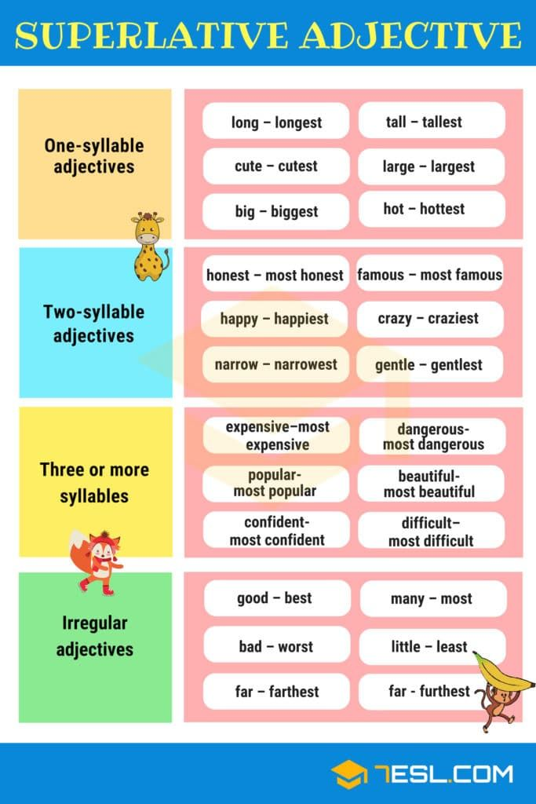

A. Fill in the correct form of the adjectives in parentheses.
- I am surely ____________________ (fluent) now than I was last year.
- Maha is very nice; I think she is ___________________ (polite) person of them all.
- She seemed __________________ (happy) than before.
- This girl was dancing really well, she is ____________________ (graceful) girl I saw.
- Could you write in a ___________________ (clear) handwriting?
- Planes can fly ____________________ (high) than birds.
- He had an accident last year. Now, he is __________________ (careful) than before.
- Jim can run __________________ (fast) than John.
- Our team played __________________ (bad) of them all; that’s why we lost the match.
- He worked ___________________ (hard) than ever before.

------------------------------------------

1. I am surely more fluent now than I was last year.
2. Maha is very nice; I think she is the most polite person of them all.
3. She seemed happier than before.
4. This girl was dancing really well; she is the most graceful girl I saw.
5. Could you write in a clearer handwriting?
6. Planes can fly higher than birds.
7. He had an accident last year. Now, he is more careful than before.
8. Jim can run faster than John.
9. Our team played the worst of them all; that’s why we lost the match.
10. He worked harder than ever before.

______________________________________________________________________________
B. Complete each the sentence by using the bold adjective in its correct form.
EXAMPLE: I have a fast car, but my friend has a faster car.

- This is a nice cat. It's much________________ than my friend's cat.
- Here is Emily. She's six years old. Her brother is nine, so he is ________________.
- This is a difficult exercise. But the exercises we did yesterday were _________________.
- He has an interesting hobby, but my sister has the _________________ one in the world.
- In the last holidays I read a good book, but father gave me an even______________ one last weekend.
- Skateboarding is a dangerous hobby. Bungee jumping is _______________ than skateboarding.
- This magazine is cheap, but that one is __________________.
- Yesterday John told me a funny joke. This joke was the ____________ joke I've ever heard.

1. This is a nice cat. It's much nicer than my friend's cat.
2. Here is Emily. She's six years old. Her brother is nine, so he is older.
3. This is a difficult exercise. But the exercises we did yesterday were more difficult.
4. He has an interesting hobby, but my sister has the most interesting one in the world.
5. In the last holidays I read a good book, but father gave me an even better one last weekend.
6. Skateboarding is a dangerous hobby. Bungee jumping is more dangerous than skateboarding.
7. This magazine is cheap, but that one is cheaper.
8. Yesterday John told me a funny joke. This joke was the funniest joke I've ever heard.


6. Writing : A comparative essay

In order to compare two items, follow the following steps:
1- Think of two things that have similarities and differences.
2- Use a diagram to help.
3- Use the simple present tense.
4- Use linking words to show comparison like:

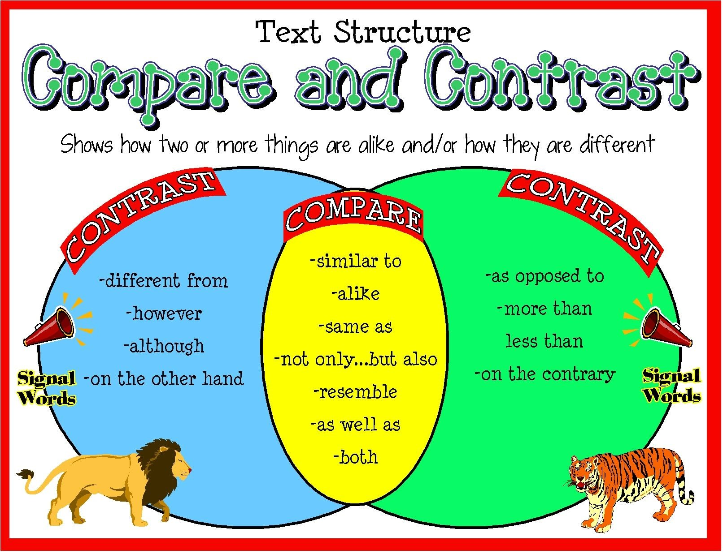

A. Read the following passage and complete the gaps using the correct word:
New York City and Los Angeles are two big cities found within the United States of America. Very large and populous. They both attract thousands of visitors in spite of being hugely crowded and costly to live in 1. ………………….. (Where, while) the cities have some similarities, New York City and Los Angeles are vastly different, especially in their climate, housing, and transportation
New York City’s (NY) Climate is much2. …………… (cold, colder) than that of Los Angeles (LA). In New York, the winter is glistening and frosty 3. ………………, (Similarly, In contrast) Los Angeles has winters and summers that are warm.
The housing characteristics are also different The age of a home in New York is 4….……………. (old, older) than the age of a home in Los Angeles. While the cost of a home in New York is $581,400, in Los Angeles it is $583,600. This implies that it is a bit cheaper to acquire a home in NY as compared to LA.
Another major difference between New York City and the city of Los Angeles is public transportation. In LA, there is a huge car culture where almost everybody drives. Most people have their own cars. 5. ………………………….., (However, Although) there is public transportation in the city, few people use it. In New York on the other hand, almost everybody takes some form of public transportation.
In conclusion, New York City and Los Angeles have many differences 6. …………………. (in spite of , although) having some similarities as large cities within the US. The cities are attractive to people from all over the world owing to their different features and characteristics. However, the climate, housing and public transportation show how vastly different the cities are.
Answers
1. While
2. colder
3. In contrast
4. older
5. However
6. in spite of

Let’s write: Instructions
Choose a topic then write a (250) words essay comparing between them.
- Video Games vs. Sports: Which Builds Better Friendships?
- Online Friends vs. Real-Life Friends: Are They Equally Important?

- Living in a Big City vs. a Small Town
- Cats vs. dogs
- Online learning vs. traditional learning
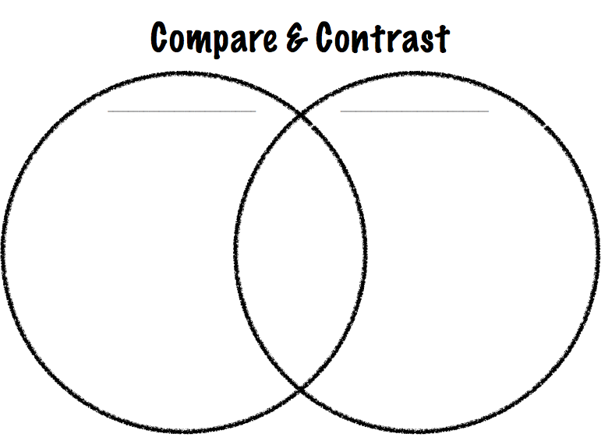
** Use the diagram to write the similarities and differences:

 Write down a descriptive essay to compare b
____________________

________________________________________________________

1. Video Games vs. Sports: Which Builds Better Friendships?
Friendships are often formed through shared activities, but not all hobbies create bonds in the same way. Video games and sports are two popular pastimes among young people today. Although both can help people make friends, they differ in how they build connections and social skills.
Both video games and sports encourage teamwork and cooperation. Similarly, they require players to work together toward common goals, whether winning a match or completing a challenging level. Moreover, both activities allow friends to celebrate achievements together and develop trust over time.
Sports develop friendships through face-to-face interaction and physical teamwork. Players practice together, communicate constantly, and often participate in social activities outside the game. In contrast, video games connect people across distances. Online friends can play together even if they live in different cities, and shy individuals may feel more comfortable interacting in a virtual space.
In conclusion, both video games and sports can create meaningful friendships, but they appeal to different personalities. Sports emphasize in-person teamwork, while video games allow long-distance connections. Together, they show that friendship can grow anywhere there is cooperation and shared interest.

2. Online Friends vs. Real-Life Friends: Are They Equally Important?
In the modern digital world, friendships are no longer limited to face-to-face encounters. People can form meaningful bonds online or in real life. Although both types of friendships provide support and companionship, they have distinct qualities.
Both online and real-life friends provide emotional support, companionship, and shared experiences. Similarly, they can celebrate successes and offer help during challenges. In both cases, trust and understanding are crucial for strong relationships.
Real-life friendships grow through physical presence, allowing people to read emotions and spend time together in person. On the other hand, online friendships offer flexibility and access to people worldwide. However, online friends may lack direct interaction, while real-life friends provide immediate help and personal connection.
In conclusion, online and real-life friendships are both important, but in different ways. Real-life friends offer closeness and shared experiences, while online friends provide accessibility and opportunities to meet diverse people. A balanced social life can include both types of friends.

3. Living in a Big City vs. a Small Town
Choosing where to live greatly affects a person’s lifestyle and opportunities. Big cities and small towns each offer unique experiences. Although both can attract residents, they differ in pace, environment, and lifestyle.
Both big cities and small towns provide a sense of community and opportunities for personal growth. Similarly, they attract people seeking either excitement, culture, or a peaceful environment. Each setting has benefits that appeal to different types of people.
Big cities provide more job opportunities, cultural events, and services. Life is fast-paced and exciting but also crowded and expensive. In contrast, small towns offer peace, close-knit communities, and lower costs of living. However, they may lack entertainment options and career opportunities.
In conclusion, big cities and small towns have advantages and disadvantages. Cities are suitable for those seeking excitement and opportunities, while towns are ideal for those valuing tranquility and close community ties. The choice depends on individual priorities.

4. Cats vs. Dogs
Pets bring joy to households, but not all pets are alike. Cats and dogs are the most popular choices. Although both offer companionship, they differ in care, personality, and the type of bond they form with their owners.
Both cats and dogs provide emotional support, joy, and affection. Similarly, they can reduce stress, improve mood, and create a sense of responsibility for their owners. Both pets form meaningful connections with humans.
Dogs are loyal, energetic, and social, requiring walks and active interaction. In contrast, cats are independent, groom themselves, and need less attention. Dogs show affection openly, while cats express love more subtly, through purring or sitting nearby.
In conclusion, both cats and dogs bring happiness, but in different ways. Dogs suit active owners seeking constant companionship, while cats fit people preferring calm and low-maintenance pets. The best choice depends on the owner’s lifestyle and personality.

5. Online Learning vs. Traditional Learning
Education is rapidly evolving, and online learning has become a popular alternative to traditional classrooms. Although both methods aim to teach students effectively, they differ in interaction, flexibility, and structure.
Both online and traditional learning provide knowledge, skills, and personal development. Similarly, they require effort, discipline, and participation to succeed. Both can help students achieve academic goals.
Traditional learning occurs face-to-face, allowing students to ask questions immediately, interact with peers, and develop social skills. In contrast, online learning offers flexibility, independence, and access to lessons from anywhere. However, online learning may lack personal interaction, making some students feel isolated.
In conclusion, both online and traditional learning have unique advantages. Traditional classrooms build social and interactive skills, while online learning provides convenience and self-paced study. The best approach depends on each student’s needs and preferences.

Evaluate your writing:
Content and ides  (Using descriptive details)  /2 | punctuation  2 | Spelling  2 | Outline & paragraphing  2 | Handwriting  2 | Grammar (Using present tense)  2 | Total  12


After you finish your first draft, check for mistakes using the following checklist

- Adding a topic sentence to the introduction
- Writing the title
- Writing supporting sentences
- Using lots of descriptive details
- Using sequence words
- Clear handwriting
- Accurate spelling
- Using correct tense
- Using correct punctuation marks and avoiding capitalization mistakes.



More Advanced Essays as an enrichment for excellent students.

1. Video Games vs. Sports: Which Builds Better Friendships?
Friendships often emerge from shared pursuits, yet not all activities cultivate bonds with equal intensity. Video games and sports are two prevalent forms of recreation among young people today. Although both can foster camaraderie, they achieve this in markedly different ways.
Both video games and sports promote collaboration and strategic coordination. Similarly, participants learn to navigate challenges collectively and celebrate joint accomplishments. Furthermore, these activities instill a sense of trust and mutual reliance, which are crucial for enduring friendships.
Sports cultivate relationships through direct, in-person interaction. Players engage continuously, communicate effectively, and often extend social bonds beyond the field through team events. In contrast, video games facilitate connections across geographical boundaries. Players can forge meaningful alliances virtually, enabling even introverted individuals to form friendships in a comfortable digital environment. However, the emotional intensity of face-to-face interactions in sports is often more palpable than in online gaming.
In conclusion, both video games and sports can engender significant friendships, yet they appeal to different social inclinations. Sports emphasize tangible collaboration and immediate interaction, whereas video games enable global connectivity and virtual cooperation. Collectively, they underscore that friendship thrives wherever shared goals and mutual engagement exist.

2. Online Friends vs. Real-Life Friends: Are They Equally Important?
In the contemporary digital era, friendships are no longer confined to physical encounters. Individuals can cultivate profound relationships online or in person. Although both forms provide emotional sustenance, they exhibit distinct characteristics.
Both online and real-life friends offer invaluable support, companionship, and shared experiences. Similarly, they celebrate successes, provide guidance during adversity, and foster trust and empathy. In both scenarios, interpersonal understanding is foundational to sustaining meaningful connections.
Real-life friendships flourish through physical presence, enabling nuanced communication and immediate emotional responsiveness. Conversely, online friendships afford unparalleled flexibility and access to a diverse network of peers. Nevertheless, the absence of in-person cues can render online bonds more tenuous compared to relationships grounded in shared physical experiences.
In conclusion, both online and real-life friendships hold intrinsic value, albeit in divergent ways. Real-life friendships provide immediacy and tangible support, whereas online friendships cultivate inclusivity and long-distance connectivity. Ideally, a balanced social framework integrates both dimensions.

3. Living in a Big City vs. a Small Town
The choice of residence profoundly shapes lifestyle, opportunities, and personal development. Big cities and small towns each offer distinct environments. Although both attract inhabitants for various reasons, they differ significantly in pace, infrastructure, and social dynamics.
Both urban and rural settings provide avenues for growth and community engagement. Similarly, they appeal to individuals seeking fulfilment, whether through professional advancement, cultural enrichment, or social cohesion.
Urban centres offer extensive employment prospects, cultural institutions, and diverse amenities. Life in a metropolis is dynamic, stimulating, and replete with opportunities. In contrast, small towns provide tranquillity, familiarity, and a strong sense of community. However, they may lack the cultural, educational, and professional resources characteristic of larger cities.
In conclusion, big cities and small towns present contrasting advantages. Urban life suits those pursuing ambition and cosmopolitan experiences, whereas small-town living appeals to individuals prioritizing serenity and social intimacy. The optimal choice depends on personal values and lifestyle aspirations.

4. Cats vs. Dogs
Pets enrich human lives, yet the experiences they offer differ substantially. Cats and dogs, as the most common household companions, provide affection and companionship in distinctive manners. Although both animals can forge profound bonds with their owners, their care requirements and behavioral traits diverge considerably.
Both cats and dogs enhance emotional well-being, alleviate stress, and cultivate responsibility. Similarly, they foster a sense of attachment and companionship, contributing to mental and emotional stability.
Dogs are loyal, exuberant, and socially interactive, requiring exercise, engagement, and attention. In contrast, cats are independent, self-sufficient, and often more subtle in displaying affection. Nevertheless, both species offer unique forms of companionship tailored to different lifestyles. Dogs suit active households, whereas cats complement more tranquil or structured environments.
In conclusion, both cats and dogs contribute significantly to human happiness, albeit in contrasting ways. Dogs offer energetic, interactive companionship, while cats provide calm, low-maintenance support. Choosing between them hinges on individual temperament, living conditions, and lifestyle preferences.

5. Online Learning vs. Traditional Learning
The landscape of education is rapidly evolving, with online learning emerging as a viable alternative to conventional classroom instruction. Although both modalities aim to impart knowledge effectively, they differ in engagement, flexibility, and pedagogical approach.
Both online and traditional learning cultivate intellectual growth, critical thinking, and skill development. Similarly, both demand discipline, commitment, and active participation to achieve academic success.
Traditional classrooms offer direct, face-to-face interaction, fostering immediate feedback, social engagement, and collaborative learning experiences. In contrast, online learning provides unprecedented flexibility, allowing students to access materials remotely and learn at their own pace. However, the relative absence of personal interaction can pose challenges to motivation and social skill development.
In conclusion, both online and traditional learning have distinct advantages. Classroom education promotes structured social interaction and immediate guidance, whereas online learning offers autonomy and convenience. Selecting the optimal approach depends on the learner’s objectives, personal preferences, and learning style.

